The Big Picture Advanced
Unit 12: The Great Depression

Name: |  | Date: |  | Period:

Part I: Analyze an Image

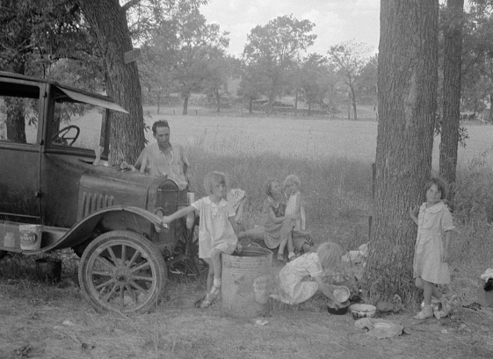  Figure 1: The Library of Congress | - What are three things you observe about the image?
- What are two things you can infer about this era of Texas history based on the image?

- What do you predict we will see in this unit based on the image?

Part II: Essential Ideas Reading Passage

In the previous unit, the Age of Oil, the United States experienced rapid industrialization that brought great economic growth for many Americans. In Texas, thousands moved to cities to take part in the booming oil industry. Though Texas farmers still faced significant financial struggles, the Age of Oil was a time of great economic growth for many.
During the 1920s, one way that some people made money was by taking part in the New York Stock Exchange. This was a financial system that allowed people to buy stocks, or shares of different companies, allowing them to share in the company’s profits. By 1929, an estimated 2.5 - 10% of the U.S. population took part in the stock market. As the economy steadily grew during the “Roaring 20s”, this small group of people often borrowed large amounts of money from banks to buy more and more stocks.
In October 1929, however, economic growth slowed and many who took part in the stock market panicked and sold their stocks. As a result, the value of stocks plummeted, and people lost a lot of money. To cover their debts, many rushed to their banks to withdraw funds, but the banks had also lost a great deal of money in the stock market crash. Unable to provide people with money from their accounts, thousands of banks closed and people lost their entire savings. Businesses closed across the country and millions of people lost their jobs. This began the Great Depression era – the worst economic depression in U.S. history.
In 1932, a man named Franklin Delano Roosevelt was elected president on the promise of a “New Deal” for the American people. Roosevelt’s administration developed a plan to provide relief and recovery opportunities to the American people and reforms to protect against future financial disasters. Roosevelt’s “New Deal” included programs to stabilize the banks and provide jobs to the millions of unemployed Americans.
In Texas, Roosevelt’s “New Deal” had a transformative effect on the state. The Rural Electrification Administration (REA) provided affordable electricity to farming communities, 98% of which had no access to electricity up to that point. The Public Works Administration (PWA) hired skilled workers for community construction projects including building roads, bridges, and schools. The Civilian Conservation Corps (CCC) provided jobs to approximately 50,000 unemployed Texas men to work on projects such as building state parks and soil conservation in west Texas, where harmful farming practices and overgrazing of cattle combined with a period of drought had caused significant soil erosion leading to dust storms hundreds of feet in the air for hours or days at a time. These dust storms lasted for much of the 1930s and came to be known as the “Dust Bowl.” Thousands of west Texas farmers fled the state to escape the Dust Bowl during the Great Depression.
The Great Depression era of the 1930s was a period of incredible challenge and hardship for millions of Americans which led to a significant expansion of the federal government.

Part III: Comprehension Questions

- How does the Age of Oil, including the decade of the 1920s, compare to the Great Depression era of history? Use the graphic organizer below to record your response.

Whereas is a word that connects two sentences containing contrasting information.

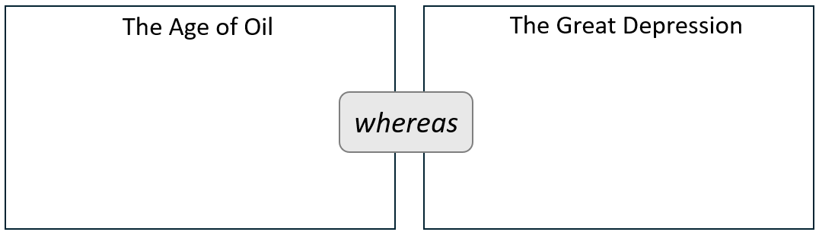

- Which of the following statements are TRUE of the stock market crash of 1929 which caused the Great Depression? Check all that apply.

- People could buy shares in businesses on the stock market.  - Over half of all American citizens held stocks by 1929.  - Texans made a lot of money off oil companies on the stock market.  - A small percentage of people made a lot of money on the stock market. | - Texas oil companies were unaffected by the market crash.  - People sold all their stocks in a panic when the economy slowed.  - Many Americans lost their savings when thousands of banks closed.  - Businesses failed and millions lost their jobs.

- The events that caused the Great Depression are listed randomly below. Order the events chronologically by writing the number of each event in the space provided.

_____ Banks closed, businesses failed, people lost their jobs, and a depression began.
_____ A small percentage of people borrowed heavily to invest in the stock market.
_____ People rushed to banks to withdraw money, but banks had lost money too.
_____ Stock prices dropped significantly, causing people to lose millions of dollars.
_____ The economy slowed in 1929, and people rushed to sell their stocks.

- What is an economic depression, and what specifically was the Great Depression?

- What did President Franklin Delano Roosevelt promise the American people? Explain.

- Name three of the programs that President Roosevelt instituted to achieve his promise and explain what each program did to help Americans.
Program | What did it do?

