Vocabulary Advanced
Unit 12: The Great Depression

Name: |  | Date: |  | Period:

Directions: Use the vocabulary readings on the slideshow presentation to complete the chart below.
Economic Depression (n)
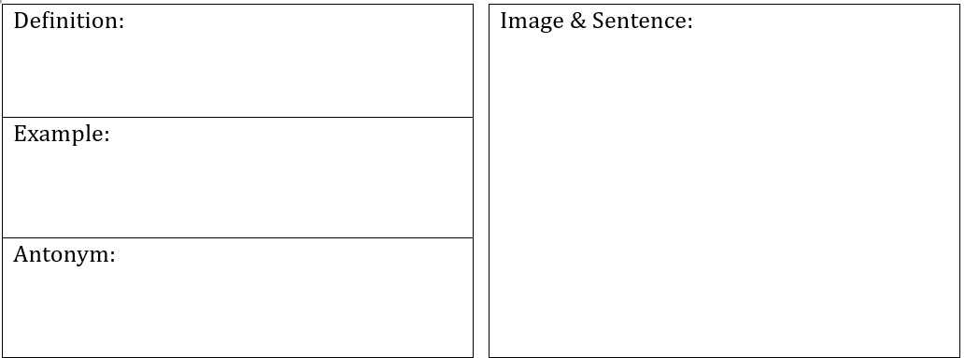

Stock Market (n)

Relief (n)
Unemployment (n)
Ecology (n)

