Growing Tension in Texas Advanced
Unit 4: The Mexican National Era

Name: |  | Date: |  | Period:

Directions: Take quick notes about six significant events that caused growing tension in Texas. Summarize and paraphrase when possible. Be sure to record information related to WHAT happened, WHO was involved, WHERE it took place, and WHY it was significant.

The Fredonian Rebellion
1826
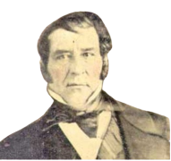
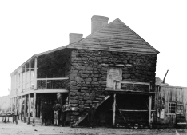

The Mier y Teran Report, 1828

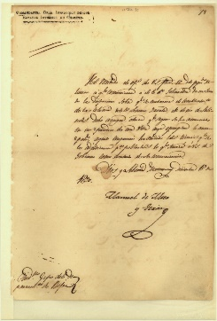

The Law of April 6, 1830



The Turtle Bayou Resolutions, 1832
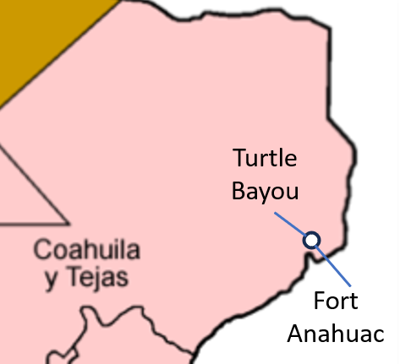

The Conventions of 1832 & 1833

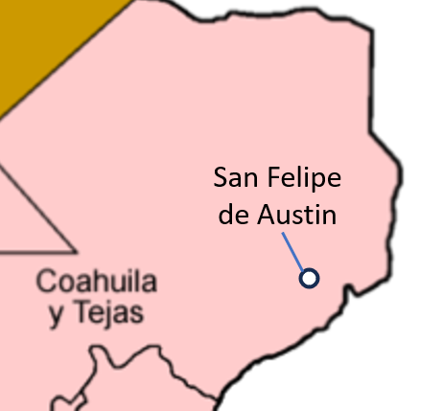

The Arrest of Stephen F. Austin, 1833

