Growing Tension in Texas Foundations
Unit 4: The Mexican National Era

Name: |  | Date: |  | Period:

Directions: Take quick notes about six significant events that caused growing tension in Texas. Summarize and paraphrase when possible. Be sure to record information related to WHAT happened, WHO was involved, WHERE it took place, and WHY it was significant.

The Fredonian Rebellion  1826  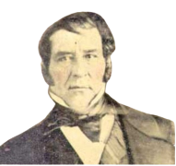  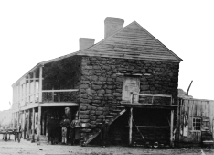 | - What: A small, unsuccessful ________________________________ ______________________ against the Mexican government.  - Who: An Anglo-American empresario named _____________ _________________________________ led the rebellion. Stephen F. Austin helped stop it.  - Where: East Texas – Nacogdoches  - Why is it Significant: Mexico easily _______________________ the rebellion with Austin’s help, but it caused the government to become concerned about ___________________ in Texas.

The Mier y Teran Report, 1828  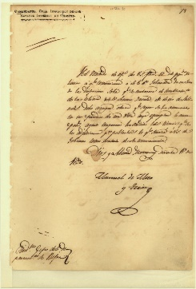 | - What: A report showing that Anglos outnumbered Tejanos in Texas ______ to ______, and there were few Mexican officials, so it was easy for people to ______________ the _____________.  - Who: General Manuel Mier y Terán  - Why is it Significant: Terán’s report showed that there were many _____________________ related to _________________ immigration in Texas. He suggested Mexico fix the issues immediately.

The Law of April 6, 1830   | - What: Laws that Mexico passed to try to ___________ the _____________________ with the Empresario System in Texas:  - Stopped all ____________________ from the U.S. into Texas  - _____________________ unfulfilled empresario contracts  - Enforced _______________ (taxes) on items from the U.S.  - Established military _______________ in Texas to enforce the laws  - Why is it Significant: Many Anglos and Tejanos were very upset with the laws, believing they would stop the growth and development of Texas and its _________________.

The Turtle Bayou Resolutions, 1832  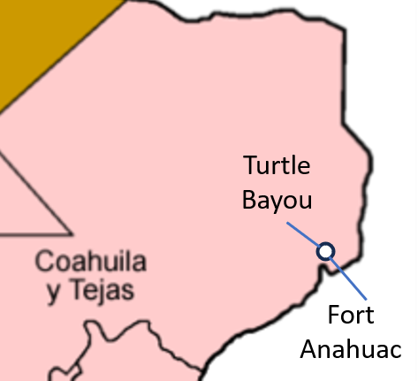 | - What: A ________________________ explaining the Anglo point of view of the conflict at _____________________________________ and showing support for the _______________________________ in the Mexican government.  - Where: Near present-day Houston  - Why is it Significant: Some Anglos in Texas were openly declaring ________________________ for Federalists in the ongoing debates between Centralists and Federalists across the country

The Conventions of 1832 & 1833  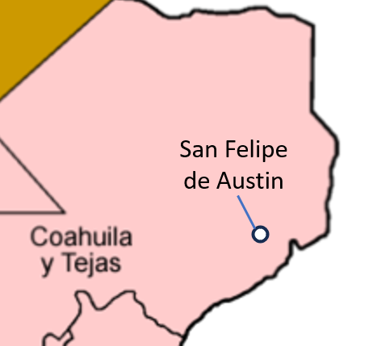 | - What: Two _________________________ of Anglo delegates to write a list of requests for the Mexican government.  - _______________________ the anti-immigration laws from the Law of April 6, 1830  - Remove the _________________________ on U.S. goods  - Grant separate ____________________________ for Texas  - Who: ___________________ of Convention: Stephen F. Austin  - Where: San Felipe de Austin (near Houston)  - Why is it Significant: ________________________ in Texas were organizing in support of development and statehood for Texas.

The Arrest of Stephen F. Austin, 1833  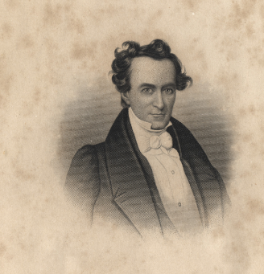 | - What: Austin was arrested and imprisoned for encouraging Anglos in Texas to start making their own ______________________________ after President Santa Anna had denied the request.  - Who: Stephen F. Austin, President Santa Anna  - Where: Arrested in Saltillo, Coahuila. Imprisoned in Mexico City for ____________ years.  - Why is it Significant: Austin’s time in prison caused him to be ____________ supportive of the Mexican government.

