Growing Tension in Texas Grade Level
Unit 4: The Mexican National Era

Name: |  | Date: |  | Period:

Directions: Take quick notes about six significant events that caused growing tension in Texas. Summarize and paraphrase when possible. Be sure to record information related to WHAT happened, WHO was involved, WHERE it took place, and WHY it was significant.

The Fredonian Rebellion  1826  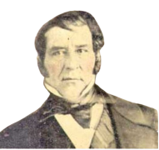  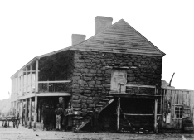 | - What: A small, _____________________________________________ against ___________________________________________  - Who: An Anglo-American _____________________________ named _________________________________ led the rebellion. ______________________________________________ helped stop it.  - Where: East Texas – _______________________________________  - Why is it Significant: Mexico easily stopped the rebellion with Austin’s help, but ________________________________________ __________________________________________________________________

The Mier y Teran Report, 1828  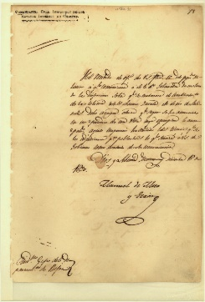 | - What: A report showing that _______________________________ _________________________________________________________________, and there were _______________________________________________, so it was easy for people ____________________________________.  - Who: General Manuel _______________________________________  - Why is it Significant: Terán’s report showed that there were ___________________________________________________________ ________________________________________________________________. He suggested Mexico ________________________________________

The Law of April 6, 1830   | - What: Laws that Mexico passed to __________________________ _________________________________________________________________  - Stopped all _______________________________________________  - Cancelled _________________________________________________  - Enforced _______________ (taxes) on items from the U.S.  - Established ________________________________________________ ______________________________________________________________  - Why is it Significant: Many Anglos and Tejanos were very upset with the laws, believing _________________________ __________________________________________________________________ __________________________________________________________________

The Turtle Bayou Resolutions, 1832  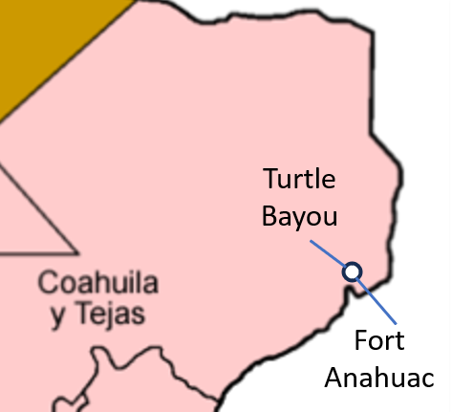 | - What: A document explaining _______________________________ __________________________________________________________________ and showing support for _____________________________________ _________________________________________________________________  - Where: Near present-day ______________________________  - Why is it Significant: Some Anglos in Texas were openly declaring ______________________________________________________ __________________________________________________________________ __________________________________________________________________

The Conventions of 1832 & 1833  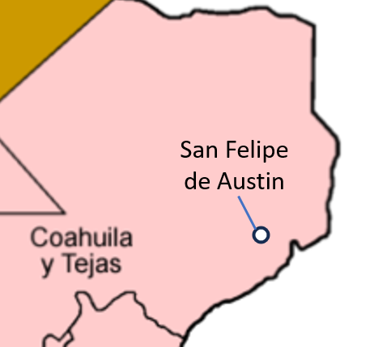 | - What: Two meetings of _____________________________________ to write ________________________________________________________ _________________________________________________________________  - ________________________________________________________ from the Law of April 6, 1830  - Remove the ________________________ on U.S. goods  - Grant __________________________________________________  - Who: President of Convention: ______________________________  - Where: ______________________________________ (near Houston)  - Why is it Significant: Anglos in Texas were organizing in support of _____________________________________________________

The Arrest of Stephen F. Austin, 1833  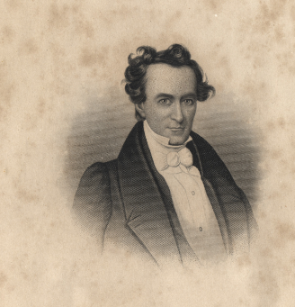 | - What: Austin was arrested and imprisoned for ____________ __________________________________________________________________ after President Santa Anna had denied the request.  - Who: Stephen F. Austin, President __________________________  - Where: Arrested in __________________________________________ Imprisoned in ________________________________ for 1 ½ years.  - Why is it Significant: ________________________________________ __________________________________________________________________ __________________________________________________________________

