Warm-up
- Student predictions will vary
Lesson

The Fredonian Rebellion  1826  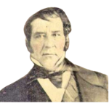  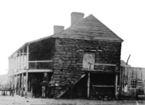 | - What: A small, unsuccessful Anglo Rebellion against the Mexican government.  - Who: An Anglo-American empresario named Haden Edwards led the rebellion. Stephen F. Austin helped stop it.  - Where: East Texas – Nacogdoches  - Why is it Significant: Mexico easily stopped the rebellion with Austin’s help, but it caused the government to become concerned about Angloes in Texas.

The Mier y Teran Report, 1828  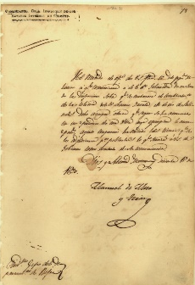 | - What: A report showing that Anglos outnumbered Tejanos in Texas 10 to 1 and there were few Mexican officials, so it was easy for people to break the laws.  - Who: General Manuel Mier y Terán  - Why is it Significant: Terán’s report showed that there were many problems related to Anglo immigration in Texas. He suggested Mexico fix the issues immediately.

The Law of April 6, 1830   | - What: Laws that Mexico passed to try to fix the problems with the Empresario System in Texas:  - Stopped all immigration from the U.S. into Texas  - Cancelled unfulfilled empresario contracts  - Enforced tariffs (taxes) on items from the U.S.  - Established military forts in Texas to enforce the laws  - Why is it Significant: Many Anglos and Tejanos were very upset with the laws, believing they would stop the growth and development of Texas and its economy

The Turtle Bayou Resolutions, 1832  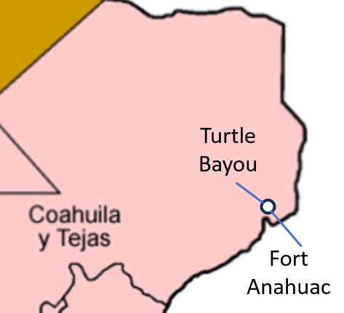 | - What: A document explaining the Anglo point of view of the conflict at Fort Anahuac and showing support for the Federalists in the Mexican government.  - Where: Near present-day Houston  - Why is it Significant: Some Anglos in Texas were openly declaring support for Federalists in the ongoing debates between Centralists and Federalists across the country

The Conventions of 1832 & 1833  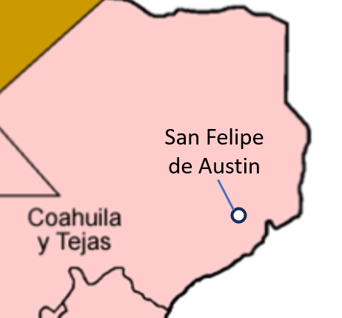 | - What: Two meetings of Anglo delegates to write a list of requests for the Mexican government.  - Repeal the anti-immigration laws from the Law of April 6, 1830  - Remove the tariffs on U.S. goods  - Grant separate statehood for Texas  - Who: President of Convention: Stephen F. Austin  - Where: San Felipe de Austin (near Houston)  - Why is it Significant: Anglos in Texas were organizing in support of development and statehood for Texas.

The Arrest of Stephen F. Austin, 1833  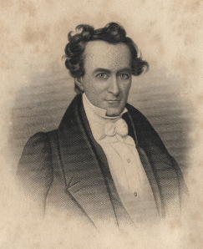 | - What: Austin was arrested and imprisoned for encouraging Anglos in Texas to start making their own state after President Santa Anna had denied the request.  - Who: Stephen F. Austin, President Santa Anna  - Where: Arrested in Saltillo, Coahuila. Imprisoned in Mexico City for 1 ½ years.  - Why is it Significant: Austin’s time in prison caused him to be less supportive of the Mexican government.

Exit Ticket
- Student responses will vary

