 Warm-up: Looking Ahead
Unit 4: The Mexican National Era
Name: |  | Date: |  | Period:

Directions: Use the image below to respond to the questions to the right.

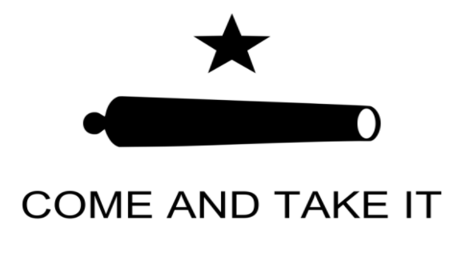

- How do you think this image relates to our unit?
- Based on this image, what do you think might happen in the next unit?

Warm-up: Looking Ahead
Unit 4: The Mexican National Era
Name: |  | Date: |  | Period:

Directions: Use the image below to respond to the questions to the right.

- How do you think this image relates to our unit?
- Based on this image, what do you think might happen in the next unit?


Looking Ahead Exit Ticket

In this lesson we learned about a small but significant battle that took place in Gonzales, Texas, in October of 1835. What do you think is going to happen next?
After the Battle of Gonzales, I predict ____________________________________________________________________________ ______________________________________________________________________________________________________________________ because ____________________________________________________________________________________________________________ ______________________________________________________________________________________________________________________

Looking Ahead Exit Ticket

In this lesson we learned about a small but significant battle that took place in Gonzales, Texas, in October of 1835. What do you think is going to happen next?
After the Battle of Gonzales, I predict ____________________________________________________________________________ ______________________________________________________________________________________________________________________ because ____________________________________________________________________________________________________________ ______________________________________________________________________________________________________________________

