 Warm-up: Mind Map Review
Unit 4: The Mexican National Era
Name: |  | Date: |  | Period:

Look at the word bank below. Complete the mind map diagram by putting each term where you think it fits best.

- Political Unrest  - Empresario System  - Increase Texas population  - Mexican National Era  - Disputes between Federalists and Centralists | 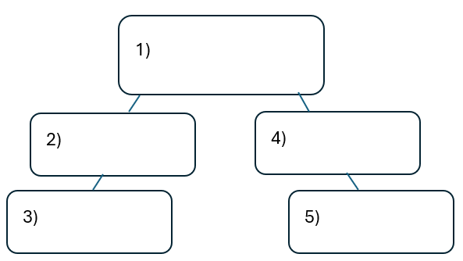

Warm-up: Mind Map Review
Unit 4: The Mexican National Era
Name: |  | Date: |  | Period:

Look at the word bank below. Complete the mind map diagram by putting each term where you think it fits best.

- Political Unrest
- Empresario System
- Increase Texas population
- Mexican National Era
- Disputes between Federalists and Centralists


Mind Map Review Exit Ticket

Directions: Complete the sentence by choosing the best answer for each blank from the chart below.

The (1)____________ is primarily characterized by (2)____________

Answer choices for blank (1)  Circle the best answer | Answer choices for blank (2)  Circle the best answer

- Political Unrest in Mexico  - Development of Plantation Agriculture in Texas  - Empresario System  - Mexican National Era | - Mexico’s long fight for independence from its colonial rulers in Spain, and its attempts at developing an alliance with the United States.  - Texas’ quest for separate statehood from Coahuila and the Centralists attempts to reinstate the Federalist Constitution of 1824.  - Tejano and Anglo efforts to develop Texas’ economy and society while political disputes grew between centralists and federalists in Mexico.  - Tejano and Anglo attempts at abolishing slavery in Coahuila y Tejas and the national government’s efforts to prohibit this action.

Mind Map Review Exit Ticket

Directions: Complete the sentence by choosing the best answer for each blank from the chart below.

The (1)____________ is primarily characterized by (2)____________

Answer choices for blank (1)  Circle the best answer | Answer choices for blank (2)  Circle the best answer

- Political Unrest in Mexico  - Development of Plantation Agriculture in Texas  - Empresario System  - Mexican National Era | - Mexico’s long fight for independence from its colonial rulers in Spain, and its attempts at developing an alliance with the United States.  - Texas’ quest for separate statehood from Coahuila and the Centralists attempts to reinstate the Federalist Constitution of 1824.  - Tejano and Anglo efforts to develop Texas’ economy and society while political disputes grew between centralists and federalists in Mexico.  - Tejano and Anglo attempts at abolishing slavery in Coahuila y Tejas and the national government’s efforts to prohibit this action.

