Station 1

Note: 1 bale equals 480 pounds of cotton
Source: USDA National Agricultural Statistics Service, Crop Production reports. January 8, 2025

Station 2

Acres of Cotton Harvested in the United States, 2017
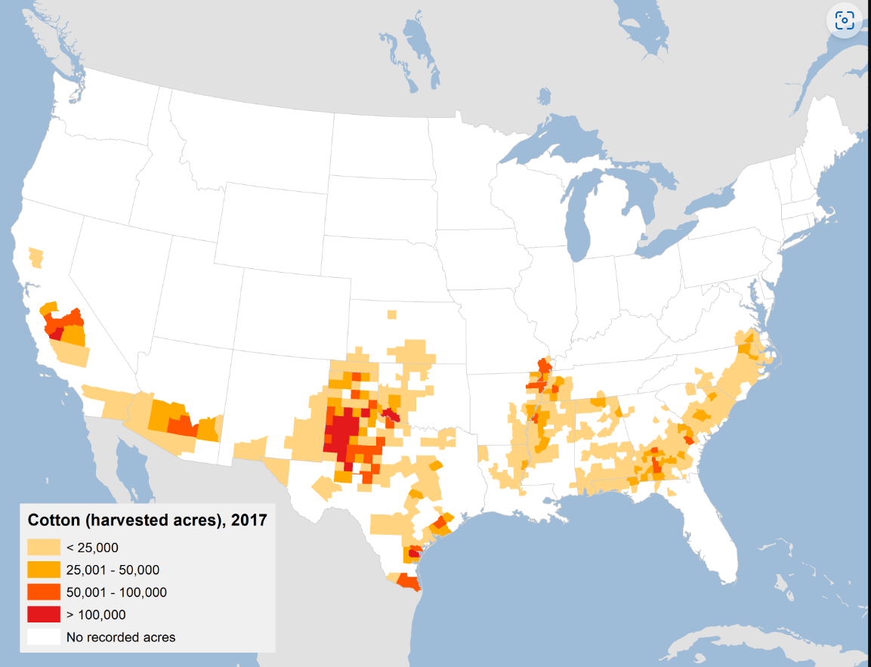
Source: USDA Economic Research Service, Cotton and Wool, Cotton Sector at a Glance January 8, 2025

Station 3

Source: U.S. Department of Agriculture, Economic Research Service

Vocabulary
Commodity: a raw material or agricultural product that can be bought and sold.
Broilers: Chickens raised for meat
Share of Receipts: The percentage of money spent on each item out of the total amount of money spent on all products.

Station 4

Source: U.S. Department of Agriculture National Agricultural Statistics Service, Annual Cotton Review, Monthly Crop Production Reports.

Vocabulary
Harvest: The amount of cotton collected from what was planted.

Station 5

Source: National Integrated Drought Information System, The National Oceanic and Atmospheric Administration.

