The Empresario System Advanced
Unit 4: The Mexican National Era

Name: |  | Date: |  | Period:

Goals of the Empresario System

Mexico’s Goals | Tejano Goals | Anglo Goals

Moses Austin |  | 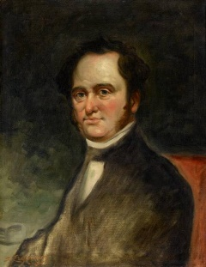
Stephen F. Austin |  | 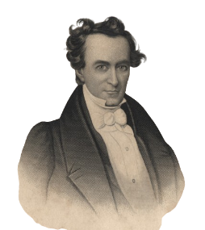
Erasmo Seguín |  | 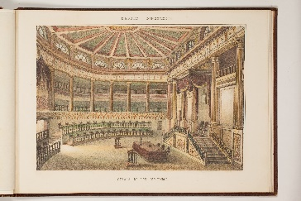
Land Grants

Requirements to Settle in Texas

Requirements to Settle in Austin’s Colony |  | 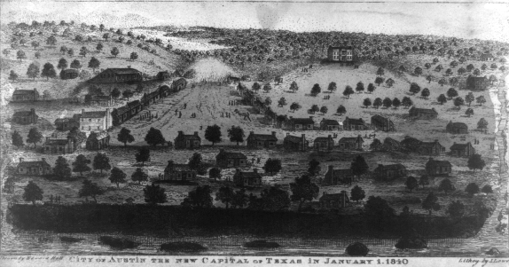
National Colonization Laws of 1823 & 1824 |  | 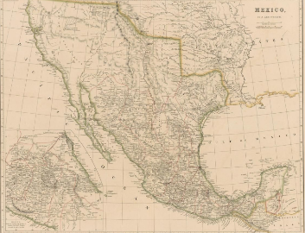
State Colonization Law of 1825, Coahuila y Tejas |  | 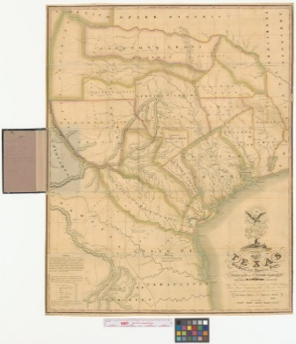

Slavery & the Empresario System

The State Constitution of Coahuila y Tejas, 1827, Article 13 |  | 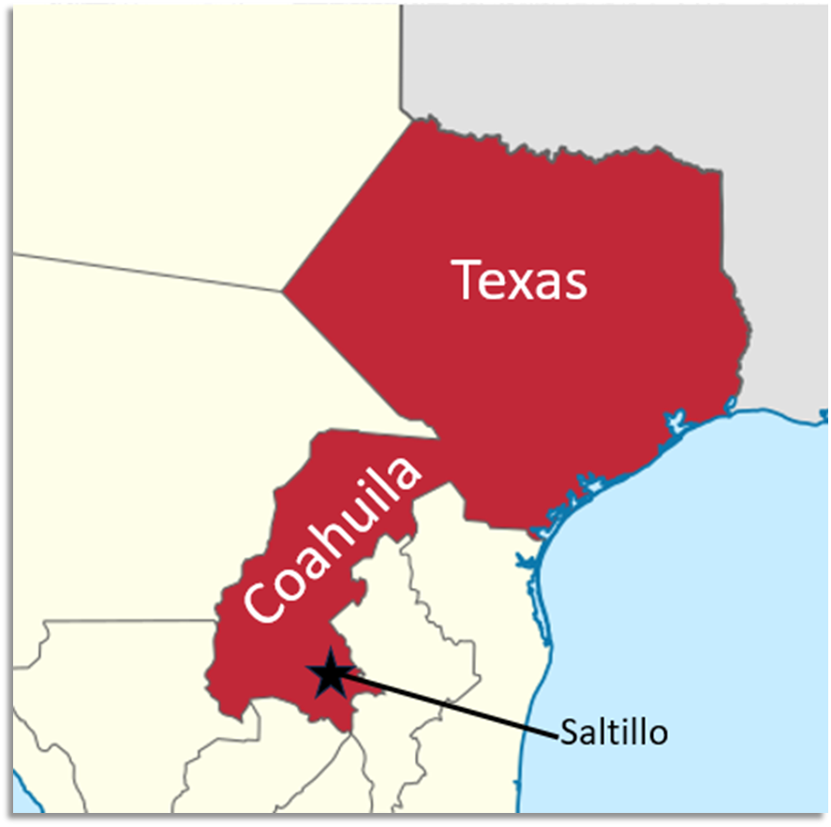
“Decree No. 56,” May 5, 1828 |  | 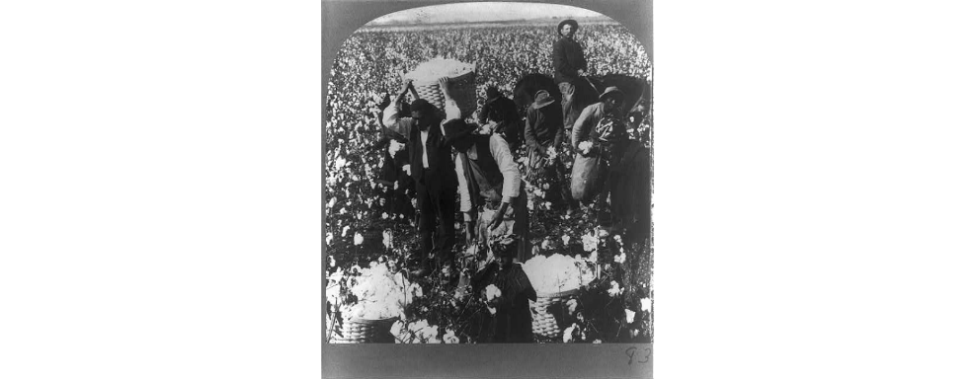

Effects of the Empresario System

The Development of Texas |  | 