The Empresario System Foundations
Unit 4: The Mexican National Era

Name: |  | Date: |  | Period:

Goals of the Empresario System

Mexico’s Goals | Tejano Goals | Anglo Goals
- Strengthen Mexico’s position in ________________ | - Increase the non-Indian _____________________ of Texas.  - Grow the ______________________ | - Get cheap land to grow the cash crop ___________________ on plantations in TX.

Moses Austin | - 1820: The first Anglo-American to work with the _____________________ government to settle other ____________________ in Texas | 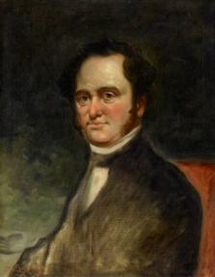
Stephen F. Austin | - 1821: The first and most successful Anglo-American ____________________________ to settle Anglos in Texas  - Considered “The ____________________ of Texas” by some in American history.  - Settled the first 300 families: “The ____________________________ ” | 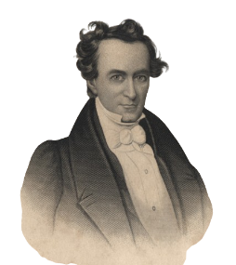
Erasmo Seguín | - A __________________ official in San Antonio  - Advocated for Anglo _______________________ in the Mexican ______________________.  - Helped ________________________ establish his colony in Texas | 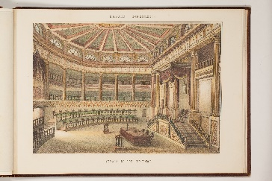
Land Grants | - Anglo settlers received ____________________:  - 4000 or more acres of land.  - More ____________________ (family & enslaved people) = More __________________

Requirements to Settle in Texas

Requirements to Settle in Austin’s Colony | - Become _______________________________ (Not strictly enforced)  - Provide reference letters showing good ________________________________  - Surveying fees: 12.5 cents per acre  - 1 ______________________ of supplies | 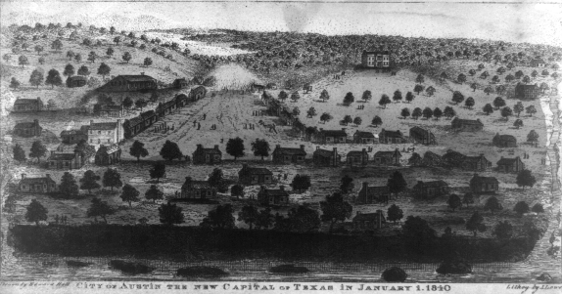
National Colonization Laws of 1823 & 1824 | - ___________________________ have the power to control colonization.  - Set restrictions on the location and amount of land settlers could receive.  - Empresarios must learn _____________.  - The federal government has power to stop immigration for national security. | 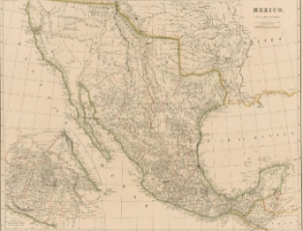
State Colonization Law of 1827, Coahuila y Tejas | - Settlers take an _______________________ to the Mexican government  - No _______________________ for 10 years  - Grants Mexican ________________________________ to Anglo settlers in Texas  - Empresarios must settle at least _____________ families  - After __________ years, unfulfilled contracts would be cancelled | 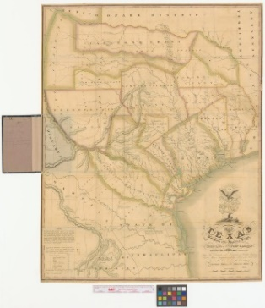

Slavery & the Empresario System

The State Constitution of Coahuila y Tejas, 1824, Article 13 | - Article 13: Eliminates ______________ from the state over time.  - Current enslaved people will remain enslaved.  - Children of the enslaved are free.  - After ___________________, no more enslaved people can be brought to the state from the U.S. | 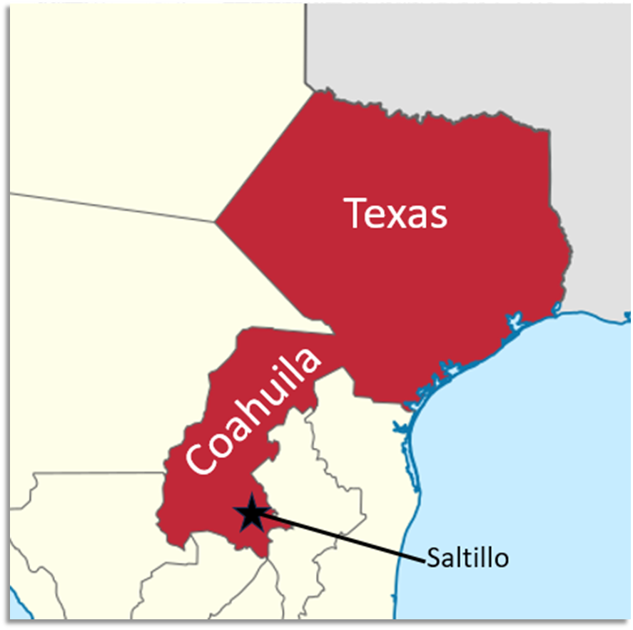
“Decree No. 56,” May 5, 1828 | “All contracts signed in foreign countries between emigrants and their laborers are valid in Texas.”  - Tejanos and Anglos worked to get this law passed in the state government.  - Some Anglos in the U.S. created _______-year contracts for the enslaved people. In this way, Anglos could legally bring enslaved people to Texas. | 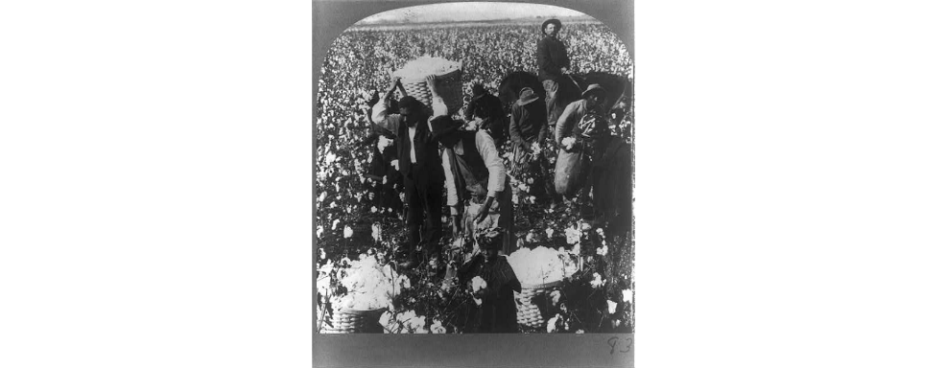

Effects of the Empresario System

The Development of Texas | - 1821 – 1825: Approximately ____________________ new settlers in Texas (300 Anglo families and enslaved people)  - More roads and new towns like San Felipe de ______________________ and ______________________________.  - Increased ____________________ with the U.S. via New Orleans. | 