The Empresario System Grade Level
Unit 4: The Mexican National Era

Name: |  | Date: |  | Period:

Goals of the Empresario System

Mexico’s Goals | Tejano Goals | Anglo Goals
- Strengthen | - Increase  - Grow | - Get

Moses Austin | - The first Anglo-American to _______________ _______________________________________________ _______________________________________________ _______________________________________________ | 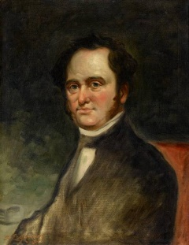
Stephen F. Austin | - The first and most successful _____________ _______________________________________________  - Considered “_______________________________ ____________” by some in American History  - Settled the first ____________________________ ______________________________________________ | 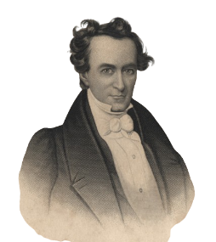
Erasmo Seguín | - A Tejano _____________________________________ _______________________________________________  - Advocated for _______________________________ _______________________________________________  - Helped ______________________________________ _______________________________________________ | 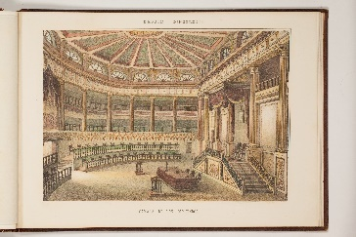
Land Grants | - Anglo settlers received land grants:  - _______________________________________________  - _______________________________________________ _______________________________________________

Requirements to Settle in Texas

Requirements to Settle in Austin’s Colony | - ______________________________________ (not strictly enforced)  - Provide _________________________________ __________________________________________  - Surveying fees: ________________________  - __________________________________________ | 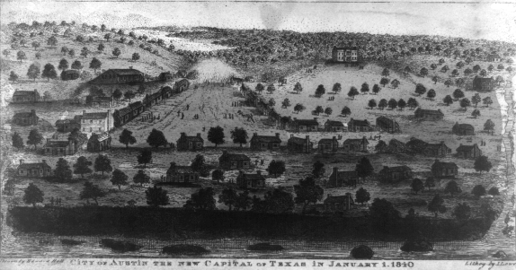
National Colonization Laws of 1823 & 1824 | - States have power to _________________ _________________________________________  - Set restrictions on ____________________ _________________________________________  - Empresarios must ____________________ __________________________________________  - Federal government has the power to __________________________________________ | 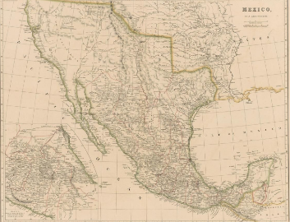
State Colonization Law of 1825, Coahuila y Tejas | - Setters take ____________________________ __________________________________________  - No ______________________________________  - Grants __________________________________ __________________________________________  - Empresarios must _____________________ __________________________________________  - After 6 years, __________________________ __________________________________________ | 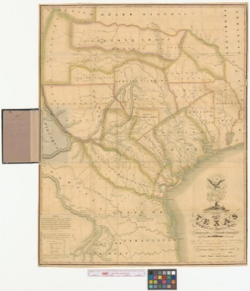

Slavery & the Empresario System

The State Constitution of Coahuila y Tejas, 1827, Article 13 | - Article 13: ___________________________ ________________________________________  - Current enslaved people will _______ ________________________________________  - Children ______________________________ ________________________________________  - After 6 months, ______________________ ________________________________________ | 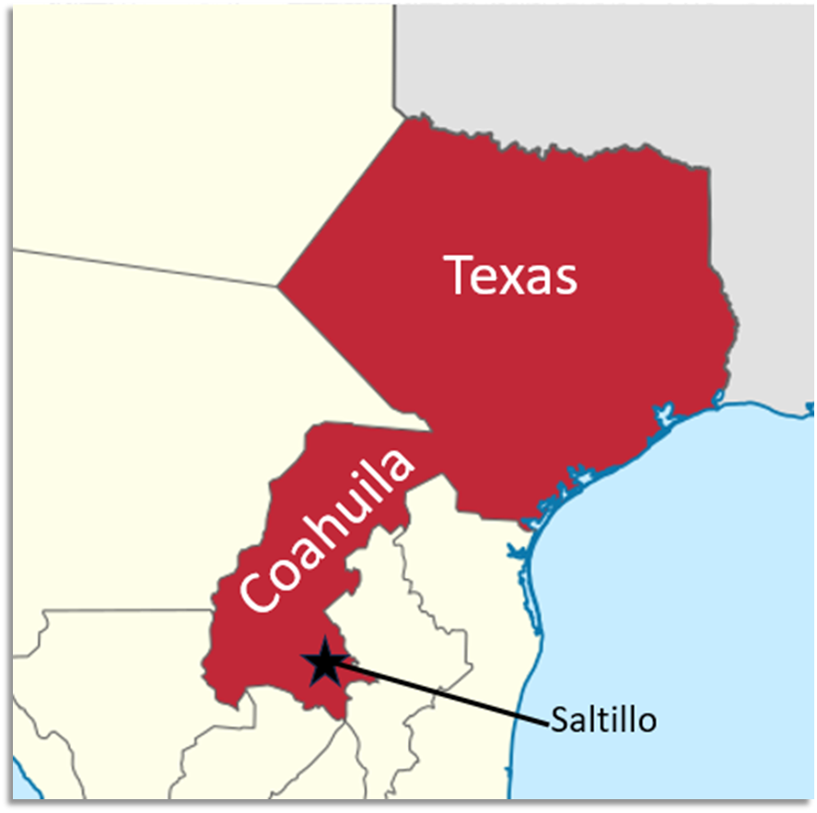
“Decree No. 56,” May 5, 1828 | “All contracts signed in foreign countries between emigrants and their laborers are valid in Texas.”  - Tejanos and Anglos worked to get this law passed in the state government.  - Some Anglos in the U.S. created _______ ___________________________________________ ___________________________________________ | 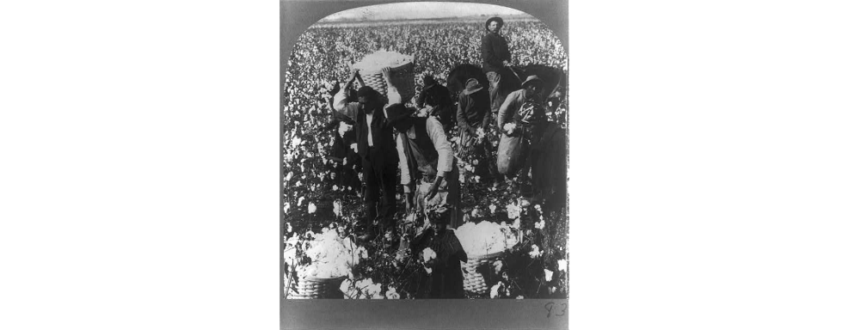

Effects of the Empresario System

The Development of Texas | - 1821 – 1825: Approximately ______ ________________________________________ (300 families & enslaved people)  - More roads and new towns like ____ _________________________________________ _________________________________________  - Increased trade with ________________ _________________________________________ | 