Warm-up
- Responses will vary
Lesson
Goals of the Empresario System

Mexico’s Goals | Tejano Goals | Anglo Goals
- Strengthen Mexico’s position in Texas | - Increase the non-Indian population of Texas.  - Grow the Economy | - Get cheap land to grow the cash crop cotton on plantations in TX.

Moses Austin | - 1820: The first Anglo-American to work with the Spanish government to settle other Anglos in Texas | 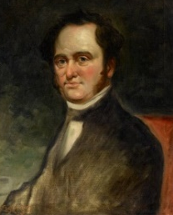
Stephen F. Austin | - 1821: The first and most successful Anglo-American Empresario to settle Anglos in Texas  - Considered “The Father of Texas” by some in American history.  - Settled the first 300 families: “The Old 300 ” | 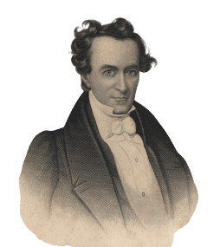
Erasmo Seguín | - A Tejano official in San Antonio  - Advocated for Anglo colonization in the Mexican Congress  - Helped Austin establish his colony in Texas | 
Land Grants | - Anglo settlers received Land Grants  - 4000 or more acres of land.  - More People (family & enslaved people) = More Land

Requirements to Settle in Texas

Requirements to Settle in Austin’s Colony | - Become Catholic (Not strictly enforced)  - Provide reference letters showing good character  - Surveying fees: 12.5 cents per acre  - 1 year of supplies | 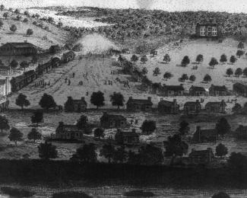
National Colonization Laws of 1823 & 1824 | - States have the power to control colonization.  - Set restrictions on the location and amount of land settlers could receive.  - Empresarios must learn Spanish  - The federal government has power to stop immigration for national security. | 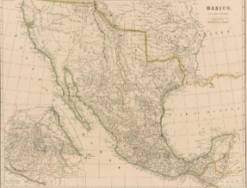
State Colonization Law of 1827, Coahuila y Tejas | - Settlers take an oath to the Mexican government  - No taxes for 10 years  - Grants Mexican citizenship to Anglo settlers in Texas  - Empresarios must settle at least 100 families  - After 6 years, unfulfilled contracts would be cancelled | 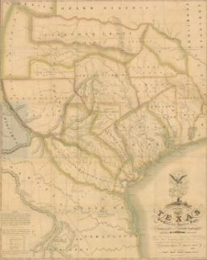

Slavery & the Empresario System

The State Constitution of Coahuila y Tejas, 1824, Article 13 | - Article 13: Eliminates slavery from the state over time.  - Current enslaved people will remain enslaved.  - Children of the enslaved are free.  - After 1827 no more enslaved people can be brought to the state from the U.S. | 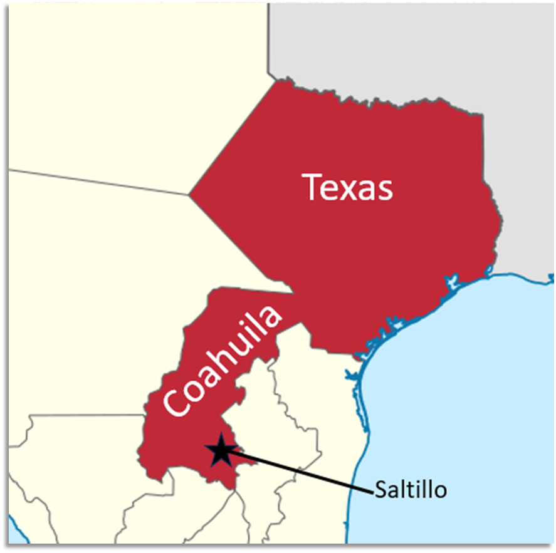
“Decree No. 56,” May 5, 1828 | “All contracts signed in foreign countries between emigrants and their laborers are valid in Texas.”  - Tejanos and Anglos worked to get this law passed in the state government.  - Some Anglos in the U.S. created 99-year contracts for the enslaved people. In this way, Anglos could legally bring enslaved people to Texas. | 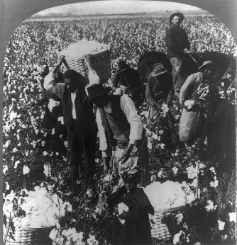

Effects of the Empresario System

The Development of Texas | - 1821 – 1825: Approximately 3,000 new settlers in Texas (300 Anglo families and enslaved people)  - More roads and new towns like San Felipe de Austin and Gonzales  - Increased trade with the U.S. via New Orleans. | 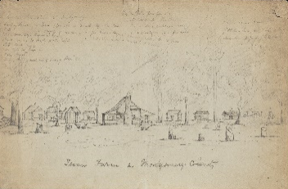

Exit Ticket
- Become Catholic
- Become a Mexican Citizen
- Complete the requirements of their contract within 6 years
- Prove they are a good person
- Be able to support themselves and their families
- Speak/Learn Spanish
- Settle at least 100 people (Empresario requirement)
- Fulfill their contract within 6 years (Empresario requirement)

