American Indian Tribes of Texas Advanced
Unit 1: Natural Texas and Its People
Name: |  | Date: |  | Period:

PART 1) Directions: Use the informational readings about each tribe to complete the chart below, taking notes for each category, and shading in the area of the map which the tribe inhabits.

Tribe | Food | Shelter | Mobility | Culture | Region
Wichita |  |  |  |  | 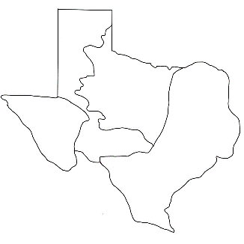
Caddo |  |  |  |  | 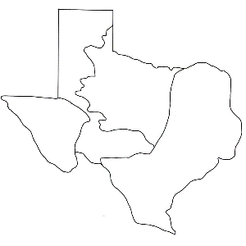
Atakapa |  |  |  |  | 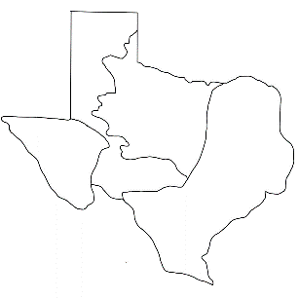
Karankawa |  |  |  |  | 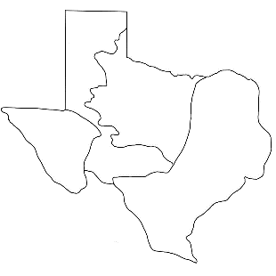
Coahuiltecan
Comanche |  |  |  |  | 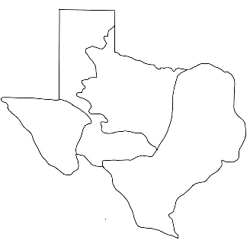
Apache
Kiowa
Jumano |  |  |  |  | 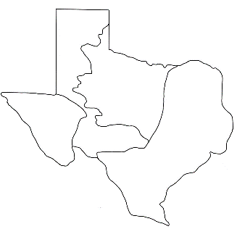
Tigua

PART 2) Directions: Choose two tribes from your chart who lived in different regions. Complete the graphic organizer on the left comparing the two tribes.
Circle any characteristics they have in common.
Then write a five to seven sentence essay comparing and contrasting the two tribes. Be sure to include a good topic sentence and conclusion.
Step 1:
Tribe: | 1: | 2:
Region
Food
Shelter
Mobility
Culture

Step 2:
Paragraph:
_______________________________________________________________________________________________________________________________________________________________________________________________________________________________________________________________________________________________________________________________________________________________________________________________________________________________________________________________________________________________________________________________________________________________________________________________________________________________________________________________________________________________________

