American Indian Tribes of Texas Foundations
Unit 1: Natural Texas and Its People
Name: |  | Date: |  | Period:

PART 1) Directions: Use the informational readings about each tribe to complete the chart below, taking notes for each category, and shading in the area of the map which the tribe inhabits. Circle or highlight the words that apply to each American Indian tribe.
Tribe | Food | Shelter | Mobility | Culture | Region
Wichita | Corn, Beans, Squash-  Bison - Rabbit -  Deer - Bear -  Alligator - Lizards -  Fish - Berries - Nuts - Roots - Prickly Pear - | Small grass huts  Large grass huts  Tipis  Adobe Pueblos  Stick & Reed | Sedentary  Nomadic  Both |  | 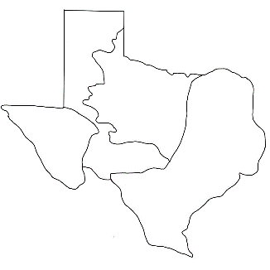
Caddo | Corn, Beans, Squash-  Bison - Rabbit -  Deer - Bear -  Alligator - Lizards -  Fish - Berries - Nuts - Roots - Prickly Pear - | Small grass huts  Large grass huts  Tipis  Adobe Pueblos  Stick & Reed | Sedentary  Nomadic  Both |  | 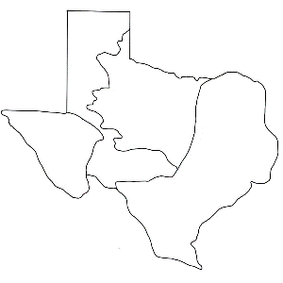
Atakapa | Corn, Beans, Squash-  Bison - Rabbit -  Deer - Bear -  Alligator - Lizards -  Fish - Berries - Nuts - Roots - Prickly Pear - | Small grass huts  Large grass huts  Tipis  Adobe Pueblos  Stick & Reed | Sedentary  Nomadic  Both |  | 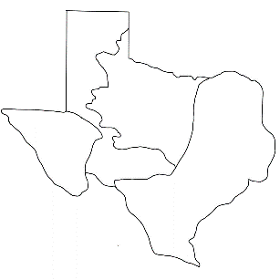
Karankawa | Corn, Beans, Squash-  Bison - Rabbit -  Deer - Bear -  Alligator - Lizards -  Fish - Berries - Nuts - Roots - Prickly Pear - | Small grass huts  Large grass huts  Tipis  Adobe Pueblos  Stick & Reed | Sedentary  Nomadic  Both |  | 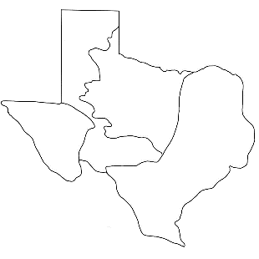
Coahuiltecan | Corn, Beans, Squash-  Bison - Rabbit -  Deer - Bear -  Alligator - Lizards -  Fish - Berries - Nuts - Roots - Prickly Pear - | Small grass huts  Large grass huts  Tipis  Adobe Pueblos  Stick & Reed | Sedentary  Nomadic  Both
Comanche | Corn, Beans, Squash-  Bison - Rabbit -  Deer - Bear -  Alligator - Lizards -  Fish - Berries - Nuts - Roots - Prickly Pear - | Small grass huts  Large grass huts  Tipis  Adobe Pueblos  Stick & Reed | Sedentary  Nomadic  Both |  | 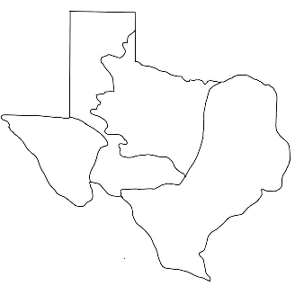
Apache | Corn, Beans, Squash-  Bison - Rabbit -  Deer - Bear -  Alligator - Lizards -  Fish - Berries - Nuts - Roots - Prickly Pear - | Small grass huts  Large grass huts  Tipis  Adobe Pueblos  Stick & Reed | Sedentary  Nomadic  Both
Kiowa | Corn, Beans, Squash-  Bison - Rabbit -  Deer - Bear -  Alligator - Lizards -  Fish - Berries - Nuts - Roots - Prickly Pear - | Small grass huts  Large grass huts  Tipis  Adobe Pueblos  Stick & Reed | Sedentary  Nomadic  Both
Jumano | Corn, Beans, Squash-  Bison - Rabbit -  Deer - Bear -  Alligator - Lizards -  Fish - Berries - Nuts - Roots - Prickly Pear - | Small grass huts  Large grass huts  Tipis  Adobe Pueblos  Stick & Reed | Sedentary  Nomadic  Both |  | 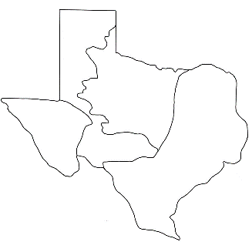
Tigua | Corn, Beans, Squash-  Bison - Rabbit -  Deer - Bear -  Alligator - Lizards -  Fish - Berries - Nuts - Roots - Prickly Pear - | Small grass huts  Large grass huts  Tipis  Adobe Pueblos  Stick & Reed | Sedentary  Nomadic  Both

PART 2) Directions: Use the information from your charts on the previous pages and the word bank below to complete the following statements below. For screen reader users, replace the repetitive "line" placeholders with words from the word bank.
WORD BANK
Comanche | Coahuiltecan | Great Plains | Mountains and Basins | Caddo

- Tribes of the ________________________________ region primarily hunted bison, using their skins for clothes, shoes, and shelter.
- The Coastal Plains American Indians that lived in large, advanced farming communities growing corn, beans, and squash was the __________________________ tribe.
- The Tigua tribe of the ______________________________________ lived in a community of approximately 200 adobe homes made of dried clay bricks.
- Although the _________________________ tribe of the Great Plains didn’t originally live in Texas, after the migrated south they came to dominate the plains as fierce hunters and warriors.
- Although much of the Coastal Plains contains fertile land and abundant water, the southern part where the __________________________________ tribe lived was a much harsher environment.

