American Indian Tribes of Texas Grade Level
Unit 1: Natural Texas and Its People
Name: |  | Date: |  | Period:

PART 1) Directions: Use the informational readings about each tribe to complete the chart below, taking notes for each category, and shading in the area of the map which the tribe inhabits.
Tribe | Food | Shelter | Mobility | Culture | Region
Wichita |  |  |  |  | 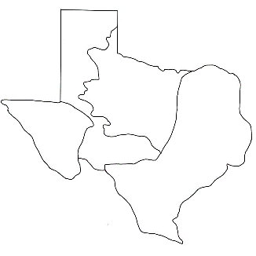
Caddo |  |  |  |  | 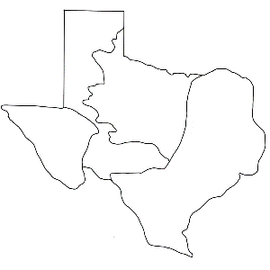
Atakapa |  |  |  |  | 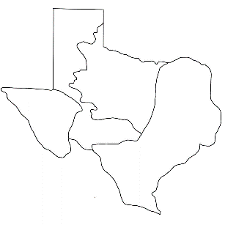
Karankawa |  |  |  |  | 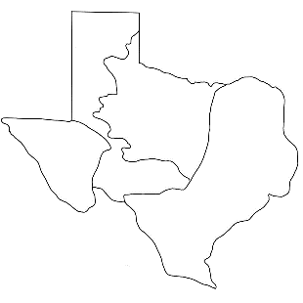
Coahuiltecan
Comanche |  |  |  |  | 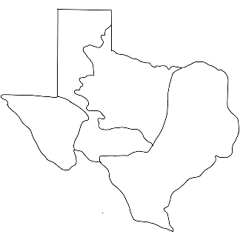
Apache
Kiowa
Jumano |  |  |  |  | 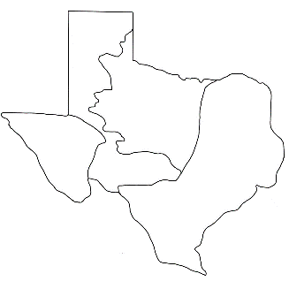
Tigua
PART 2) Writing Practice
Step 1: Choose two tribes who lived in different regions from the chart on the previous pages. Use the graphic organizer to compare and contrast how the two tribes lived.
Tribes | Region | Food | Shelter | Culture | Mobility
1.
2.

Step 2: Now use the sentence stems below to write complete sentences comparing and contrasting the two tribes using your notes above.
- While the ________________________ tribe of the ______________________ region lived in ___________________________ shelters made of __________________________________________, the ________________________ tribe of the _________________ region lived in _______________________________________ shelters made of ______________________________________________.
- The _____________________ tribe of the ___________________________ region took part in cultural practices like _____________________________________________________________________. The ______________________ tribe, on the other hand, took part in cultural practices like _________________________________________________________________.
- The _______________________ tribe was typically sedentary / nomadic because ________________________________

______________________________________________________. The _________________________ tribe, however, was typically sedentary /

nomadic because _____________________________________________________________________________

