 ***Warm-up:*** American Indian Tribes of Texas – Day 2

*Unit 1: Natural Texas and Its People*

|  |  |  |  |  |  |
| --- | --- | --- | --- | --- | --- |
| Name: |  | Date: |  | Period: |  |

***Directions***: Imagine you are an early American Indian from one of the tribes you learned about yesterday, and you are living in Texas hundreds of years ago. In the space provided below tell a little about a typical day in your life. What do you see when you look at the landscape? How do you get food, what is life in your community like, what does your shelter look like, what do you do in your spare time?

***Which tribe:*** ***Which region:***

|  |
| --- |
|  |

 ***Warm-up:*** American Indian Tribes of Texas – Day 2

*Unit 1: Natural Texas and Its People*

|  |  |  |  |  |  |
| --- | --- | --- | --- | --- | --- |
| Name: |  | Date: |  | Period: |  |

***Directions***: Imagine you are an early American Indian from one of the tribes you learned about yesterday, and you are living in Texas hundreds of years ago. In the space provided below tell a little about a typical day in your life. What do you see when you look at the landscape? How do you get food, what is life in your community like, what does your shelter look like, what do you do in your spare time?

***Which tribe:*** ***Which region:***

|  |
| --- |
|  |

American Indian Tribes of Texas ***Exit Ticket***

Examine the image below. Make inferences about the early Texas people in this image based on what you see in the image. Consider things like where they might live, their food and shelter, culture, and mobility. Write your inferences next to the image.

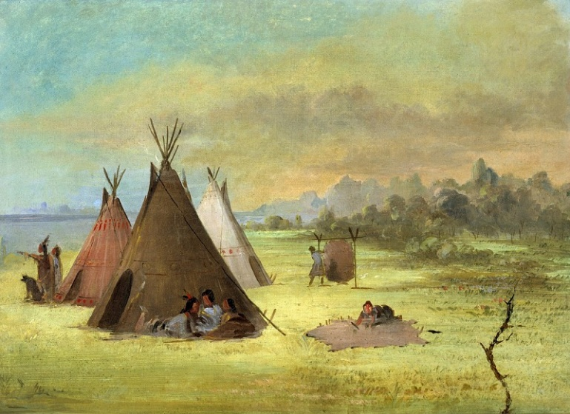

Figure 1 Painting by George Catlin of an Indian encampment.

|  |
| --- |
|  |

American Indian Tribes of Texas ***Exit Ticket***

Examine the image below. Make inferences about the early Texas people in this image based on what you see in the image. Consider things like where they might live, their food and shelter, culture, and mobility. Write your inferences next to the image.

A painting of a group of people in a field

Painting by George Catlin of an Indian encampment.

Figure 1 Painting by George Catlin of an Indian encampment.

|  |
| --- |
|  |