American Indian Tribes of Texas Exit Ticket
Examine the image below. Make inferences about the early Texas people in this image based on what you see in the image. Consider things like where they might live, their food and shelter, culture, and mobility. Write your inferences next to the image.
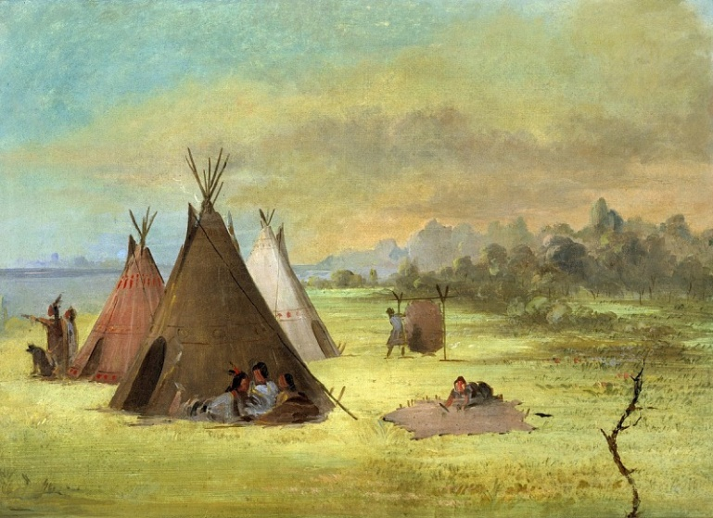
Figure 1 Painting by George Catlin of an Indian encampment.

