American Indians in Texas Today: Enrichment Lesson
Unit 1: Natural Texas and Its People

Name: |  | Date: |  | Period:

Today, there are three federally recognized American Indian tribes living in Texas. This means that these three tribes have the right and the power to govern themselves. Their tribal governments have an official political relationship with the United States’ government. This relationship is similar to an alliance between two countries. They can receive certain rights, benefits, and services from the U.S. government as a result. These three tribes are the Alabama Coushatta, Kickapoo Traditional, and Ysleta del sur Pueblo, also known as the Tigua.
Some tribes that historically inhabited Texas now live in Oklahoma, like the Kiowa and the Comanche. There are also tribes in Texas today that are not federally recognized, like the Atakapa Ishak and the Comanche Panateka.
In order to become federally recognized, a tribe must meet certain criteria. Tribes must be able to prove their history as an Indigenous group in America since before the arrival of European settlers. They can prove this through various types of documentation. This can be difficult, considering many tribes did not keep written records. Many tribes today are actively working toward federal recognition.
In this enrichment activity, you will choose one of the contemporary tribes listed below to research. Record your research in the appropriate place on this worksheet. Be thorough in your responses. You may choose a federally recognized tribe, or a non-federally recognized tribe.
Federally Recognized Texas Tribes | Non-federally Recognized Texas Tribes
- Alabama Coushatta  - Kickapoo Traditional  - Ysleta del sur Pueblo (Tigua) | - Atakapa Ishak Nation of Southeast Texas  - Penateka Comanche  - Lipan Apache Nation of Texas  - Lipan Apache Tribe of Texas

Directions: Complete the chart below by researching one of the tribes from the list on the previous page. The best place to begin your research is on your tribe’s official website.
Name of the tribe you have chosen:
Where is this tribe located in Texas today?  Label the approximate location on the map below. Answer the questions on the right.  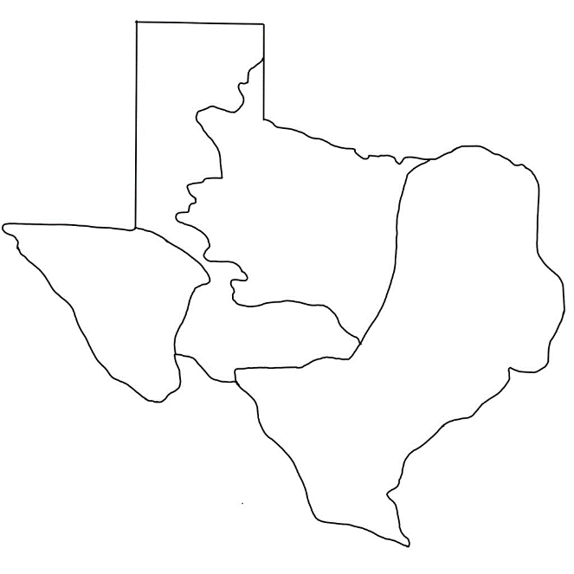 | Did the tribe originate in Texas?  Has the tribe ever lived anywhere else? Explain.
On what date did this tribe become officially federally recognized?

Explain the process of getting this recognition for this tribe
What are some significant events in this tribe’s history?

Include at least three, if possible.
Describe the government of this tribe:
How does it operate?
What are some of the leadership positions?
What does the government do?
Who are some of the people in positions of leadership in this tribe today?
What are their leadership roles or titles?
What are some cultural practices this tribe still takes part in?
If completing this activity digitally, copy and paste at least one image related to your tribe today in the box to the right.

If completing this activity on paper, draw or describe an image that you found in your research.

Federally recognized: The United States government acknowledges that the tribe is official.
Alliance: A political partnership
Criteria: Requirements
Contemporary: Modern, present-day

