Unit 1:
Natural Texas and Its People

Lesson 2:

How do we know what we know?
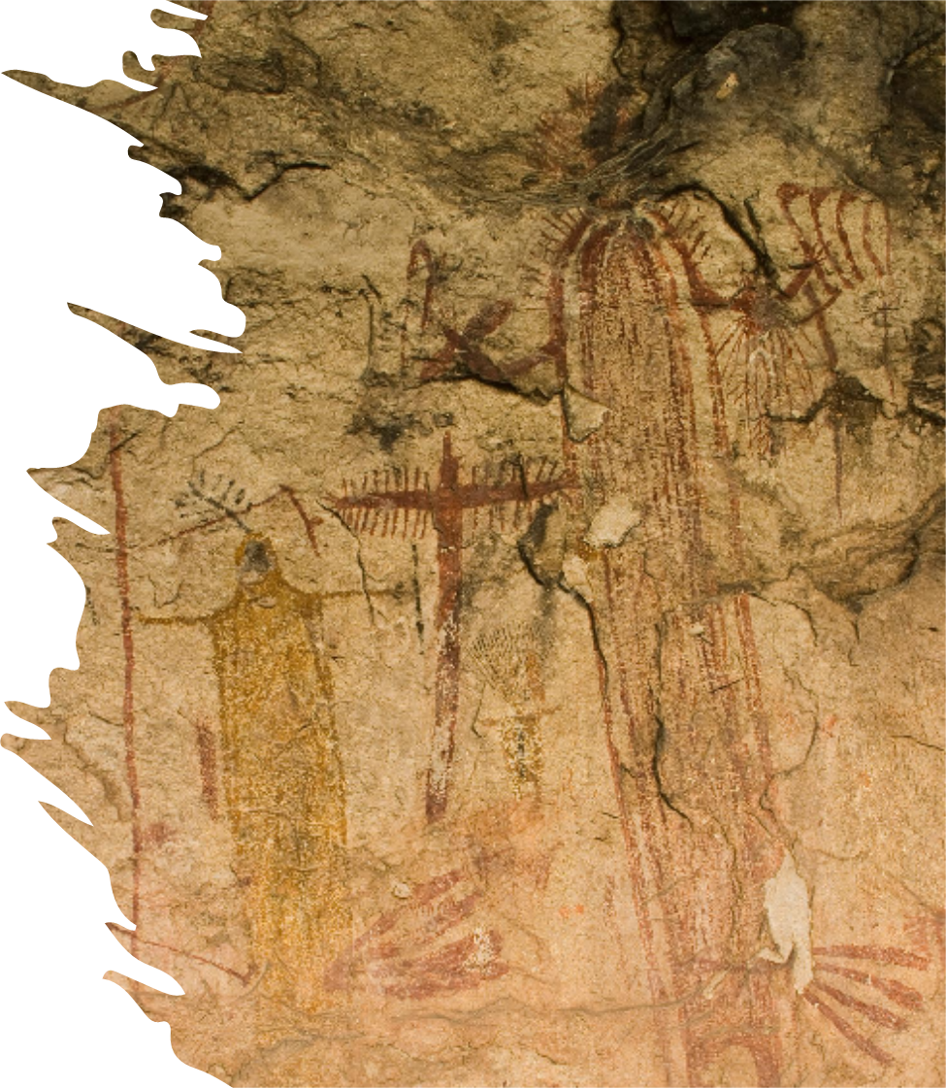

How do we know what we know?
Warm-up
Warm-up:
Follow the directions below to complete your warm-up
1. Read the scenario.
2. Examine the list of items
3. Write your answer in the box provided.
4. While you wait for class to begin, share your responses with a shoulder partner.
5. Do not complete the Exit Ticket yet.

Warm-up:
Share with the class
Directions: Use the sentence stem example below to share your answer with the class
“Based on the (specific item in the list), I can infer that the person who buried the box probably (blank).”

Essential Question
How do people today obtain* information about the past?
*Obtain: to get

In today’s lesson…
1. We will examine and categorize different types of historical sources, discussing both their strengths and weaknesses.
2. I will make inferences about early Texas people by analyzing three American Indian artifacts.

How do we know what we know?
Lesson

Has this ever happened to you?
You’re sitting in your social studies class, listening to your teacher tell you something that happened hundreds of years ago. You think, “But, how do we really know?” Your teacher wasn’t there. Where did we get the information?
How do you think we discover information about the past?

Artifacts
Make a prediction before you read...
What do you think the term “artifact” means based on this image and what we have talked about so far?
“I think artifact means (blank) because (blank)”

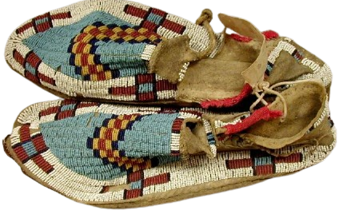
Studying history with artifacts
Directions: Read the passage about artifacts and answer the questions that follow. Be prepared to share your responses with the class.
“An artifact is (blank).”
“One example of an artifact from the reading activity is (blank).”

Artifacts in your life
Directions: Share your answer to number three about artifacts in your life.
“An item in my life that could be an artifact for future people to study is (blank). Future people might infer that I (blank) based on this item.”

Primary Source
Make a prediction before you read...
What do you think the term “primary source” means based on this image and what we have talked about so far?
“I think primary source means (blank) because (blank)”

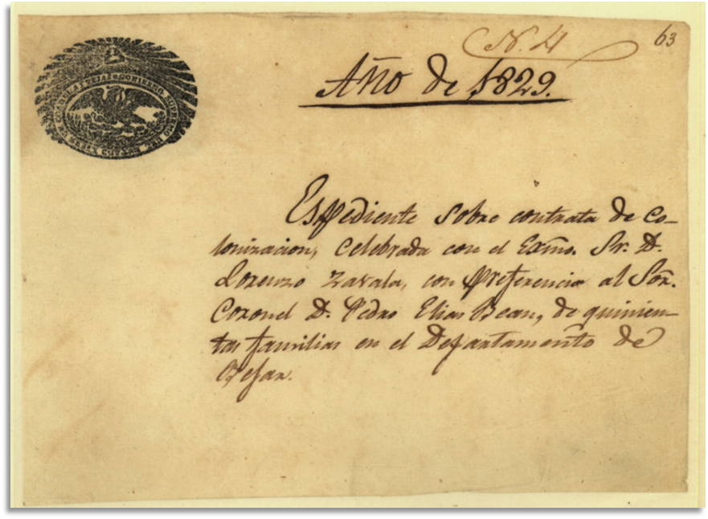
What is a primary source?
Directions: Read the passage about primary and secondary sources. Share an example of a primary or secondary source from the list.
“One example of a primary source is (blank).”
“One example of a secondary source is (blank).”

Using Primary Sources to Understand an Event
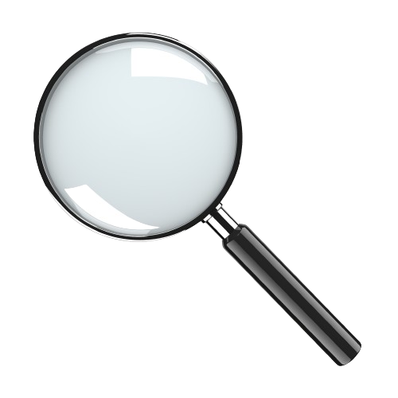Read the passage about a specific event happening at a school. Answer the questions that follow.
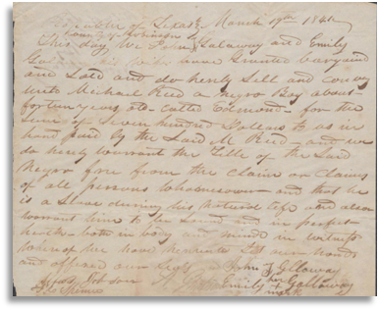

Share your responses
“Bias means (blank)”
“Bias influenced how the students talked about the incident in the hall when (blank)”
“I think I could get the most accurate account of events by (blank)”

Primary Sources
Benefits and Drawbacks
Statement
1. Primary sources usually present only one person’s point of view of a historic event. Benefit (blank) Drawback (blank)
2. Primary sources give us a firsthand account of an event. Benefit (blank) Drawback (blank)
3. Primary sources help us understand past people’s experiences. Benefit (blank) Drawback (blank)

4. Primary sources often contain biases that don’t reflect the whole truth. Benefit (blank) Drawback (blank)
Writing Exercise
Example sentence structure:

Primary sources are helpful because they provide us with a firsthand account of an event, however we should be aware that they also might present only one point of view.
Evaluating Primary Sources
Use the images on your worksheet to complete the chart.
The images can also be found on this presentation to see them better.
Figure 1: Indian petroglyphs, The Portal to Texas History

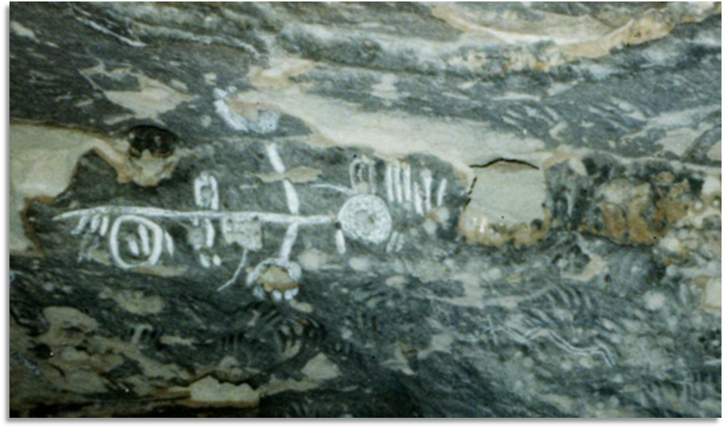
Figure 2: Elongated, rectangular buckskin beaded Indian bag, The Portal to Texas History

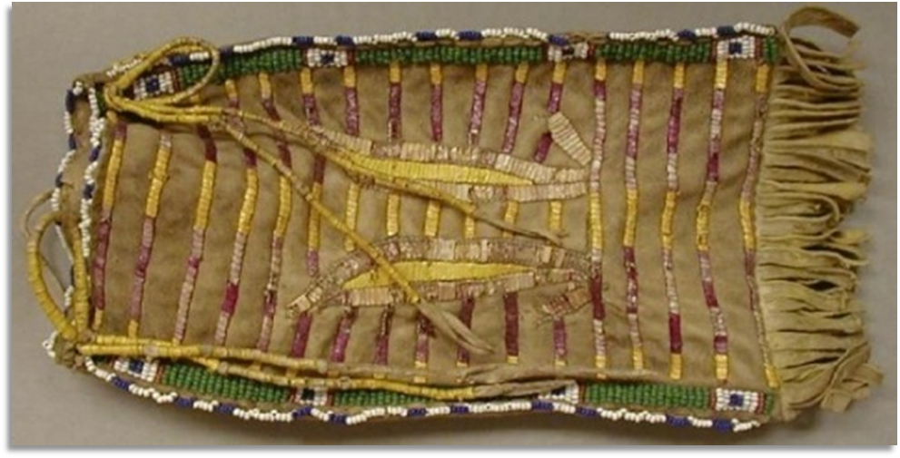
Figure 3: Indian stone tool artifacts from the Buddy Webb family, The Portal to Texas History

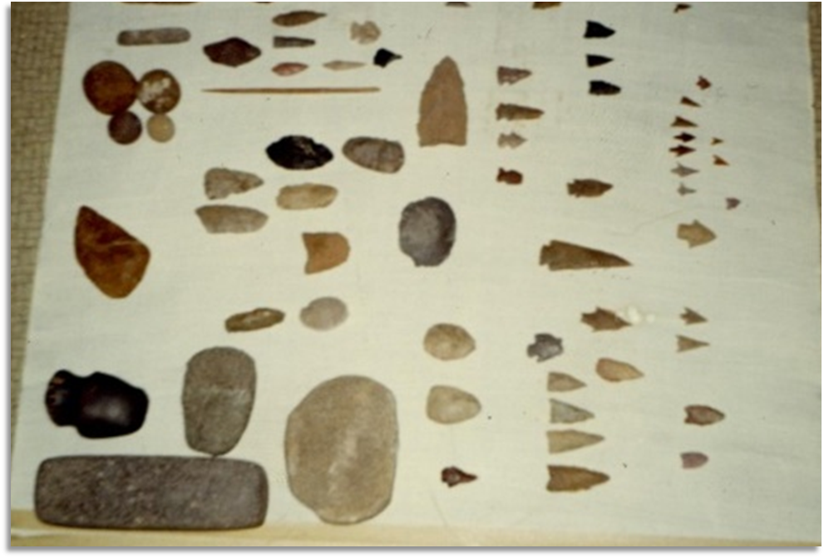
Share with the class
First Item: Petroglyphs (rock art)
Second Item: Beaded bag
Third Item: Stone tools
“One thing I inferred about the (name of item) was that (blank)(blank)(blank)(blank)(blank)(blank)(blank)(blank)(blank)
“One question I had about the (name of item) was (blank)(blank)(blank)(blank)(blank)(blank)(blank)(blank)(blank)”

Important Note:
Why is there not much written information from American Indians in the past?
“There is not much written information from American Indians in the past because (blank)”

Important Note: 2
What do you think the difficulties of only using artifacts to study past people might be?
“I think one of the difficulties of only using artifacts to study past people is (blank)”

How do we know what we know?
Exit Ticket

