How do we know what we know? Foundations

Unit 1: Natural Texas and Its People
Has this ever happened to you? You’re sitting in your social studies class, listening to your teacher tell you something that happened hundreds of years ago. You think, “But, how do we really know?” Your teacher wasn’t there. Where did we get the information?
How do you think we discover information about the past? Write your answer below.

Artifacts
History is a record of human activities. For thousands of years, people have walked the earth doing normal, great, or even terrible things. Over the course of their lives, people create evidence of their actions. Whenever someone painted on a stone, carved a wooden bowl, or made a tool, they were leaving clues for future generations to learn from. We call these objects that they created artifacts. These items could be used in many different ways, like for meals, self-defense, or even art. No matter how they were used, we can learn about past people from the artifacts they left behind.
1. The best definition of an artifact according to the passage is
THIS CHOICE REMOVED a. A natural resource produced by the earth that people can use
b. Any item created by past people that we can learn from now
c. Items people used for necessary activities like eating and shelter
d. Things past people created for entertainment or enjoyment
2. Circle all items that would be considered artifacts.

a. Paintings on a cave wall
b. Animal bones
c. A shell necklace
d. A raspberry bush
e. A deerskin blanket
f. A child’s toy

3. Think about the types of things you make, buy, or use now. Future people might study these objects to learn about our society. Give an example of an artifact that you might leave behind. What could future people learn about you from that object?

Primary Sources
What is a primary source?
One really helpful type of artifact we can learn from is called a primary source. Primary sources provide us with a firsthand account of an event from the past. They are materials created by people who were actually alive during the time the event took place. In contrast, secondary sources are secondhand accounts. They are materials created by people who were not alive at the time to experience the event. Often, secondary sources are created by referencing, or using, primary sources.
Directions: Read each example of a source below. Write P next to examples of primary sources, and S next to examples of secondary sources.

(blank) A textbook in your classroom about Texas history
(blank) An autobiography about Abraham Lincoln
(blank) A letter from George Washington to his wife
(blank) A newspaper article from 2001 about the events of 9/11
(blank) A photograph taken by a soldier serving in World War Two
(blank) A student book report on ancient Egypt
(blank) A local newspaper article from 2024 about the 100th anniversary of a town festival
(blank) A journal entry from a Spanish explorer sailing to North America in 1585
(blank) Notes from an interview of someone who lived through the Great Depression in the 1930s

Using Primary Sources to Understand an Event
Primary sources can help us understand what happened in the past, what people in that situation thought and how they felt at the time. Primary sources are like small windows into the past. While primary sources offer a lot of benefits in helping us understand the past, we should be aware that they aren’t perfect.
Imagine this: you’re walking down the hall on your way to your next class period. Suddenly, you hear shouting farther down the hall, and you see a lot of sudden movement. You can’t tell what’s going on, but it looks like there’s a problem between some students.
When you get to your next class, you hear your classmates talking about what happened. Someone says there was a fight, and a student you know started it. Another student says actually, a different student started it. A third student says there wasn’t really a fight, they were just messing around. All three students were there, but they each have their own point of view about what happened.
Maybe one of them had a better view than the others. Maybe one of them didn’t like the student they accused of starting the fight. When our own opinions influence our point of view, that is called bias, and it can affect the story we tell.
Directions: Answer the following questions based on the passage on the previous page.
1. What is the best definition for the term bias?

a. The facts
THIS CHOICE REMOVED b. Additional information
c. Irrelevant information
d. Opinion

2. How did bias influence how the students talked about the incident in the hall?

a. Everyone experienced the same thing
b. Some students had different ideas about the event
c. Many students didn’t care about the truth
THIS CHOICE REMOVED d. All answers are correct

3. How could we get the most accurate account of what happened in the hall?

a. Gather as much information as possible from many people
b. Listen to the people I know more than anyone else
c. Assume that only the people involved will tell the truth
THIS CHOICE REMOVED d. We can never know what really happened
Directions: Read each statement about primary sources. Place a checkmark in the correct box demonstrating whether each statement is a benefit or drawback of using primary sources.
Statement Benefit Drawback
1. Primary sources usually present only one person’s point of view of an historic event
Benefit: (blank) Drawback: (blank)
2. Primary sources give us a firsthand account of an event
Benefit: (blank) Drawback: (blank)
3. Primary sources help us understand past peoples’ experiences
Benefit: (blank) Drawback: (blank)
4. Primary sources often contain biases that don’t reflect the whole truth
Benefit: (blank) Drawback: (blank)

Writing Exercise:
Directions: Using the statements above, or your own statement about primary sources, write a complete sentence explaining the benefits and drawbacks of using primary sources.
Primary sources are beneficial because (blank), however we should be aware that (blank).

Evaluating Primary Sources
Directions: Complete the chart below by using the images of Native American artifacts to make inferences about the early Texas people.
Primary Source Artifact
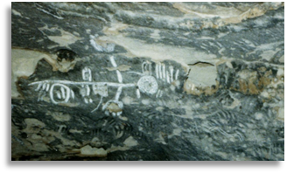
Figure 1: Indian petroglyphs, The Portal to Texas History
What’s something you notice about the artifact shown?
Primary Source Artifact
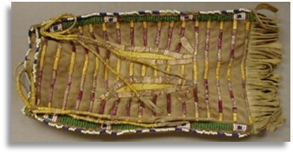
Figure 2: Elongated, rectangular buckskin beaded Indian bag, The Portal to Texas History
What’s something you notice about the artifact shown?
Primary Source Artifact
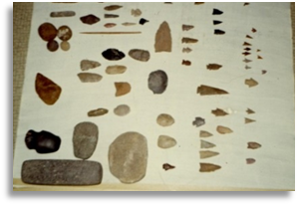
Figure 3: Indian Artifacts from the Buddy Webb Family, The Portal to Texas History
What’s something you notice about the artifact shown?

Important Note:
Most early American Indian tribes of North America passed down information orally, or by word of mouth. For this reason, there is not much written information from the past to tell us their story from their own point of view. We have learned some of what we know from artifacts like the ones pictured above.
Question to consider: What do you think is one of the difficulties of only using artifacts to study past people?

