Unit 1:
Natural Texas and Its People

Lesson 8:

Looking Ahead

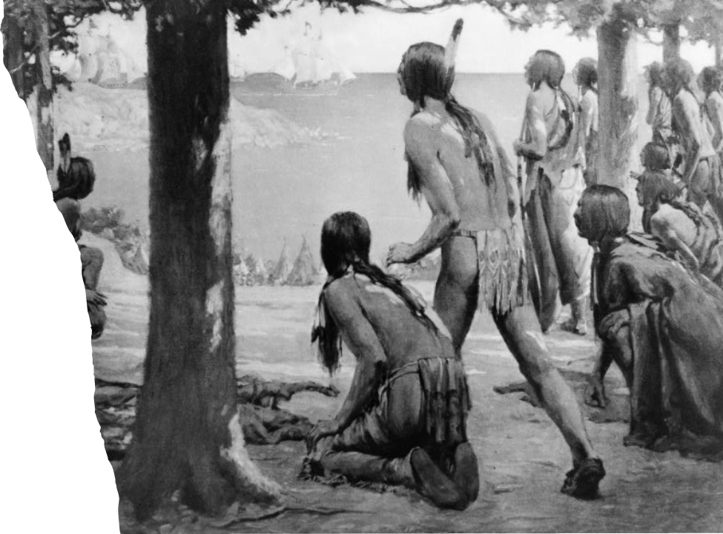
Looking Ahead

Warm-up

Warm-up
Follow the directions to complete your warm-up
Imagine your experience landing on another planet with human life.
Record your responses to the prompts in your warm-up.
Discuss with a partner.

Share with the class
Read your response for the class

Essential Question
How might the arrival of new people from a different culture affect American Indians in Texas and the course of Texas history?

In today’s lesson…
1. We will examine and anticipate the outcome of the first encounters between Spanish explorers and American Indians in Texas.
2. I will analyze a primary source document about the first encounter between Texas Indians and Spanish explorers.

The End of an Era
Part I

Part I: The End of an Era
For 12,000 years on the land we now call Texas, American Indians had lived, worked, played, established communities, raised families, ran their governments, formed alliances, and fought their enemies. This era of Texas history was a time characterized by Indigenous people living their lives, without any influence from outside of the Americas.
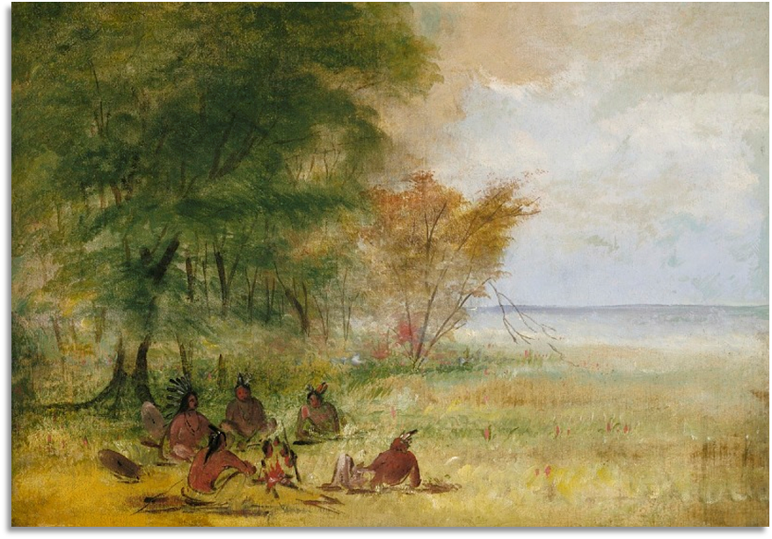
A gathering of American Indians

Part I: The End of an Era 2
Then, on what probably seemed like any other November day in 1528, a group of American Indians along the coast encountered unknown people from a far-off place. This encounter set off a chain of events that would change Texas history forever.
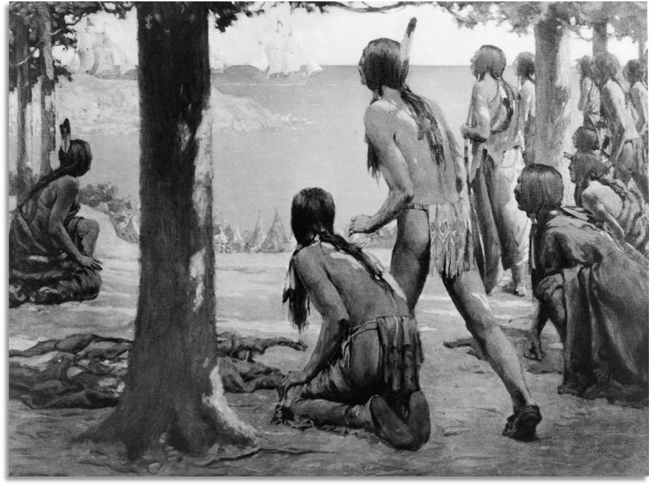
American Indians view far off ships in the distance

Answer the Comprehension Questions
Use the sentence stems to share your prediction
I think the unknown people are (blank)
I think the outcome of the encounter will be(blank)

Two Worlds Collide

Part II

Part II: Two Worlds Collide
In November of 1528, a group of Spanish explorers met members of the Karankawa tribe of the Coastal Plains. The Spanish men were shipwrecked, lost, and starving. One of the survivors, a man named Alvar Nuñez Cabeza de Vaca, would later write a book about his experience. In his book, he detailed this first encounter between the Spanish and the Indigenous people of Texas.
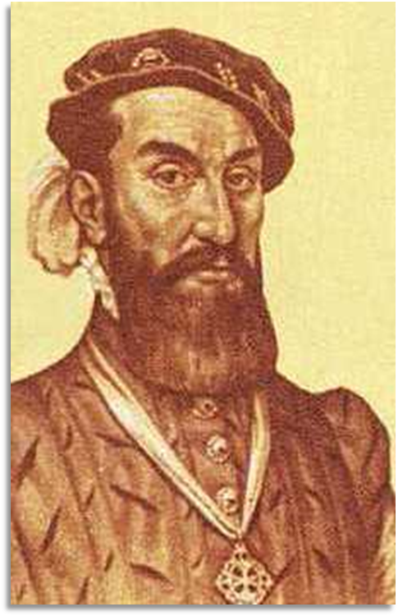
Cabeza de Vaca

Part II: Two Worlds Collide 2
They... saw that three Indians, with bows and arrows, were following and calling to him, while he did the same to them by signs. So he came to where we were, the Indians remaining behind, seated on the beach. Half an hour after a hundred Indian archers joined them, and our fright was such that, whether tall or little, it made them appear giants to us. They stood still close to the first ones, near where we were.
The Journey of Alvar Nuñez Cabeza de Vaca and His Companions from Florida to the Pacific, 1528-1536, The Portal to Texas History, University of North Texas

Answer the Comprehension Questions 2
Use the sentence stems to share your answer to number three
I think the early people might have felt (blank) because (blank)

Another Point of View

Part III – Advanced

Part III: Another Point of View
Follow the instructions to write about the encounter from another point of view.

Looking Ahead

Exit Ticket

Exit Ticket
Follow the directions to complete your Exit Ticket
Consider the space travel encounter in our Warm-up from the opposite perspective. You are the person on the far-off planet and strangers arrive at your home.
Write your response in the box provided.
Discuss with a partner.

Share with the class 2
Read your response for the class

