 Warm-up: Mind Map Review
Unit 1: Natural Texas and Its People
Name: |  | Date: |  | Period:

Directions: Read the question to complete the diagram below.
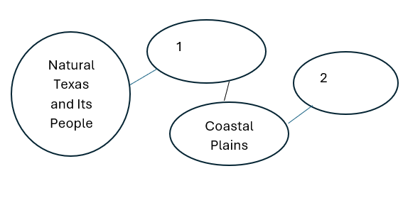

Which of the following terms fits best in each blank circle on the Mind Map? Write each term in the circle where it fits best.
- Regions
- Comanche
- Hot and arid
- Caddo

Warm-up: Mind Map Review
Unit 1: Natural Texas and Its People
Name: |  | Date: |  | Period:

Directions: Read the question to complete the diagram below

Which of the following terms fits best in each blank circle on the Mind Map? Write each term in the circle where it fits best.
- Regions
- Comanche
- Hot and arid
- Caddo


Mind Map Review Exit Ticket

Directions: The sentence below gives a brief summary of the main idea of this unit. Complete the sentence by choosing the best answer for each blank from the chart below.

The ______(1)______of Texas is significant because it is directly connected to ______(2)________

Answer choices for blank (1)  Circle the best answer | Answer choices for blank (2)  Circle the best answer
- American Indian tribes  - Geography  - Natural Resources  - Regions | - The climate across the state.  - The major cities like Houston.  - The plant and animal life.  - How people live their lives.

Mind Map Review Exit Ticket

Directions: The sentence below gives a brief summary of the main idea of this unit. Complete the sentence by choosing the best answer for each blank from the chart below.

The ______(1)______of Texas is significant because it is directly connected to ______(2)________

Answer choices for blank (1)  Circle the best answer | Answer choices for blank (2)  Circle the best answer
- American Indian tribes  - Geography  - Natural Resources  - Regions | - The climate across the state.  - The major cities like Houston.  - The plant and animal life.  - How people live their lives.

