North Central Plains  (Map) | 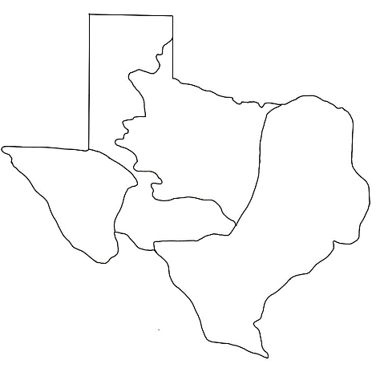
Mountains and Basins
(Map)
Coastal Plains
(Map)
Great Plains
(Map)
Mountains and Basins  (Characteristics) | High elevation  Hot, arid climate  Very little precipitation  Chihuahuan Desert  Guadalupe Mountains  Bears & Mountain lions
North Central Plains  (Characteristics) | Flat, rolling grasslands  Cross Timbers  Moderate precipitation  Spring and Summer tornadoes  Deer, Coyotes, and Raccoons
Great Plains  (Characteristics) | Large, flat grasslands  Bison (American buffalo)  Llano Estacado  Palo Duro Canyon  Little precipitation  Hot summers, Cold winters
Coastal Plains  (Characteristics) | Marshy swamplands  Piney Woods Forest  Balcones Escarpment  Fertile soil  Abundant precipitation  Fish, Alligators, Deer, Rabbits  Most major modern cities
Coastal Plains  (Tribes) | Caddo  Karankawa  Coahuiltecan  (Farmers, hunters, gatherers)
Great Plains  (Tribes) | Apache  Comanche  Kiowa  (Bison hunters, gatherers)
North Central Plains  (Tribes) | Wichita  Comanche (overlapped)  (Farmers, hunters, gatherers)
Mountains and Basins  (Tribes) | Jumano  Tigua  (Farmers, hunters, gatherers)
The Caddo Confederacy  (Characteristics) | Many tribes allied together  Northeast Coastal Plains  Large farming communities  Grew corn, beans, squash  Very organized and powerful  Trade relationships  Large, multi-family grass shelters
The Coahuiltecan  (Characteristics) | Southern Coastal Plains  Harsh land, fewer resources  Poor, many struggles  Hunter-gatherers  Small, mobile grass huts
Jumano  (Characteristics) | Traders, farmers, hunters  Adobe pueblo villages  “Naked People”  “Painted People”
Comanche  (Characteristics) | Migrated to Texas – 1700s  Bison hunters  Nomadic  Lived in teepees  Fierce warriors
Significant | Worthy of attention  Important
Region | A large area of land that shares similar geographic features, climate, and environment.
Physical Geographic Feature | A natural feature of the land: lakes, forests, mountains, rivers.
Agriculture | Taking part in growing and cultivating crops; Farming.
Natural Resource | Things produced by the earth that humans use to meet their needs: lumber, oil, rocks, plants, and animals.
Culture | The traditions, customs, beliefs, achievements, and activities people take part in as part of their way of life.
Nomadic | Moving frequently from place to place, often in search of resources.
Sedentary | Primarily staying in one location.

