# **Study Guide *Advanced***

*Unit 1: Natural Texas and Its People*

|  |  |  |  |  |  |
| --- | --- | --- | --- | --- | --- |
| Name: |  | Date: |  | Period: |  |

**Part I: Matching**

Match the terms in the word bank to their best definition or description in the chart below.

**Mountains and Basins // Sedentary // Coastal Plains // Nomadic // Great Plains // Comanche // The Three Sisters // Caddo //**

|  |  |
| --- | --- |
|  | The most fertile region, which receives the greatest amount of precipitation and contains the largest Texas cities today. |
|  | Tribes of this region were primarily nomadic bison hunters, living in teepees, like the Comanche. |
|  | Tribes of this region are often referred to as Puebloan people because they typically lived in adobe pueblo houses made out of clay bricks. In order to farm they built irrigation systems to get water to their crops. |
|  | The powerful and successful tribe that lived in the Coastal Plains and took part in large scale agriculture. |
|  | Tribes that primarily took part in agriculture tended to have this type of mobility. |
|  | Tribes that were hunter-gatherers tended to have this type of mobility. |
|  | Corn, beans, and squash were often referred to as this because they grew so well together. |
|  | This tribe arrived in Texas later than other tribes of this time period. They migrated on the Great Plains to hunt bison and became fierce warriors in Texas. |

**Part II: Geography**

Use the map to complete this section. Write the letter for the correct region in the blank for its corresponding characteristic. You will use each region more than once in your answer.

1. North Central Plains
2. Mountains and Basins
3. Coastal Plains
4. Great Plains
5. Highest annual precipitation
6. Rich, fertile soil
7. Lowest annual precipitation
8. Grasslands and bison
9. Jumano, Tigua
10. Nomadic hunting tribes
11. Irrigation-based farming
12. Most densely populated
13. Comanche, Kiowa, Apache
14. Wichita

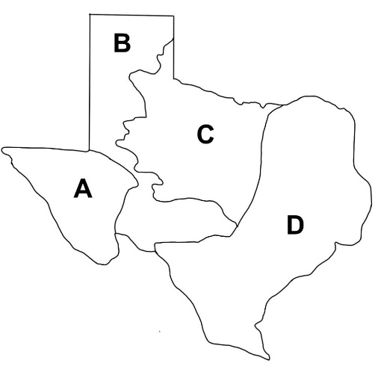

Which region has been the most densely populated throughout Texas history? Why?

**Part III: Practice Questions**

Practice answering these questions to prepare for the types of questions you may see on the test.

|  |  |  |
| --- | --- | --- |
| **Coahuiltecan** | Shared Characteristic | **Comanche** |
| * Lived in the Coastal Plains * Built small grass huts | ? | * Lived in the Great Plains * Hunted bison |

1. Which of the following answer choices best replaces the question mark in the diagram?
   1. Fierce warriors
   2. Primarily nomadic
   3. Primarily sedentary
   4. Part of the Puebloan culture

|  |
| --- |
| (A) The earliest people who arrived in Texas were migrating in order to follow the large herds of animals they depended on for survival. As those animals died out and the climate warmed, (B) the early Texas people spread out across Texas in search of new resources. Over time, (C) some of these people who lived in regions with fertile soil and abundant rainfall began developing agriculture. This development allowed tribes to become more settled in one location. Additionally, (D) it allowed a surplus of food, so they could build bigger and more complex societies. |

1. How did the development of agriculture influence the lives of early Texas people?
   1. It allowed American Indians to develop more complex tools including hunting weapons like bows and arrows.
   2. It required the frequent movement of tribes from region to region to adapt to the constantly changing food sources.
   3. It created hostilities between tribes that had fewer resources.
   4. It allowed for societies to become larger and more successful.
2. Which statement from the excerpt supports your answer in the previous question?
   1. The earliest people who arrived in Texas were migrating in order to follow the large herds of animals they depended on for survival
   2. The early Texas people spread out across Texas in search of new resources.
   3. Some of these people who lived in regions with fertile soil and abundant rainfall began developing agriculture.
   4. It allowed a surplus of food, so they could build bigger and more complex societies.
3. Read each statement below about American Indian tribes in Texas. Write the letter of the description in the chart under the correct tribe.
   1. Migrated to Texas in the 1700s to hunt bison, known as fierce warriors.
   2. Semi-nomadic hunter-gatherers who used dug-out canoes for fishing.
   3. Powerful agricultural tribe who lived in large farming communities.
   4. Puebloan people who farmed, traded, and lived in houses made of adobe bricks.

|  |  |  |  |
| --- | --- | --- | --- |
| Caddo | Comanche | Jumano | Karankawa |
|  |  |  |  |

1. How did the lives of the Comanche of the Great Plains compare with the lives of the Caddo of the Coastal Plains?

|  |
| --- |
|  |