# **Study Guide *Foundations***

*Unit 1: Natural Texas and Its People*

|  |  |  |  |  |  |
| --- | --- | --- | --- | --- | --- |
| Name: |  | Date: |  | Period: |  |

**Part I: Matching**

Look at both options in the answer box. Choose the option that best matches the definition or description on the right side of the chart. Highlight or circle the correct answer.

|  |  |
| --- | --- |
| 1. *Coastal Plains //*   *Mountains* & Basins | The most fertile region, which receives the greatest amount of precipitation and contains the largest Texas cities today. |
| 1. *Great Plains //*   *Mountains* & Basins | Tribes of this region were primarily nomadic bison hunters, living in teepees, like the Comanche. |
| 1. *North Central Plains //*   *Mountains* & Basins | Tribes of this region are often referred to as Puebloan people because they typically lived in adobe pueblo houses made out of clay bricks. In order to farm they built irrigation systems to get water to their crops. |
| 1. *Comanche //*   *Caddo* | The powerful and successful tribe that lived in the Coastal Plains and took part in large scale agriculture. |
| 1. *Nomadic //*   *Sedentary* | Tribes that primarily took part in agriculture tended to have this type of mobility. |
| 1. *Nomadic // Sedentary* | Tribes that were hunter-gatherers tended to have this type of mobility. |
| 1. *The Three Sisters //*   *Cash crops* | Corn, beans, and squash were often referred to as this because they grew so well together. |
| 1. *Comanche // Jumano* | This tribe arrived in Texas later than other tribes of this time period. They migrated on the Great Plains to hunt bison and became fierce warriors in Texas. |

**Part II: Geography**

Use the map to complete this section. Write the letter for the correct region in the blank for its corresponding characteristic. You will use each region more than once in your answer.

1. North Central Plains
2. Mountains and Basins
3. Coastal Plains
4. Great Plains
5. Highest annual precipitation
6. Rich, fertile soil
7. Lowest annual precipitation
8. Grasslands and bison
9. Jumano, Tigua
10. Nomadic hunting tribes
11. Irrigation-based farming
12. Most densely populated
13. Comanche, Kiowa, Apache
14. Wichita

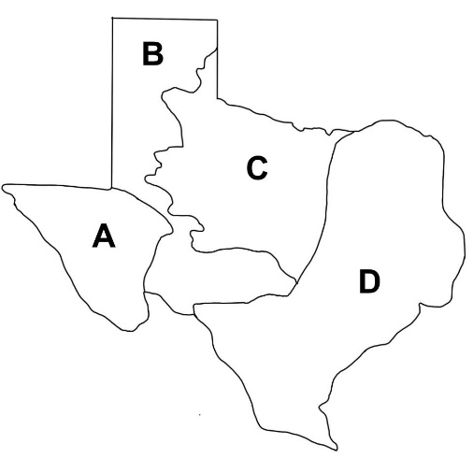

Complete the sentence below by circling or highlighting the correct answer for each part.

The **Coastal Plains / / Great Plains / / Mountains and Basins** has been the most densely populated throughout Texas history because **it has a high elevation and large desert / / it is rich in natural resources / / the rolling grassy plains are the perfect place to build large communities.**

**Part III: Practice Questions**

Practice answering these questions to prepare for the types of questions you may see on the test.

|  |  |  |
| --- | --- | --- |
| **Coahuiltecan** | Shared Characteristic | **Comanche** |
| * Lived in the Coastal Plains * Built small grass huts | ? | * Lived in the Great Plains * Hunted bison |

1. Which of the following answer choices best replaces the question mark in the diagram?
   1. Fierce warriors
   2. Primarily nomadic
   3. Primarily sedentary
   4. ~~Part of the Puebloan culture~~

|  |
| --- |
| (A) The earliest people who arrived in Texas were migrating in order to follow the large herds of animals they depended on for survival. As those animals died out and the climate warmed, (B) the early Texas people spread out across Texas in search of new resources. Over time, (C) some of these people who lived in regions with fertile soil and abundant rainfall began developing agriculture. This development allowed tribes to become more settled in one location. Additionally, (D) it allowed a surplus of food, so they could build bigger and more complex societies. |

1. Which statement from the excerpt supports the claim that agriculture helped the development of large American Indian communities ?
   1. ~~The earliest people who arrived in Texas were migrating in order to follow the large herds of animals they depended on for survival~~
   2. The early Texas people spread out across Texas in search of new resources.
   3. Some of these people who lived in regions with fertile soil and abundant rainfall began developing agriculture.
   4.  It allowed a surplus of food, so they could build bigger and more complex societies.