Unit 1: Natural Texas and Its People

Lesson 4: Texas Regions
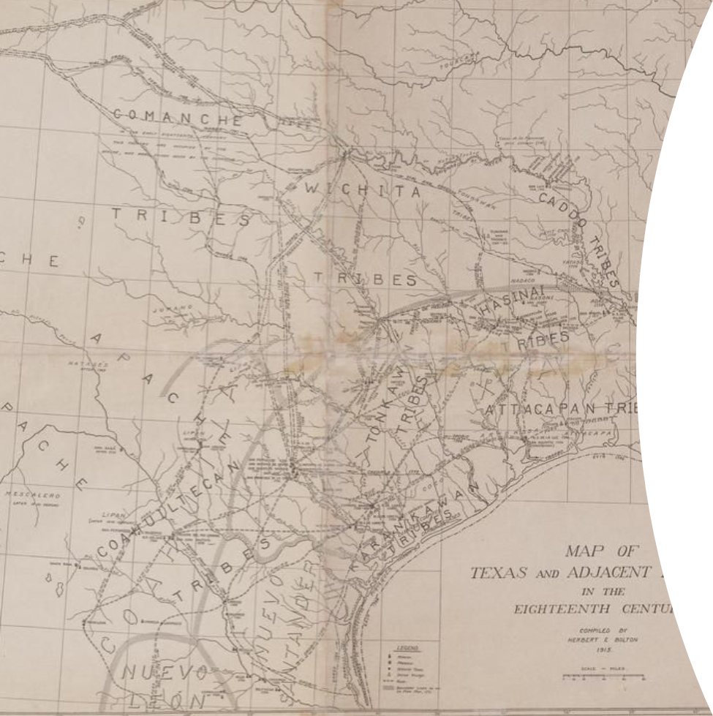

Warm-up: Day 1
Follow the directions below to complete your warm-up
Directions: Think about the area of Texas where you live now. Make a list under each category below describing what you know or believe about your area of Texas. Don’t worry about being wrong, and don’t spend too long thinking about what you write, just quickly list as many things as you can.
Climate
What’s the weather like during the different seasons here?
Landforms
What are some of the natural features of the earth here?
Plants and Animals
What animals would you be likely to see in the wild?
Discuss with a shoulder partner when you are finished

Share with the class:
The climate in our region is typically (blank)
One of the landforms we have in this region is (blank)
A plant / animal we have in this area is (blank)

Essential Question
What are the significant environmental characteristics of each region of Texas?

In Today’s Lesson
1. We will examine the climate, geography, natural resources, and plant and animal life of each Texas region
2. I will identify and record significant characteristics of each region on my guided note chart

Warm-up: Day 2
Follow the directions to complete your warm-up
Directions: Choose two regions you took notes on in the last lesson. write the name of each region at the top of each column. Under each region, write their distinct characteristics. In the middle column, write any characteristics they have in common.
Region 1:
Characteristics:
Region 2:
Characteristics:
Similarities:
Discuss with a shoulder partner when you are finished

Share with the class:
Both the (blank) and (blank) regions have (blank)
The (blank) region has (blank), while the (blank) region has (blank)

Essential Question

Day 2
How might the distinct characteristics of each region affect early American Indians who settled there?

In Today’s Lesson

Day 2
1. We will compare and contrast the characteristics of two regions.
2. I will make a claim about which region I think early American Indians would have settled in based on the characteristics of the regions.

Migrating to Texas
Approximately 12,000 years ago, the earth was coming out of a period of colder, drier temperatures known as an ice age.
As the earth’s temperature warmed, large animals like mammoths, dire wolves, and saber-toothed cats in North America began migrating farther south across the Great Plains. The early people who depended on these animals for necessities like food and clothing followed closely after them.
When the last ice age ended, many of those large, prehistoric animals went extinct. The nomadic people who had followed them south across the Great Plains began to spread out across Texas in search of new food sources.
Let’s take a look at the land they encountered in Texas.
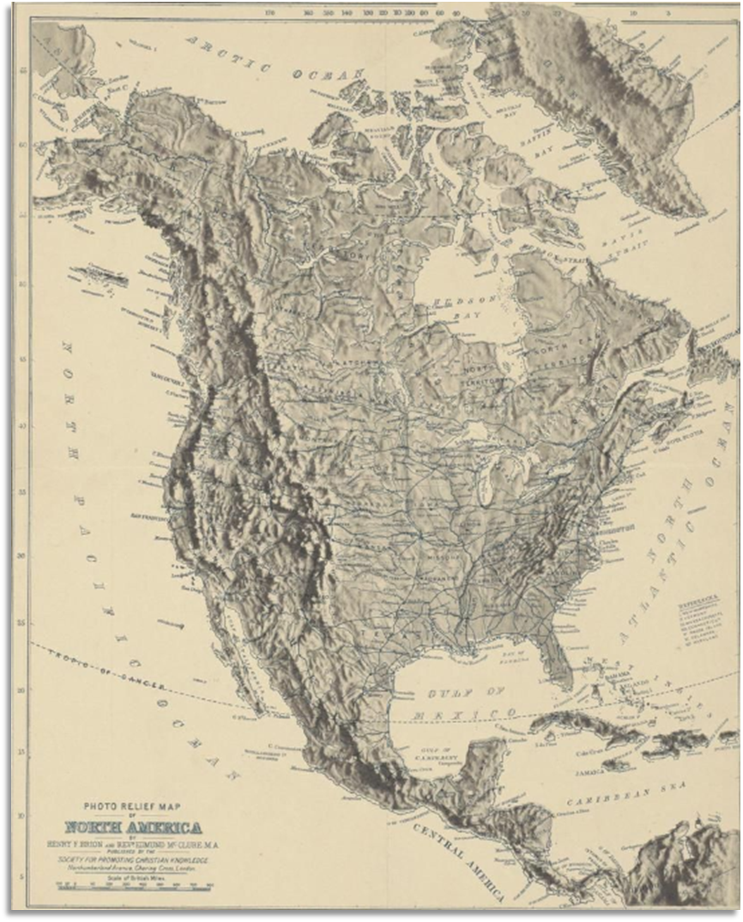

The Four Regions of Texas
The state of Texas covers an area more than 260,000 square miles and contains an incredibly diverse range of geographic landforms including marshes, forests, mountains, plateaus, plains, hills, basins, desert, and even the second largest canyon in the United States!
These geographic landforms are spread out across the state’s four primary regions: The Great Plains, the North Central Plains, the Coastal Plains, and the Mountains and Basins. Each region has its own distinct* geography, climate, environment, plant and animal life, and natural resources.
*Distinct: Different and unique
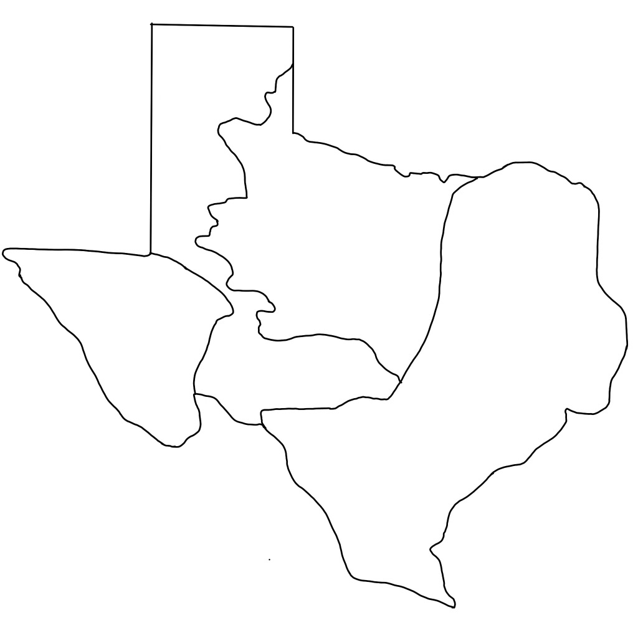
North Central Plains
Coastal Plains
Great Plains
Mountains and Basins
S
W
N

Make a prediction
Observe the map to the right. Based on the information presented in this map, where do you think the most plants, animals, and people are located in Texas?
Why?
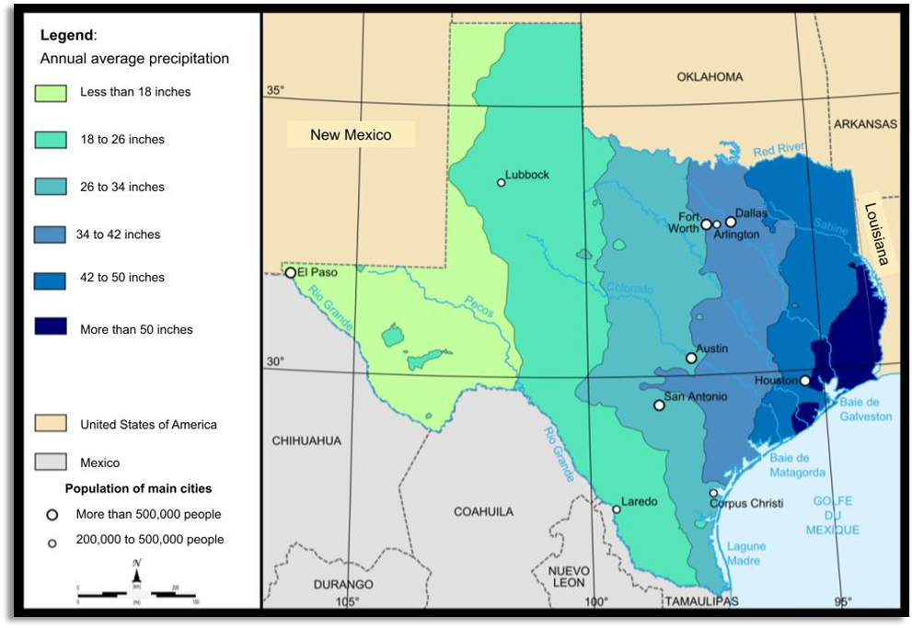

The Great Plains
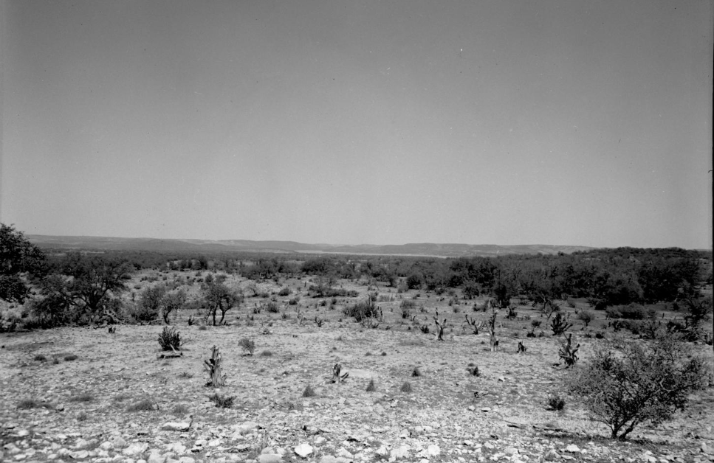

Climate

The Great Plains
The Great Plains region of Texas experiences long, hot summers with average highs in the 90s and cold winters with lows in the 20s. This region receives less rainfall than many other parts of Texas, averaging only 14 to 26 total inches of precipitation annually.
The Great Plains is prone to tornadoes in the spring and summer. In fact, it is one of the windiest regions not only in Texas, but in the whole country. The average annual wind speed in Amarillo, TX is 14.3 miles per hour, which makes it one of the top 10 windiest cities in the U.S! This can cause dust storms that reduce visibility from the average of 3 miles on a clear day to less than 1 mile during a storm.
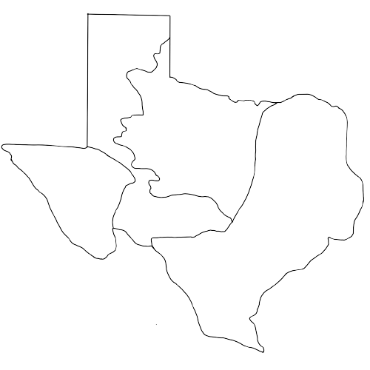

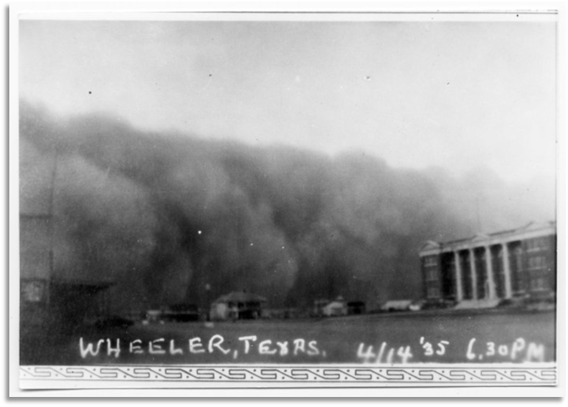
The Great Plains experienced some of the most extreme dust storms in the 1930s during a period of time know as “The Dust Bowl”.

Geography

The Great Plains
The Great Plains is a large landform that takes up the majority of the central portion of the United States, extending as far south as central Texas. It is comprised primarily of flat, rolling plains that grow tall grasses.
Though the majority of the Great Plains region of Texas is composed of rolling grasslands, this region also boasts the Palo Duro Canyon, which is the second largest canyon in the United States.
One interesting part of the Great Plains geography is actually below ground: the Oglalla aquifer. An aquifer is a natural supply of water below the earth’s surface. The Oglalla aquifer is the largest aquifer in the United States, spanning 8 states!
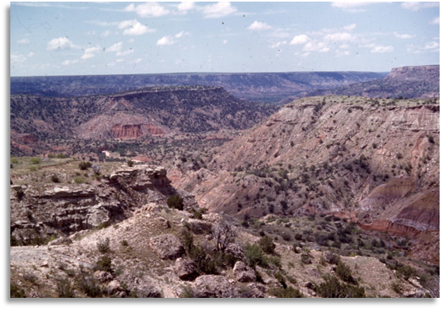
The Palo Duro Canyon
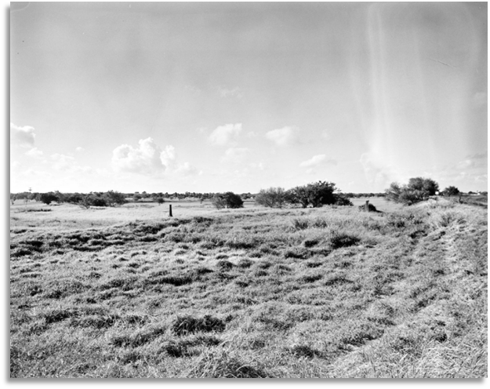
A view of the rolling plains

Plant and Animal Life

The Great Plains
While the Great Plains region experiences an extreme climate which makes it difficult for some plants and animals to survive, it is home to many species that can survive in the region’s extreme temperatures with little water.
Some plants that are indigenous to the region are cottonwood and mesquite trees, prickly pear cactus which bears a red fruit that the American Indians often ate, and tall western wheat grass.
Some indigenous animals that inhabit the region are prairie dogs, jackrabbits, mountain lions, and bison, which are also known as American buffalo. Hundreds of years ago, these animals roamed the plains more abundantly than they do today.
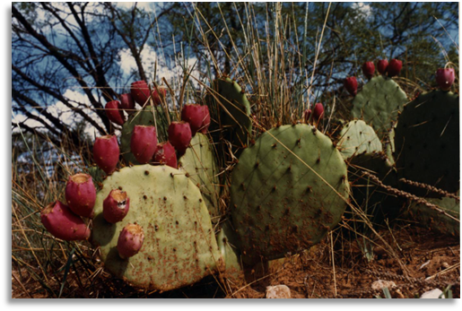
Prickly pear cactus
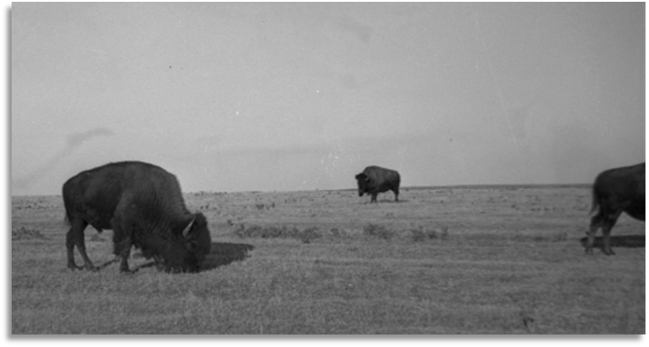
Bison grazing on the plains

Natural Resources

The Great Plains
Like many other parts of the state, the Great Plains has oil and natural gas reserves stored below the earth’s surface. People today drill for these resources to use as energy to power vehicles and provide heating for homes and businesses. While important to our modern economy, these resources were unknown to the early American Indians who called the Plains home.
The Great Plains region is also abundant in tall grasses that provide food for livestock like cattle and longhorns which are raised on ranches in this region. These grasses fed the bison that tribes of the Great Plains depended on for their survival.
Though the dry climate of the Great Plains prevented most early American Indians from taking part in agriculture in any significant way, modern farmers use irrigation to direct distant water sources to their farms. In this way, people on the Great Plains today are able to successfully take part in agriculture.
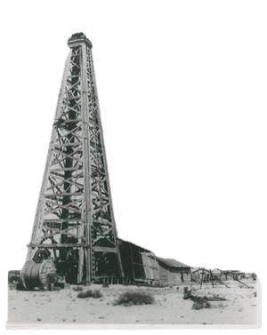
Oil rig
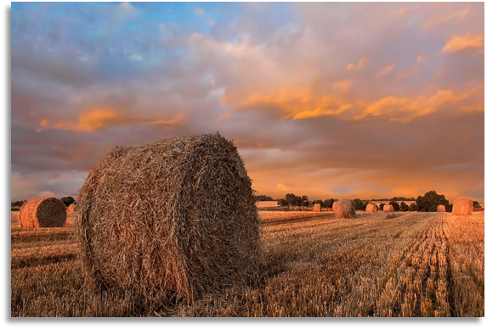
Bales of hay to feed livestock

The North Central Plains
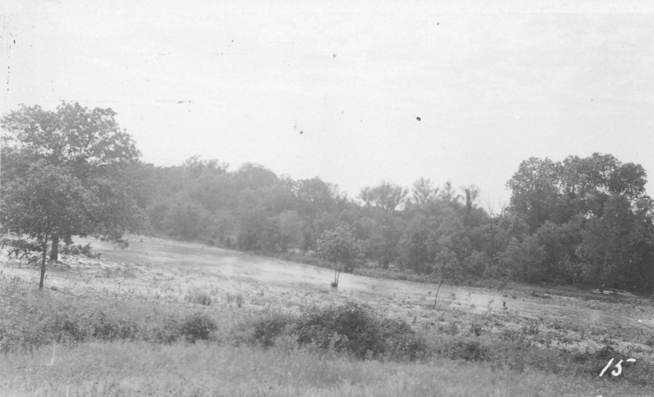

Climate

The North Central Plains
The North Texas region has a more diverse climate than other parts of Texas. The western part of this region is more arid, receiving only about 22 annual inches of rainfall, while the eastern part is more humid, receiving nearly 40 inches per year.
This region experiences cold winters with average low temperatures in the 30s. The summers are long and hot with an average temperature in the high 90s, though it is quite common for this region to experience temperatures above 100 degrees.
Like the Great Plains, the North Central Plains can experience tornadoes in the spring and summer.

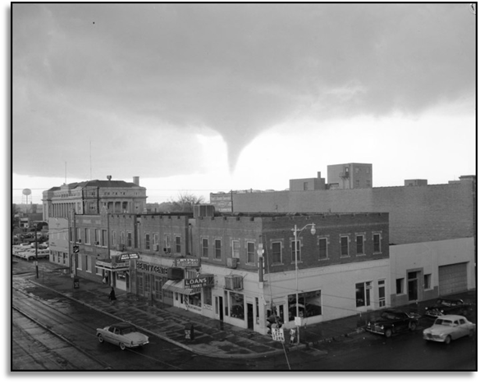
A tornado approaching Wichita Falls, 1958

Geography

The North Central Plains
North Central Texas is mostly comprised of flat, rolling grassy plains. A forested area called the Cross Timbers covers much of the eastern portion of the region in elm and a variety of oak trees. The Cross Timbers also contains hills and rocky escarpments, or long, steep, rocky slopes of land.
North Central Texas contains several small lakes and a few major rivers, including the Brazos River and the Red River. Today, the Red River makes up part of the northern border between Texas and Oklahoma.
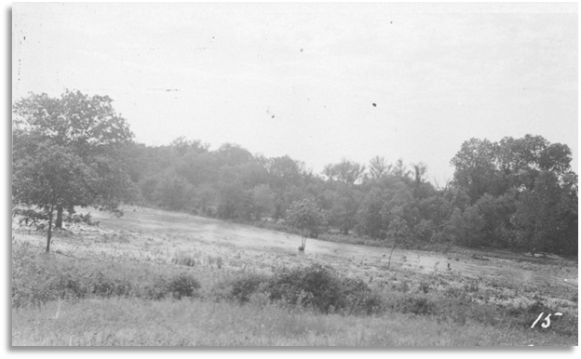
Near Little Elm Creek, North of Dallas
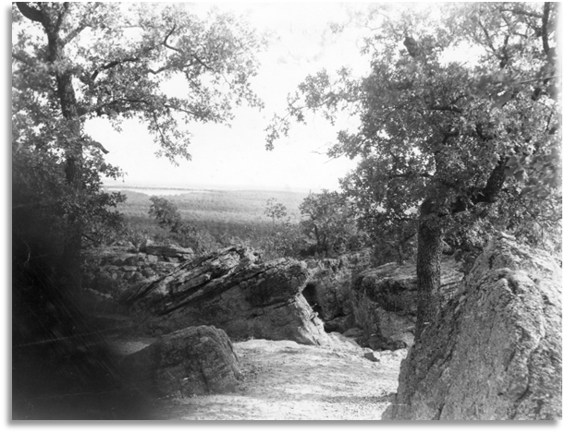
Inspiration Point near Fort Worth

Plant and Animal Life

The North Central Plains
There are many indigenous wildflowers that are found in the North Central Plains including bluebonnets and Indian paintbrush. Low trees and shrubs like the Texas mesquite tree are also common in this region.
Many different animals call the North Central Plains home including white-tailed deer, coyotes, prairie dogs, armadillos, rabbits, and a variety of birds.
Early Texans would have also often encountered antelope, bear, and bison in this region.
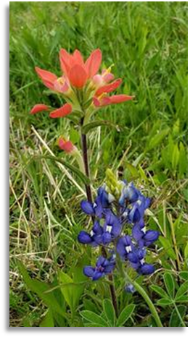
Indian Paintbrush and bluebonnets
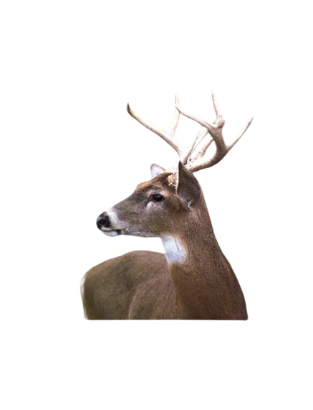
White-tailed deer

Natural Resources

The North Central Plains
The North Central Plains region is rich in oil and natural gas, which are found beneath the earth’s surface. Both oil and natural gas provide people with energy, like gasoline for cars or heating and electricity for homes. Early American Indians in this region didn’t appear to be aware of the oil below the earth’s surface.
Today, common rocks in the region like limestone, sandstone, and shale are used to make gravel, which is often used in construction and landscaping.
Early American Indians living in the North Central Plains hundreds of years ago made use of the fertile soil by taking part in agriculture.
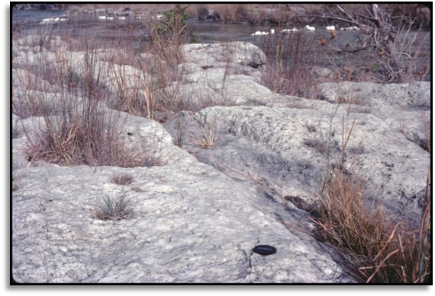
Limestone
An oil rig

The Coastal Plains
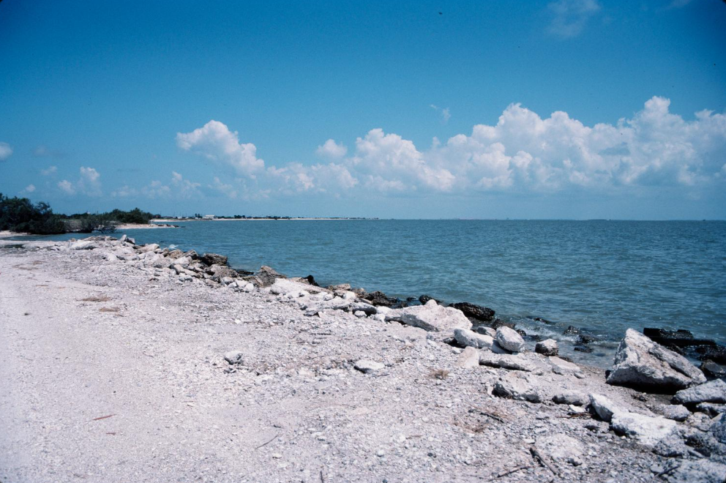

Climate

The Coastal Plains
On average, the Coastal Plains is the most humid of all four Texas regions. The southern portion of the region receives the least rainfall, with an annual average precipitation of only about 22 to 34 inches.
The northeast portion of this region receives from 34 to more than 54 inches of rainfall annually. This amount of rainfall can be extremely beneficial for plant and animal life and agriculture; however, it can also lead to dangerous flooding.
The Coastal Plains also occasionally experiences hurricanes along the coast of the Gulf of Mexico in the summer and fall months.

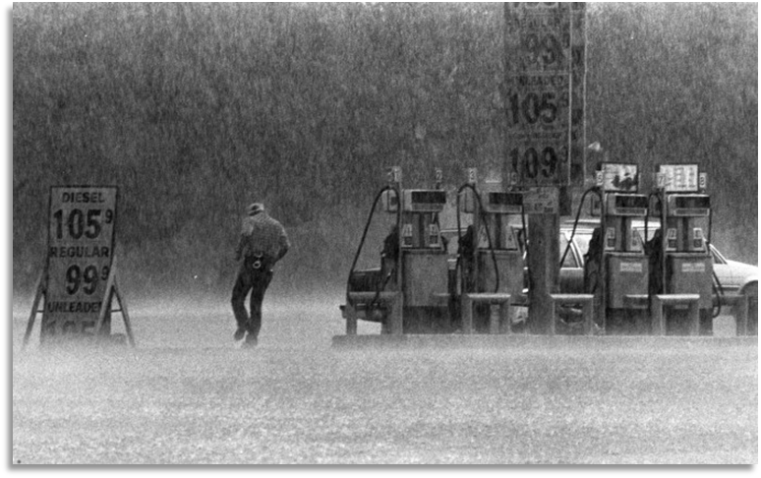
Heavy rainfall in Austin, Texas

Geography

The Coastal Plains
The Coastal Plains region contains some of the most diverse geography of all the Texas regions.
Along the Gulf Coast there are swampy marshlands and beaches that border the Gulf of Mexico. In the eastern part of the region, the Piney Woods Forest covers 23,500 square miles of rolling terrain with elm, ash, mesquite, oak, and pine trees.
Forming the western border of the Coastal Plains region is the Balcones Escarpment - a sharp ridge of rock similar to a cliff that ranges in height from 300 to 1000 feet at its tallest point.
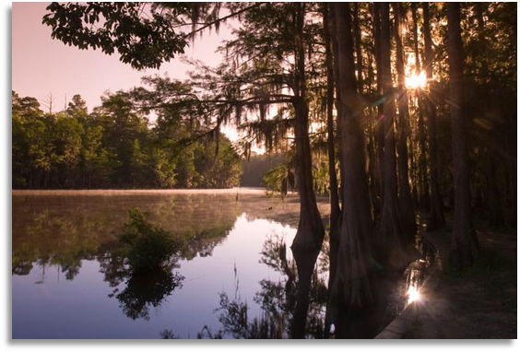
Sunset in the Piney Woods
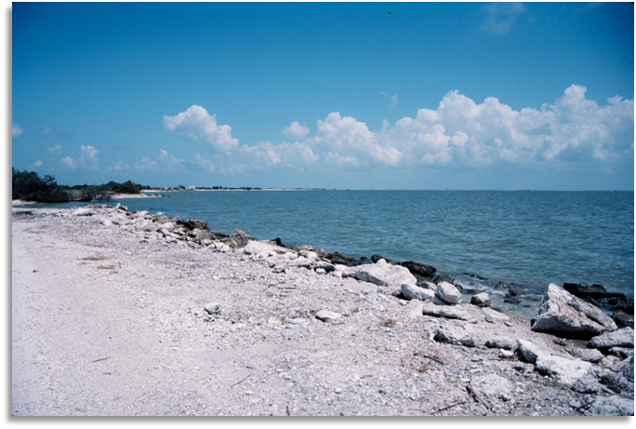
The coast at Matagorda Bay

Plant and Animal Life

The Coastal Plains
This region contains some of the richest and most diverse plant and animal life of all the Texas regions.
In the marshy wetlands of the Coastal Plains are alligators, turtles, and lizards. Numerous different types of fish like the spotted sea trout and blue catfish live in the rivers, lakes, and Gulf of Mexico. The Piney Woods in the east are home to cottonmouth snakes, white-tailed deer, rabbits, moles, raccoons, and opossums. The largest colony of Mexican Free-tailed bats in the world is located in Austin, TX.
The plant life of the region includes a large variety of trees, grasses, wildflowers, climbing vines, and succulents.
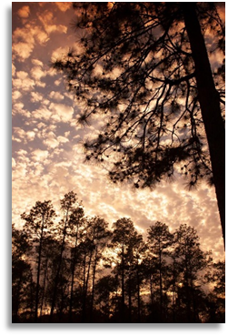
Trees in the Piney Woods
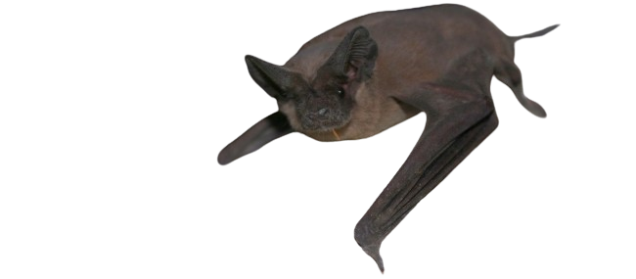
A Mexican free-tailed bat
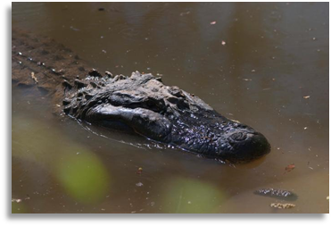
American Alligator

Natural Resources

The Coastal Plains
Like many areas of Texas, the Coastal Plains region is rich in oil and natural gas. People use these resources for energy to power their cars and heat their homes and businesses. The early American Indians in this region often used the oil that seeped out of the soil for medicinal purposes to treat skin diseases, and as fuel for their fires.
The Piney Woods provides lumber for construction. Additionally, the rich soil, abundant rainfall, and numerous water sources make the region perfect for agriculture and fishing for Texans today, as well as early Texas people who lived in the region hundreds of years ago.
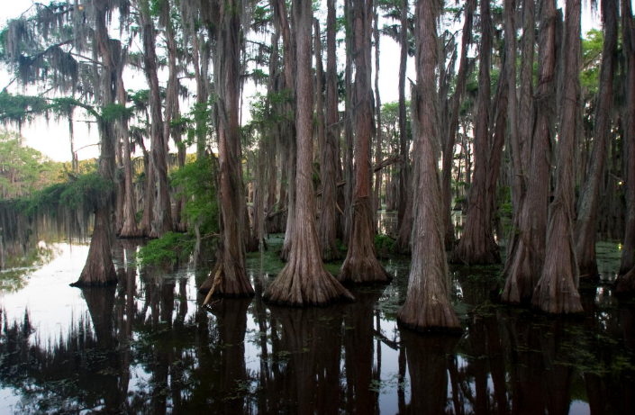
A swampy area of the Piney Woods Forest
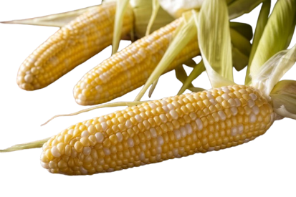
Maize, or corn, a common American Indian Crop
An oil rig

The Mountains and Basins
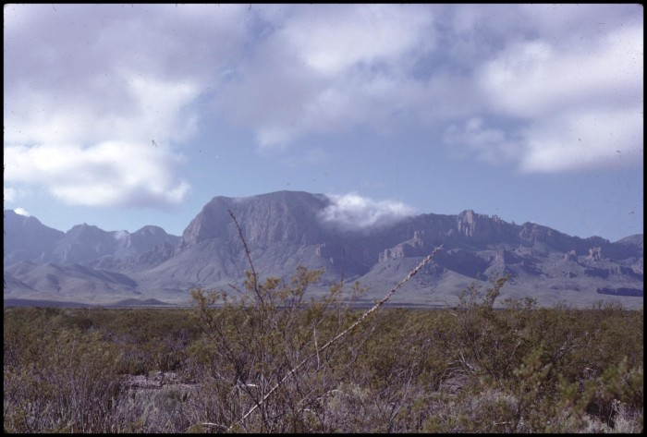

Climate

The Mountains and Basins
The Mountains and Basins region has an arid* desert climate. It receives only 9 to 18 inches of rain annually and there are very few significant sources of water in the region. The signature climate characteristic of this region is its extreme aridity.
The winter is very short though cold, while the summer is long and hot. Due to the desert conditions of the region, the days are typically long and hot though the nights are cooler.
*Arid: Very dry

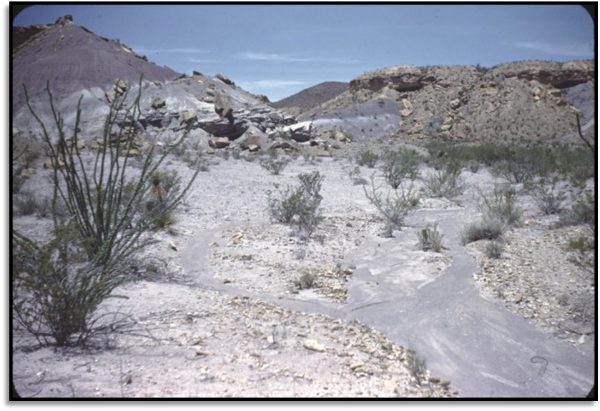
The arid, desert conditions

Geography

The Mountains and Basins
The Mountains and Basins contains some of the most dramatic natural geographic landforms in Texas. There are three mountain ranges that stand at an elevation of approximately 7,000 to 8,000 feet each: The Chisos Mountains, Guadalupe Mountains, and Davis Mountains.
The Chihuahua Desert covers the entire region, and on the southern border of this region is the Rio Grande River, which today provides the border between Texas and Mexico.
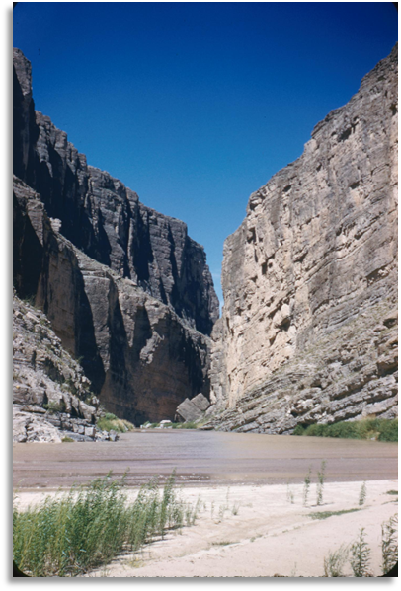
The Rio Grande, running between the Rio Grande Gorge
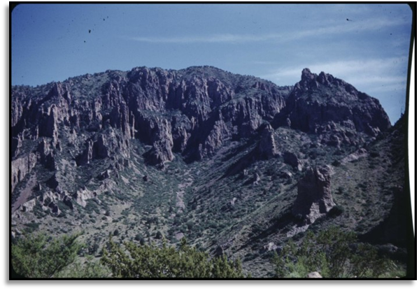
The Chisos Mountains

Plant and Animal Life

The Mountains and Basins
The Mountains and Basins are home to many species of plants and animals that are capable of surviving in the arid, desert conditions of the region.
Desert plants like yucca, pinyon trees, and prickly pear cactus exist today and hundreds of years ago during the era of early Texas people. The fruit of the prickly pear, often known as tuna to early Texas people, were part of the diets of many American Indians.
The region is also home to animals including gray banded kingsnakes, cougars (also known as mountain lions) and an animal similar to a wild boar known as a javelina.
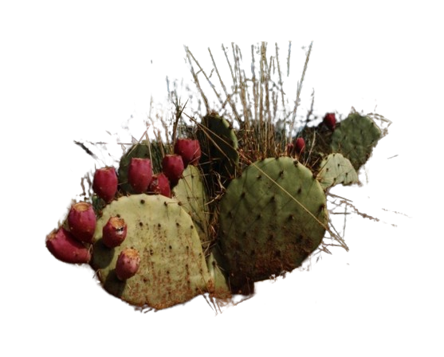
Prickly Pear Cactus
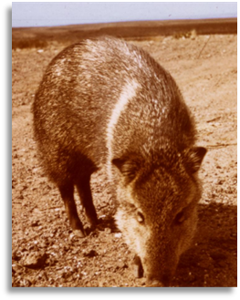
Javelina
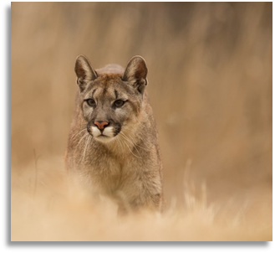
Puma, or mountain lion

Natural Resources

The Mountains and Basins
Like much of the rest of Texas, oil and natural gas are both natural resources of the Mountains and Basins region. The majority of these items are found only in the eastern part of the region, closest to the Great Plains.
Farming is limited in this region due to its extremely arid climate, though some farmers are able to grow cotton and vegetables, and raise chickens, sheep, cattle, and goats. Early Texas people had similar struggles hundreds of years ago in this difficult environment, but many were also able to take part in limited farming and hunting bison in the area.
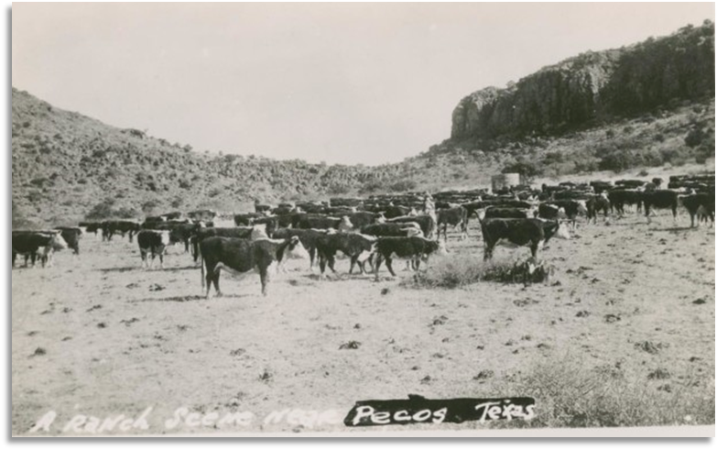
A cattle ranch in Pecos, Texas, 1930s

Exit Ticket – Day 1
Directions: Consider what you learned about the region of Texas where you live. Complete the following chart using your answers from the Warm-up and the information from your notes today.
Sentence stem:
1. I was right about…
Your Response:
2. I wasn’t quite right about…
Your Response:
3. I didn’t know…
Your Response:

Exit Ticket – Day 2
Prompt: Compare and contrast the geography, climate, natural resources, and plant and animal life of two Texas regions.

