Unit 1: Natural Texas and Its People

Lesson 7: Texas Today
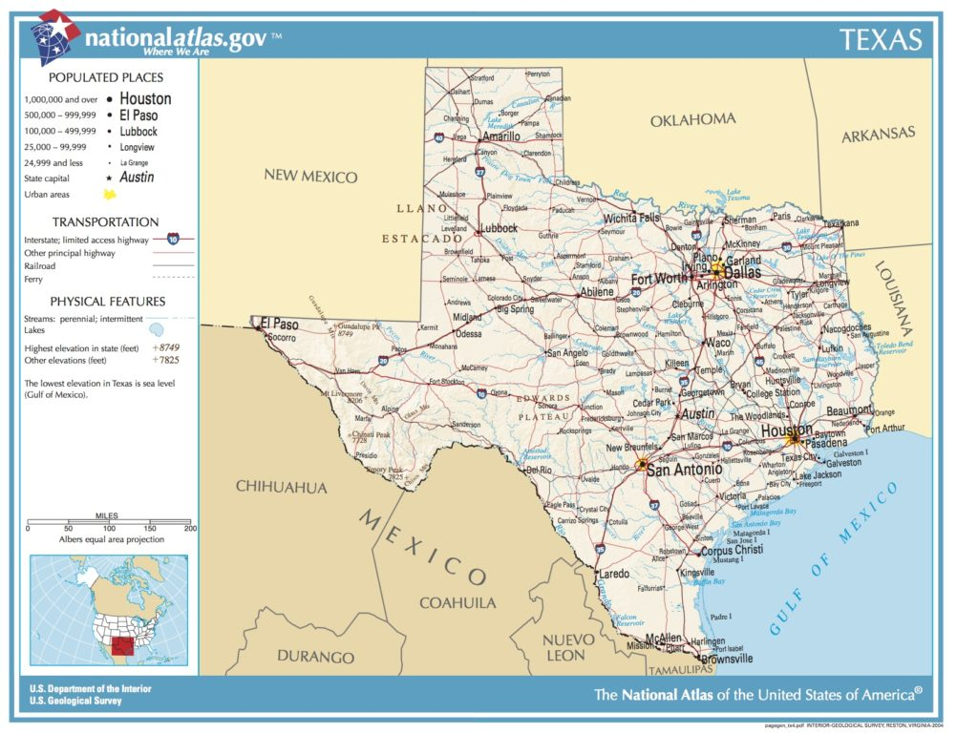

Texas Today

Warm-up

Warm-up
Follow the directions to complete your warm-up
What would you put in a time capsule for people 500 years from now to learn about life in Texas today?
Write your response on your warm-up.
Discuss with a partner

Share with the class
I would put (blank) in a time capsule for future people to learn about Texas today because (blank).

Essential Question
What are the defining characteristics of Texas today, and how do they compare with early Texas history?

In today’s lesson…

Day 1
1. We will examine Texas geography, population, culture, and economy today.
2. I will create a map of Texas including the major cities and bordering locations. I will answer comprehension questions about modern Texas.

Welcome to Texas Today!

Lesson

Welcome to Texas Today!
Today, at 268,596 square miles and 30.3 million people, Texas is the second largest state in the nation both in terms of land mass and population.
Three of the top ten largest cities in the U.S. are located in Texas: Austin, Dallas, and Houston. In fact, Houston is the 4th largest city in the country at over 2.3 million people!
Texas industries like agriculture, energy, and oil and gas are so successful that Texas’ economy is the 8th largest in the world!
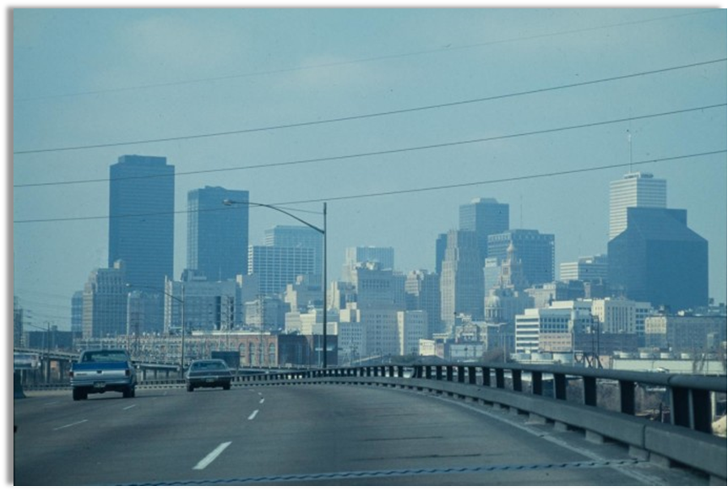
A view of the Houston skyline

Texas Economy
Most people know Texas produces a large amount of oil and natural gas. Texas produces 42% of the nation’s oil – in other words, nearly half of all oil in the U.S. comes from Texas!
Did you know that Texas is also the number one producer of wind energy in the nation? In fact, Texas wind energy accounts for nearly 25% of total wind energy generated in the U.S.
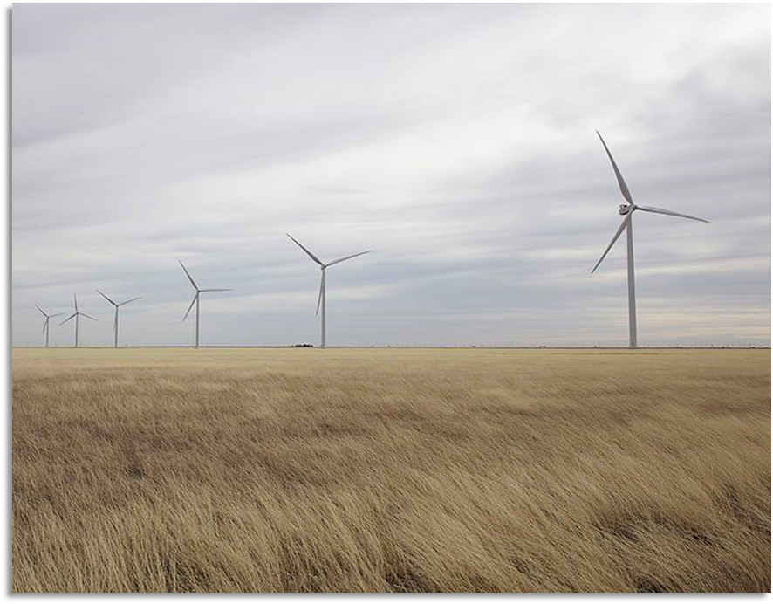
Wind turbines at work in the South Texas Plains

Natural and Human Geography

Make a prediction
Where do you think most Texans live today based on your prior knowledge of Texas geography and the map to the right?
Where do you think they would be least likely to live?
Explain your answer
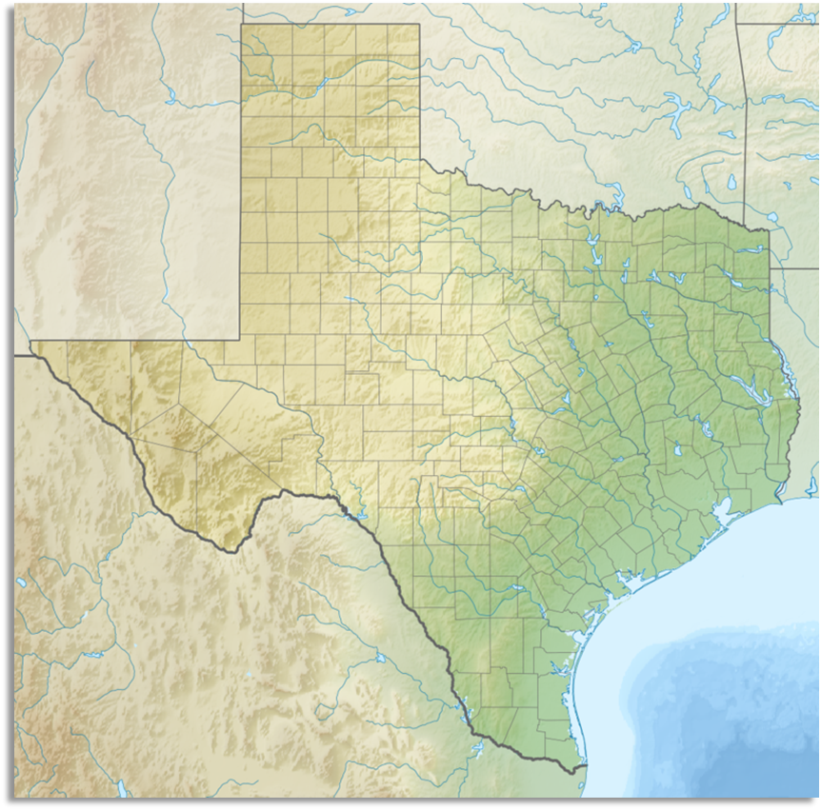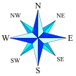

Texas Population Density*
Was your prediction from the previous slide correct? Share with the class. Use the map key to support your answer.
Key: Population per square mile
This map shows how many people live in a one-mile area.
*Density: How many are in one area
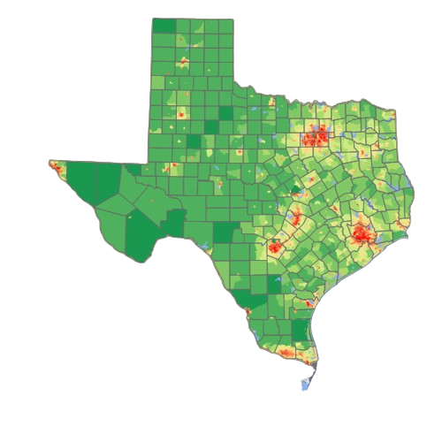

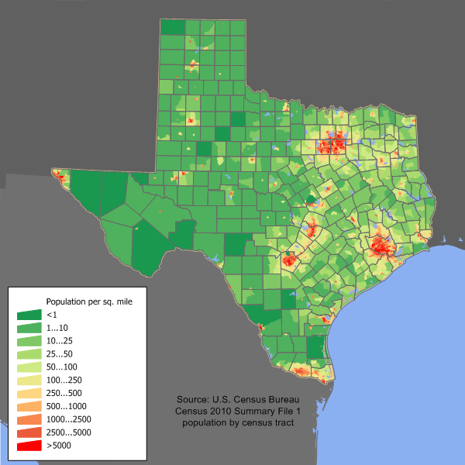

Texas Urban Areas
What is the purpose of this map?
What do you think “urban areas” means?
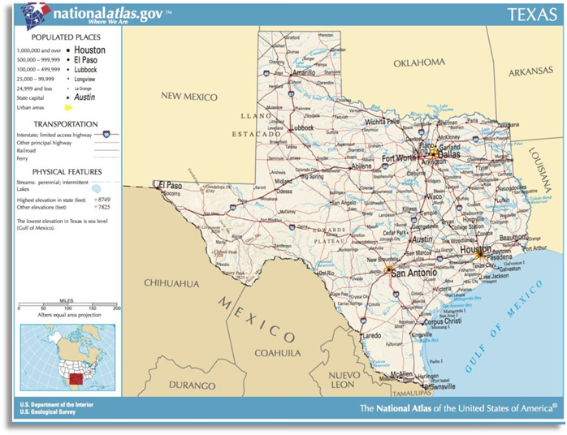

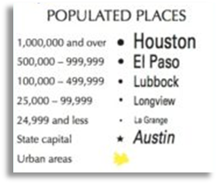

Use the enlarged map on the following slide to label your map on your worksheet.
Enlarged map of Texas cities and borders
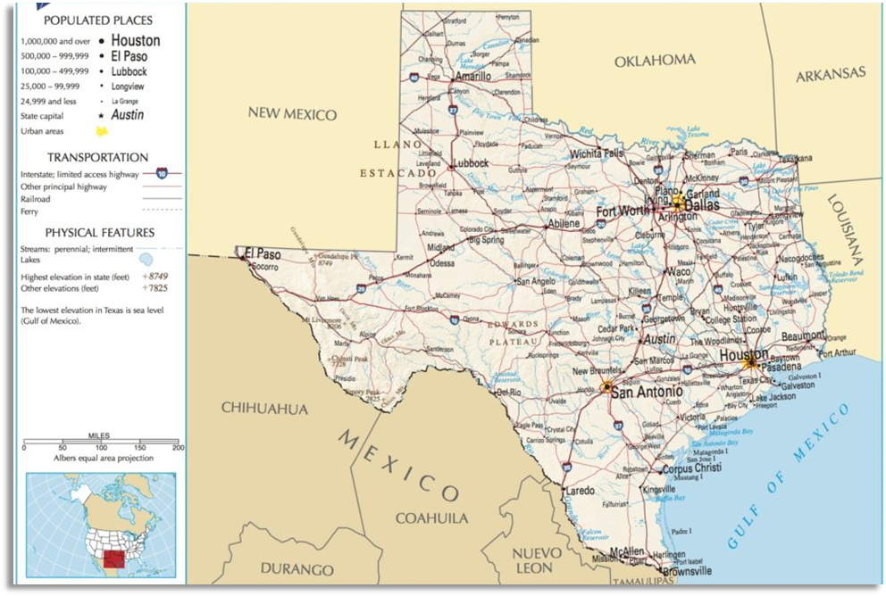

American Indians in Texas Today
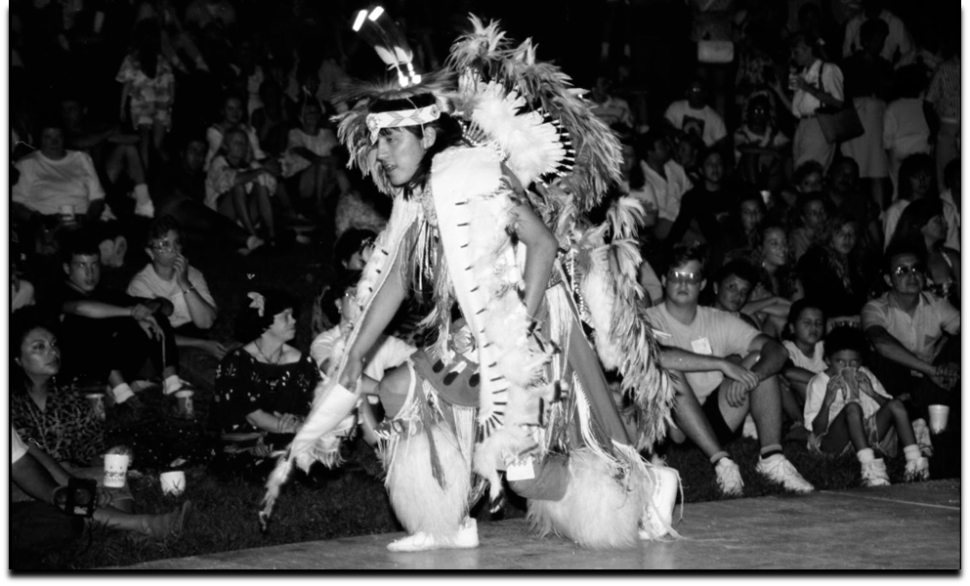

American Indians in Texas Today
Today, there are three federally recognized American Indian tribes in Texas: the Alabama-Coushatta in east Texas, the Kickapoo Traditional in south Texas, and the Ysleta Del Sur Pueblo in west Texas.
There are also more than 30 tribes that are not federally recognized like the Lipan-Apache tribe of south Texas.
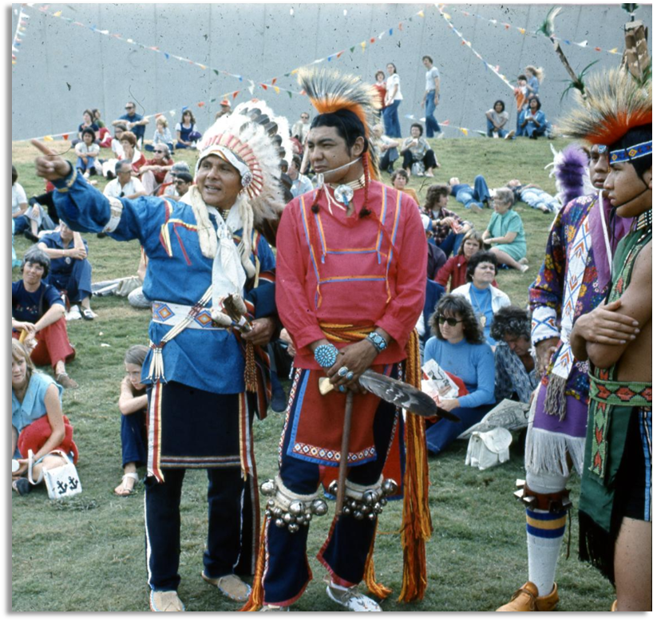
Members of the Alabama-Coushatta and Apache tribes at a tribal gathering in 1974

American Indian Culture Today
Many members of American Indian tribes in Texas today keep their tribal culture and heritage alive in a variety of different ways.
Pictured here are dancers from the Texas American Indian Heritage Society preparing to perform a traditional dance in 1997.
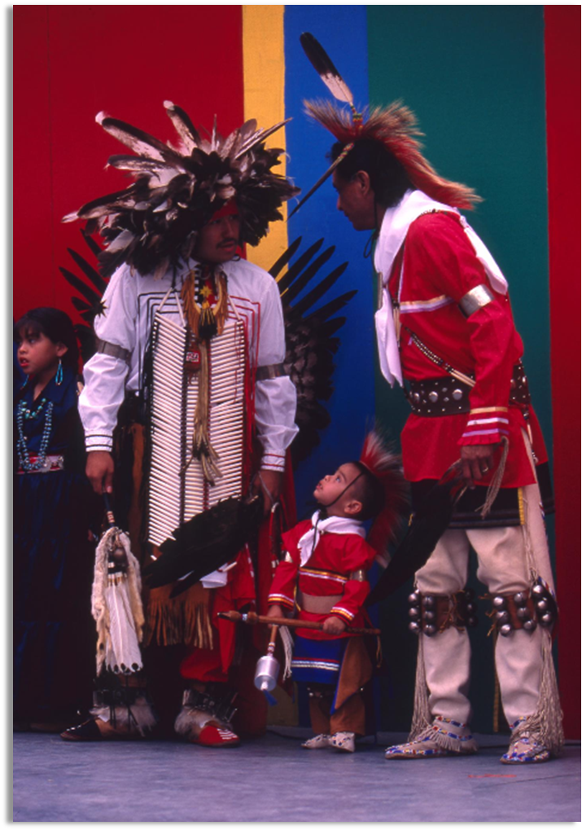
Texas American Indian Heritage Society Dancers, 1997

Texas Today Exit Ticket

Exit Ticket
Follow the directions to complete your exit ticket
Answer the multiple-choice question on your exit ticket based on the map available.
Write your response
Discuss with a partner
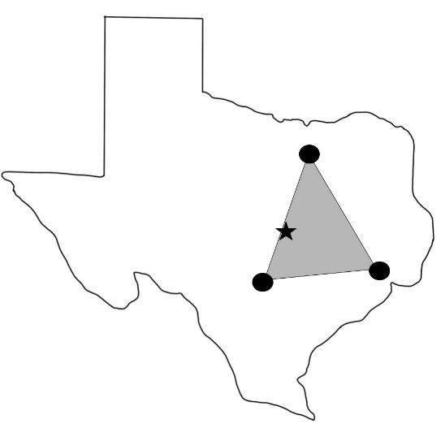

Share with the class
The significance of the map is that (blank)

