Texas Today Foundations

Unit 1: Natural Texas and Its People

Part I: Welcome to Texas Today!

Today, at 268,596 square miles and 30.3 million people, Texas is the second largest state in the nation both in terms of land mass and population.
Three of the top ten largest cities in the U.S. are located in Texas: Austin, Dallas, and Houston. In fact, Houston is the 4th largest city in the country at over 2.3 million people!
Texas industries like agriculture, energy, and oil and gas are so successful that Texas’ economy is the 8th largest in the world!
1. Circle or highlight three facts in the reading about Texas today.
2. Using the context of the reading, what do you think economy means?
a. Culture and heritage
b. Wealth and resources
c. Population and cities
d. Geography and landforms

Make a prediction
Where do you think most Texans live today based on your prior knowledge of Texas geography and the map to the right? Circle the area.
Where do you think they would be least likely to live? Draw an X over the area.
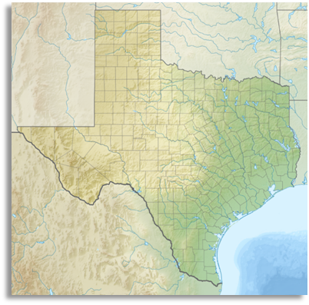

Part II: Texas Map Activity
Step 1: Write the letter of the correct letter in the blank next to the correct answers below. Use the map on the slide presentation to assist you.

1. Louisiana (blank)
2. San Antonio (blank)
3. Mexico (blank)
4. Lubbock (blank)
5. Dallas (blank)
6. New Mexico (blank)
7. Oklahoma (blank)
8. Texas (blank)
9. Arkansas (blank)
10. Gulf of Mexico (blank)
11. Fort Worth (blank)
12. Houston (blank)
13. Amarillo (blank)
14. Austin (blank)
15. El Paso (blank)
16. Rio Grande River (blank)
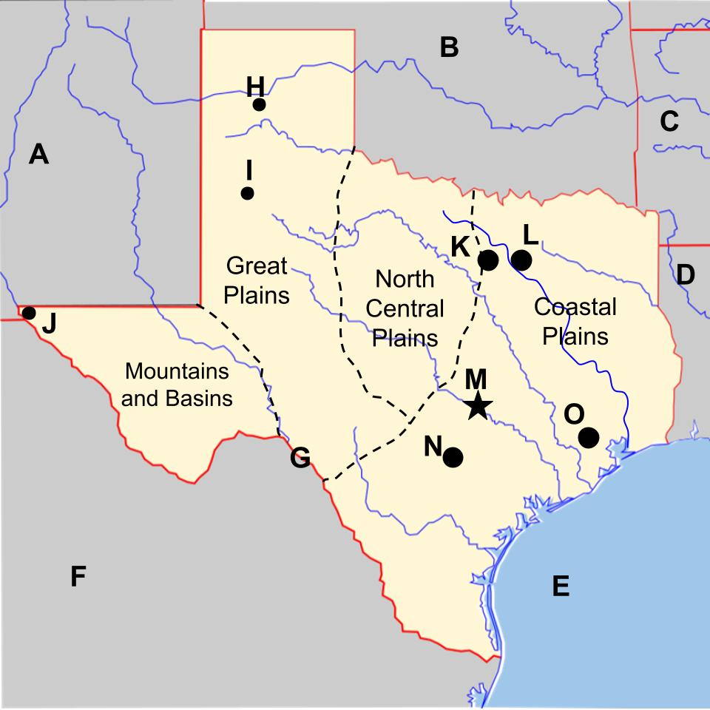

Part III: American Indians in Texas Today

Directions: Answer the following questions about Texas
1. The Alabama-Coushatta tribe is located northeast of Houston. Which region does this tribe reside in?

a. North Central Plains
b. Mountains and Basins
THIS CHOICE REMOVED c. Great Plains
d. Coastal Plains

2. The Ysleta del Sur Pueblo people live in present-day El Paso, Texas. Which region does this tribe reside in?

a. North Central Plains
b. Mountains and Basins
c. Great Plains
THIS CHOICE REMOVED d. Coastal Plains

3. The Kickapoo Traditional people live in the Coastal Plains on the border that Texas shares with Mexico. Near which major river does this tribe reside?

a. The Red River
b. The San Antonio River
c. The Rio Grande
THIS CHOICE REMOVED d. The Trinity River

4. One of the three federally recognized tribes in Texas are descendants of an American Indian tribe we learned about that also lived in the Mountains and Basins region. Which tribe are they the descendants of?

a. Tigua
b. Karankawa
c. Caddo
THIS CHOICE REMOVED d. Wichita

5. Based on the locations given in these questions and answers, label the map below with the correct tribes. Write the letter of the location next to the correct tribe.

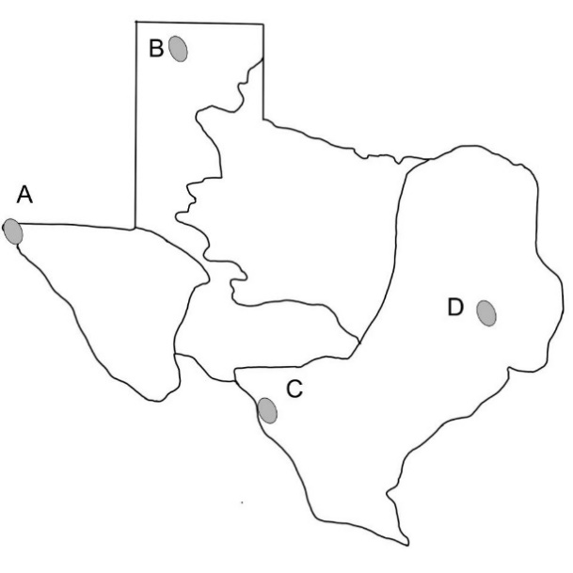
(blank) Alabama-Coushatta
(blank) Ysleta Del Sur Pueblo
(blank) Kickapoo Traditional

