Texas Today Grade Level

Unit 1: Natural Texas and Its People

Part I: Welcome to Texas Today!

Today, at 268,596 square miles and 30.3 million people, Texas is the second largest state in the nation both in terms of land mass and population.
Three of the top ten largest cities in the U.S. are located in Texas: Austin, Dallas, and Houston. In fact, Houston is the 4th largest city in the country at over 2.3 million people!
Texas industries like agriculture, energy, and oil and gas are so successful that Texas’ economy is the 8th largest in the world!
1. Give three facts about Texas today according to the reading.
2. Using the context of the reading, what do you think economy means?
a. Culture and heritage
b. Wealth and resources
c. Population and cities
d. Geography and landforms

Make a prediction
Where do you think most Texans live today based on your prior knowledge of Texas geography and the map to the right? Circle the area.
Where do you think they would be least likely to live? Draw an X over the area.
Explain your answer below.
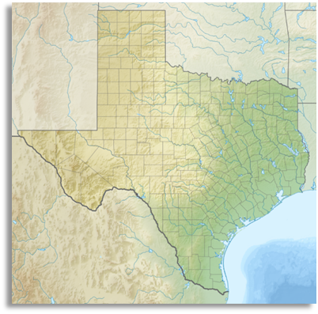

Part II: Texas Map Activity
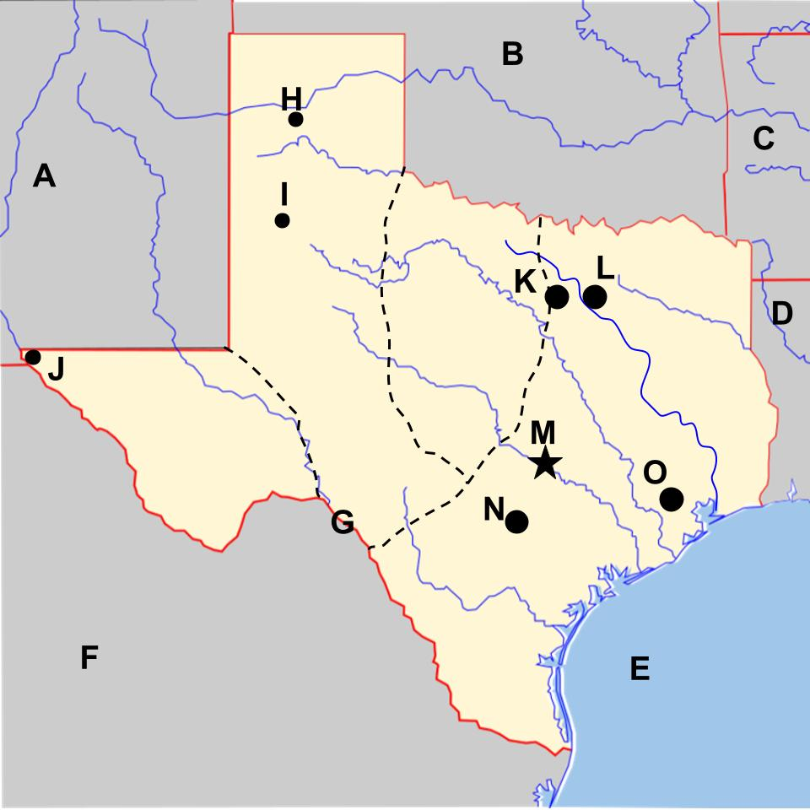
Step 1: Use the word bank and the map on the slides presentation to complete your map.
Word Bank
Louisiana
San Antonio
Mexico
Lubbock
Dallas
New Mexico
Oklahoma
Texas
Arkansas
Gulf of Mexico
Fort Worth
Houston
Amarillo
Austin
El Paso
Rio Grande River
Step 2: Label each region within the dotted lines. Use the word bank below for assistance.
Word Bank
Coastal Plains
Mountains and Basins
North Central Plains
Great Plains

Part III: American Indians in Texas Today
Directions: Answer the following questions about Texas
1. The Alabama-Coushatta tribe is located northeast of Houston. Which region does this tribe reside in?

a. North Central Plains
b. Mountains and Basins
c. Great Plains
d. Coastal Plains

2. The Ysleta del Sur Pueblo people live in present-day El Paso, Texas. Which region does this tribe reside in?

a. North Central Plains
b. Mountains and Basins
c. Great Plains
d. Coastal Plains

3. The Kickapoo Traditional people live in the Coastal Plains on the border that Texas shares with Mexico. Near which major river does this tribe reside?

a. The Red River
b. The San Antonio River
c. The Rio Grande
d. The Trinity River

4. One of the three federally recognized tribes in Texas are descendants of an American Indian tribe we learned about that also lived in the Mountains and Basins region. Which tribe are they the descendants of?

a. Tigua
b. Karankawa
c. Caddo
d. Wichita

5. Based on the locations given in these questions and answers, label the map below with the correct tribes. Write the letter of the location next to the correct tribe.

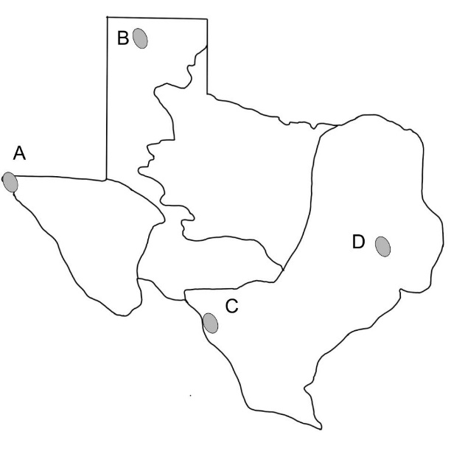
(blank) Alabama-Coushatta
(blank) Ysleta Del Sur Pueblo
(blank) Kickapoo Traditional

