 Warm-up: Texas Today
Unit 1: Natural Texas and Its People
Name: |  | Date: |  | Period:

Imagine you and your class are creating a time capsule of what life is like in Texas today. You program the capsule to open only after 500 years. You want the people of the future to get a good picture of what life was like for you in Texas at this moment in time.
Consider what kinds of things you would include in the time capsule to act as artifacts specifically related to Texas for the future people to learn from 500 years from now.
Write at least three things you would include. Leave space to add more as your class shares.

Warm-up: Texas Today
Unit 1: Natural Texas and Its People
Name: |  | Date: |  | Period:

Imagine you and your class are creating a time capsule of what life is like in Texas today. You program the capsule to open only after 500 years. You want the people of the future to get a good picture of what life was like for you in Texas at this moment in time.
Consider what kinds of things you would include in the time capsule to act as artifacts specifically related to Texas for the future people to learn from 500 years from now.
Write at least three things you would include. Leave space to add more as your class shares.


Texas Today Exit Ticket

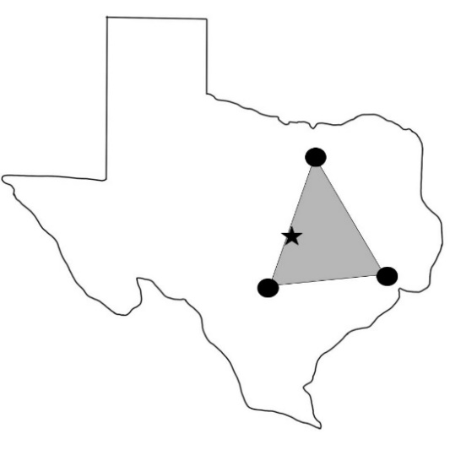

- Which statement below best demonstrates the significance of this map based on the major themes of this unit?

  - The majority of the modern population of Texas lives within the triangle as a direct result of the natural abundance of resources, excellent soil, and favorable climate of this region.
  - The triangle demonstrates the settlement patterns of the very first American Indian tribes to settle in Texas who explored and settled Texas in search of new resources.
  - The cities in the map are very large. Some of the largest cities in the country are found in Texas. Houston has more than 2 million people.
  - The triangle demonstrates a geographic region of Texas which is very difficult to populate due to harsh living conditions and a lack of resources.

Texas Today Exit Ticket

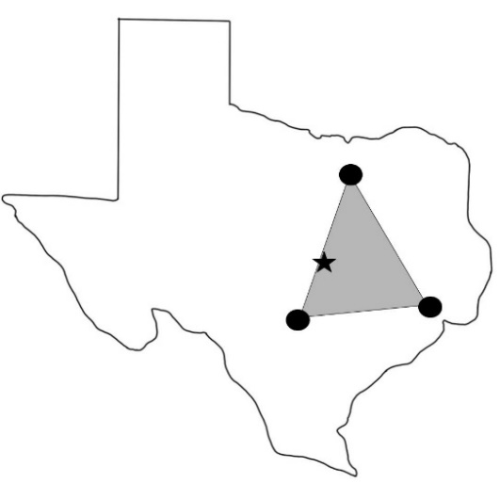

- Which statement below best demonstrates the significance of this map based on the major themes of this unit?

  - The majority of the modern population of Texas lives within the triangle as a direct result of the natural abundance of resources, excellent soil, and favorable climate of this region.
  - The triangle demonstrates the settlement patterns of the very first American Indian tribes to settle in Texas who explored and settled Texas in search of new resources.
  - The cities in the map are very large. Some of the largest cities in the country are found in Texas. Houston has more than 2 million people.
  - The triangle demonstrates a geographic region of Texas which is very difficult to populate due to harsh living conditions and a lack of resources.

