The Big Picture Teacher Guide
Slide | Advanced | Grade Level | Foundations
Link to material | Link to material | Link to material  Link to Warm-up / Exit Ticket | Link to Material
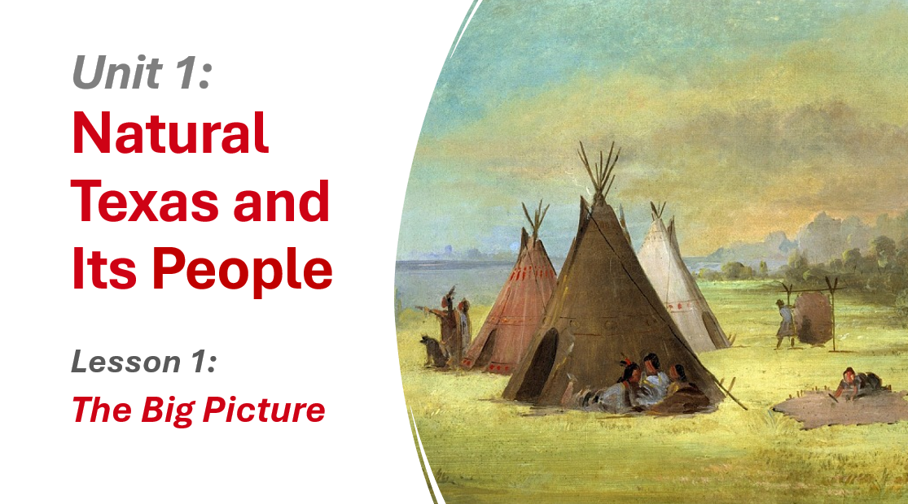 |  | Class Questions:  -What do you notice about this picture?  -What do you predict we will talk about today based on this picture?
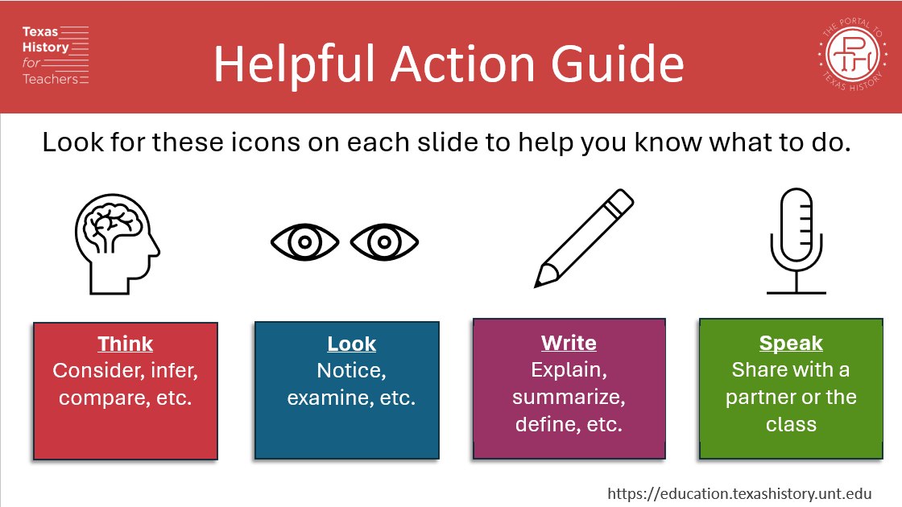 |  | Introduce these images to students. Ask them to look for these icons on the slides as another cue for what they should be doing.
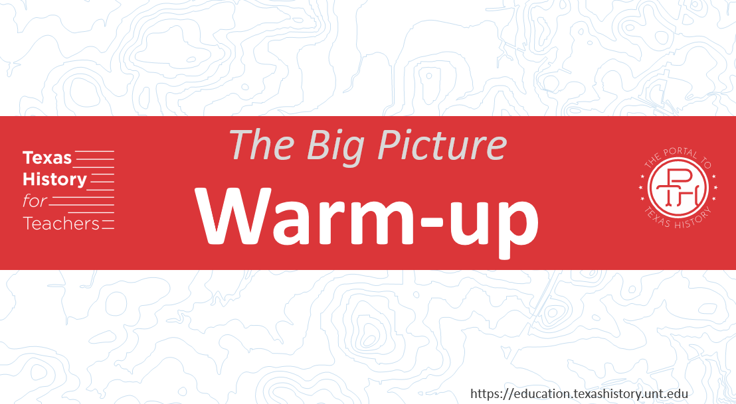  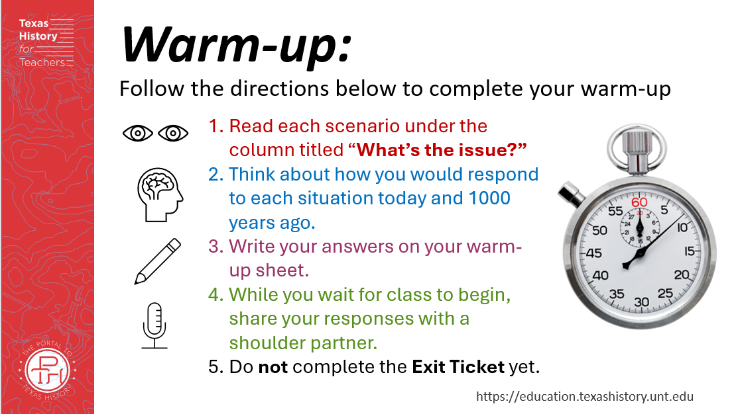  Restates directions with visual cues. | Students who finish early can discuss and compare answers with a shoulder partner. | 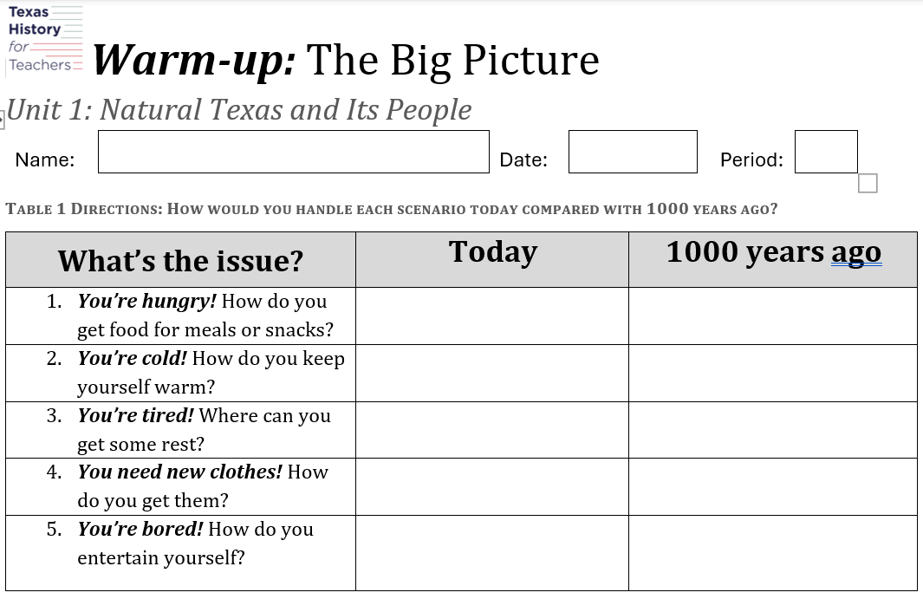  Students complete the chart by responding how they would handle each scenario today, and how they imagine they would complete each scenario 1000 years ago. | Reduce writing by requiring students only choose one or two scenarios to respond to.
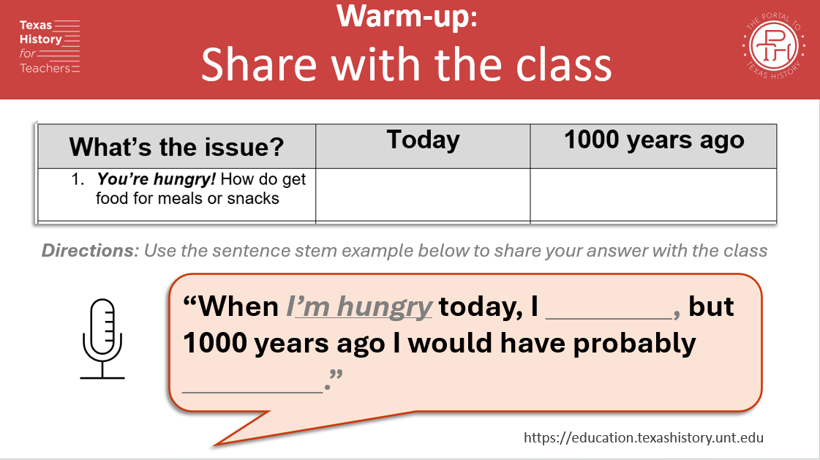 |  | Students share their responses with the class.  Slide: Sentence stem provided to guide student responses in a complete sentence.  Direct student attention to the microphone icon to remind them about the action guide symbols.
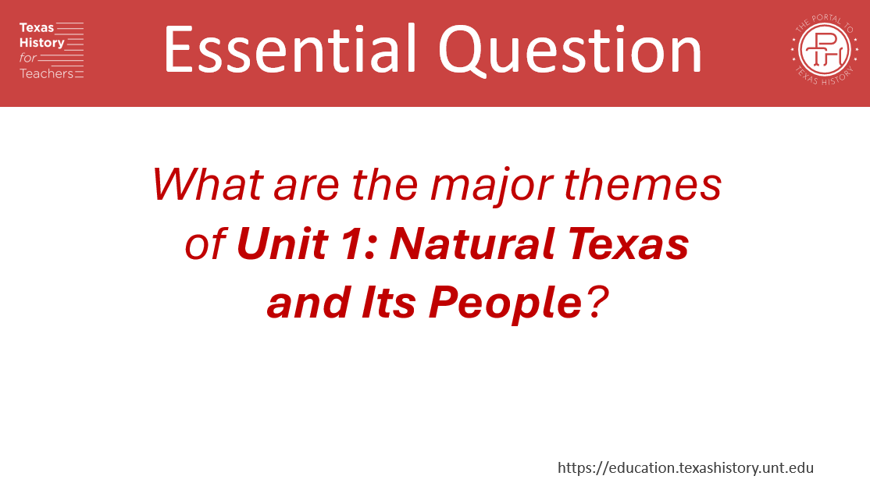 | Have students predict what the answer to this essential question might be. | Read the essential question together as a class.  Encourage students to keep this question in mind during the lesson. They should be able to answer this question by the end of class.
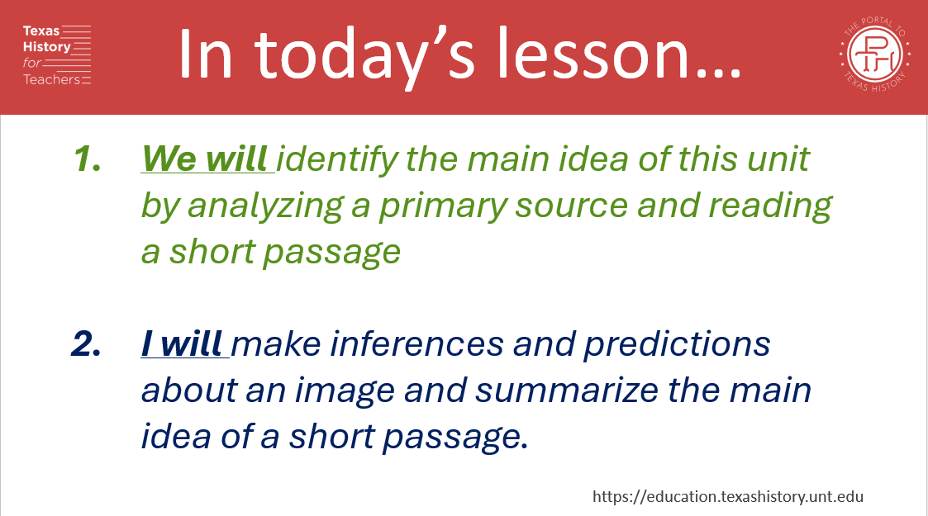 | Have students predict what the main idea of the unit might be basted on the title, the warm-up, and the image from the title slide. | Read the “We will / I will” statements together.  Review words like inference, prediction, summarize. Check for student understanding.
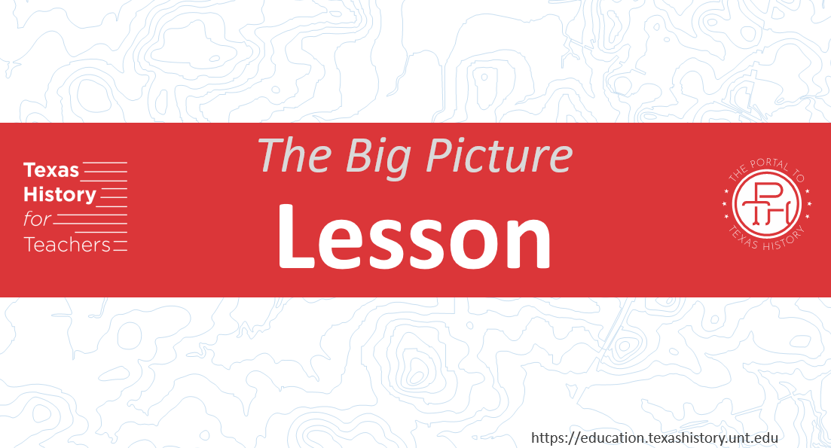

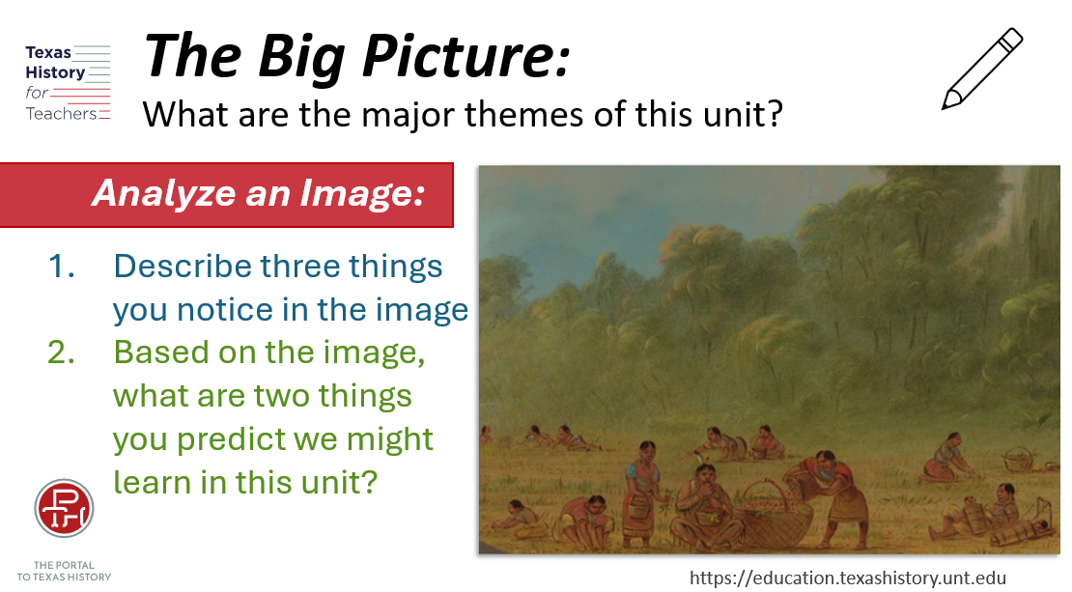  The image from the student worksheet is displayed larger on this slide. |  | 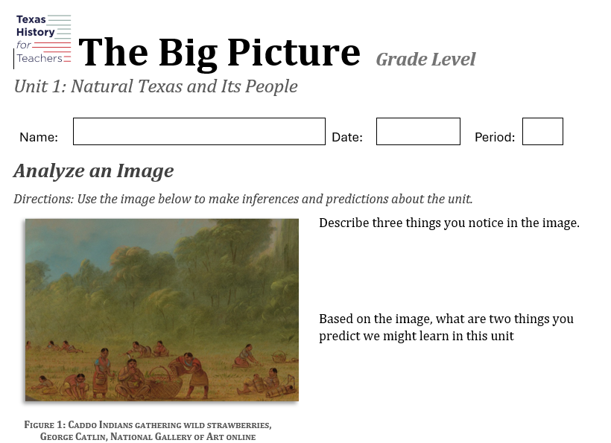 | Foundations questions require fewer examples to reduce writing.
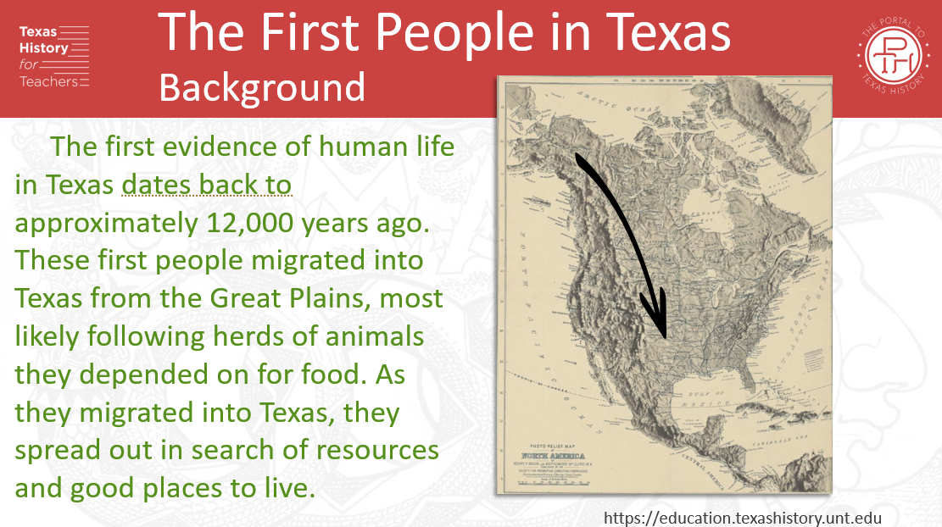 | Extend the Learning:  Ask students if they know the mountain range the early people followed south.  What types of animals would the early people be following? | Teacher calls on individual students to read passage, sentence by sentence. | Literacy support suggestion:  Teacher reads the passage first.  Class reads along with teacher the second reading.  Teacher calls on individual students to read sentence by sentence the third reading.
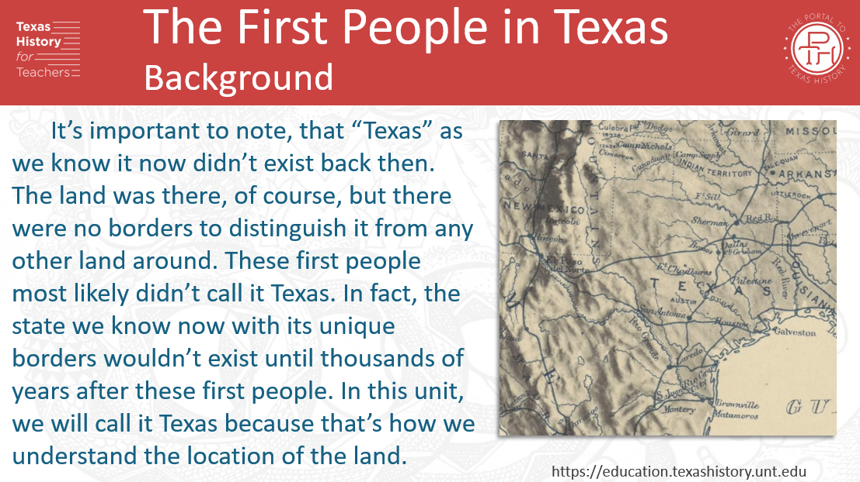 |  | Continue the reading strategies from the previous slide.  Comprehension Question:  Did “Texas” exist thousands of years ago? What DID exist? Why are we calling the land Texas if the early people didn’t call it that? | Continue the reading strategies from the previous slide.
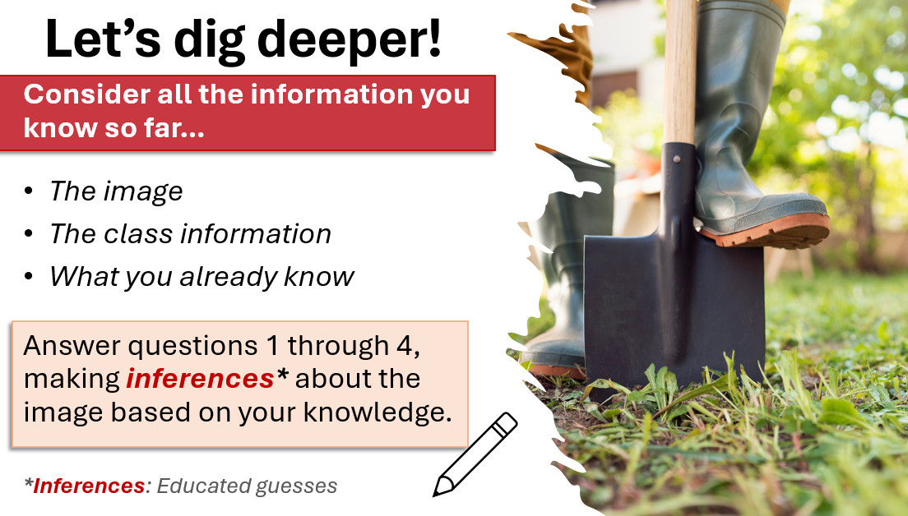 | Answer in complete sentences or give at least 2 answers per question. | 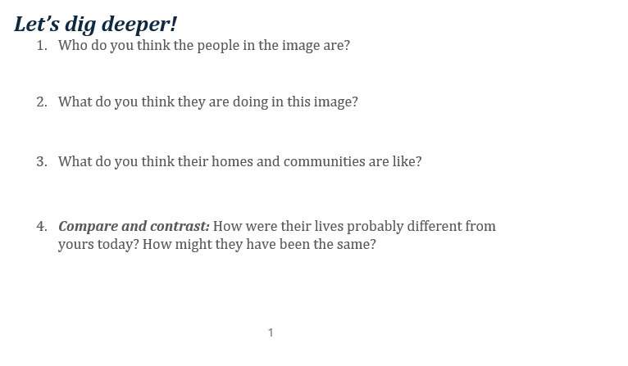 | 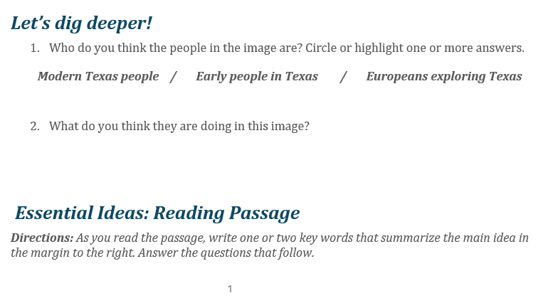  Students have answer options to circle or highlight, to reduce writing.
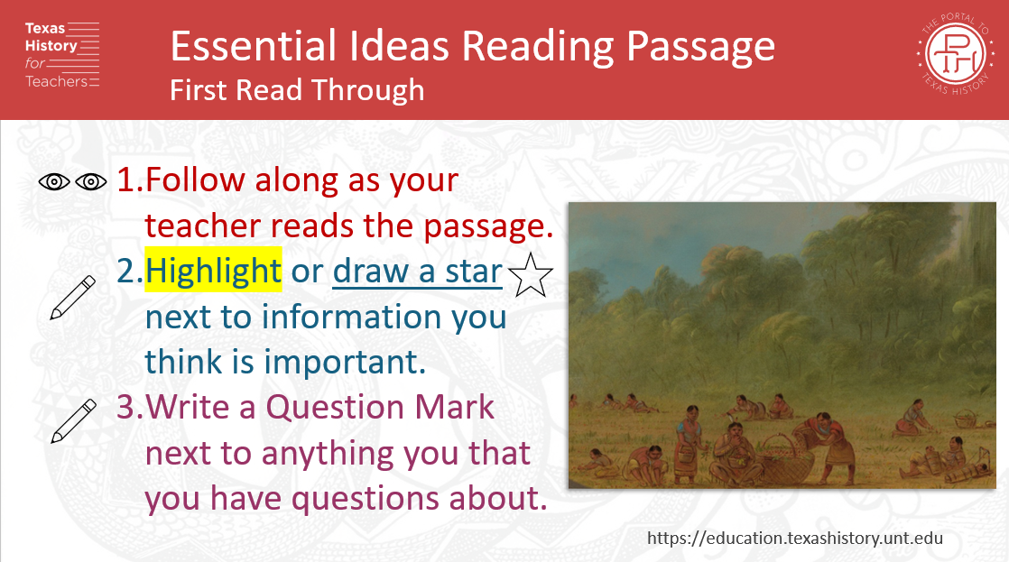  Directions for each read-through. |  | 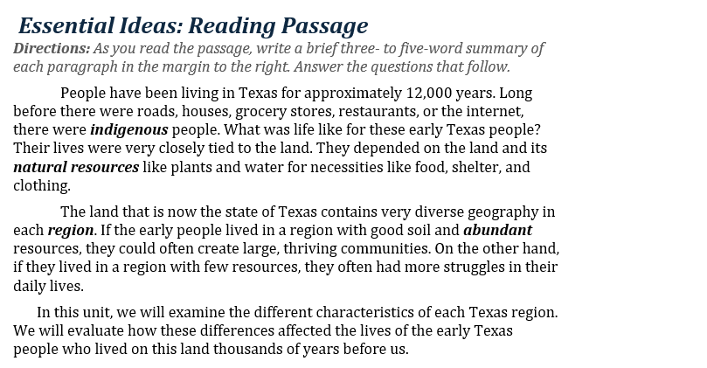  Students follow the directions on the slide for each read through to annotate their passage.  There are three read-throughs requiring different annotation steps.
 | 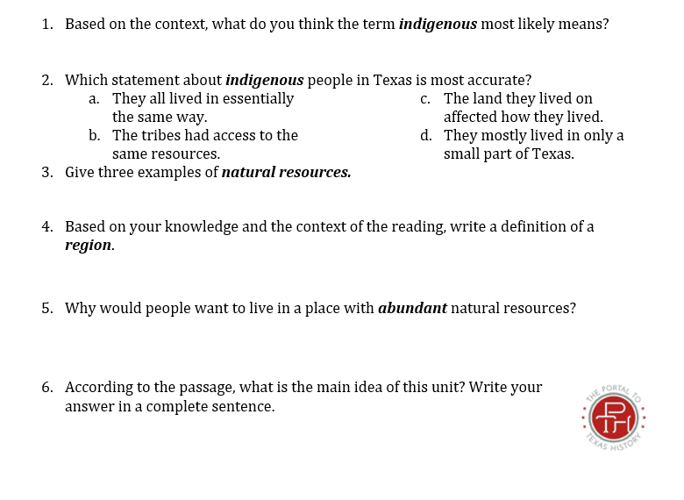  Comprehension questions are short, constructed response. | 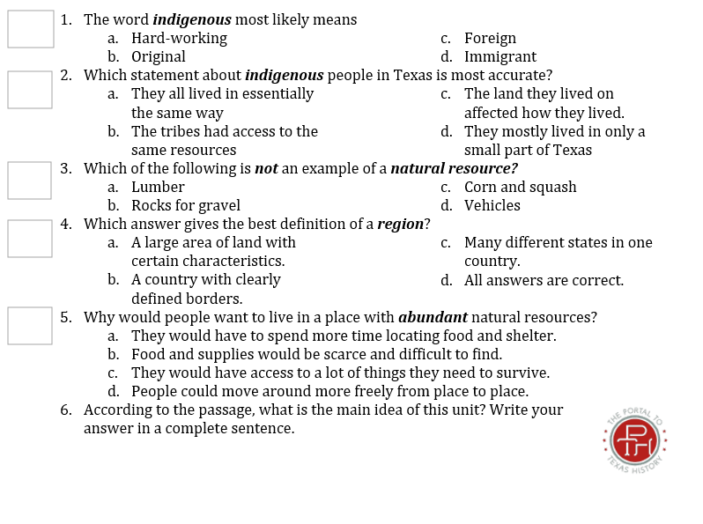  Comprehension questions are multiple choice. | 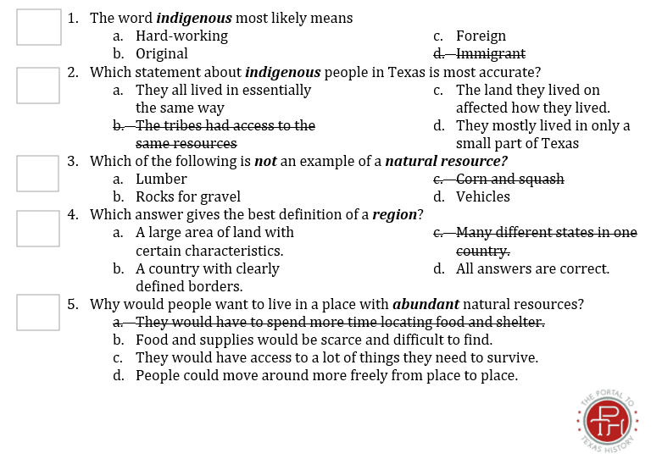  Comprehension questions are multiple choice with one answer choice eliminated.
  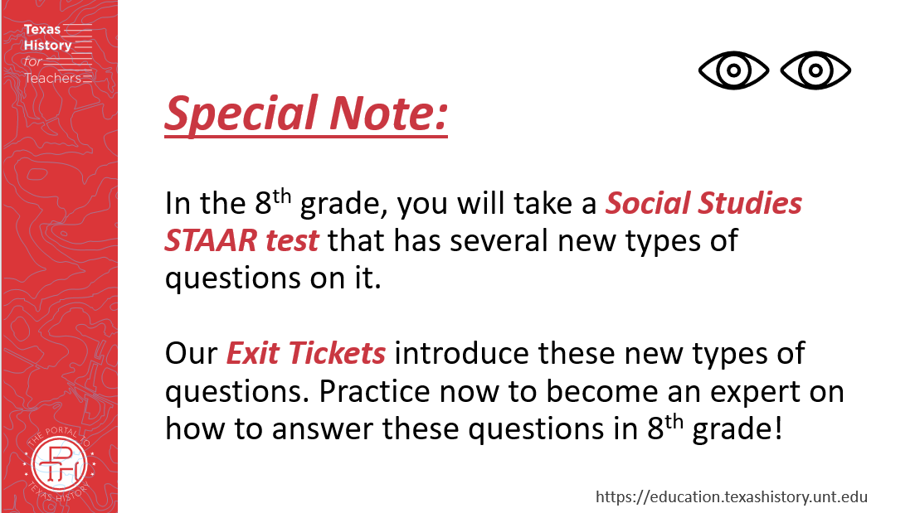  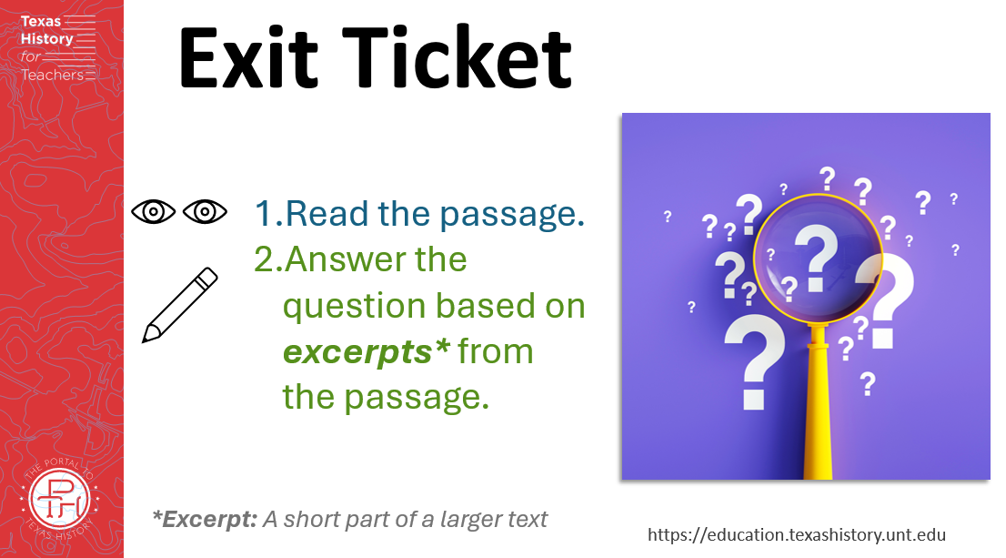 |  | 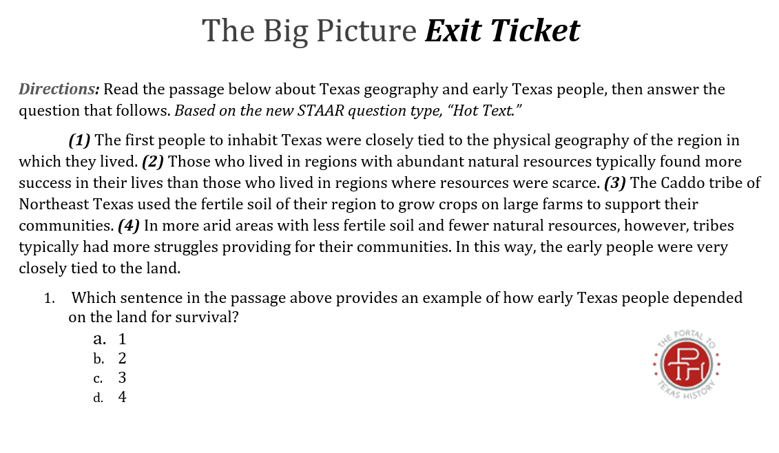  Note: Many exit tickets in the TX4T materials use the new STAAR item type questions to help prepare students for their test in the 8th grade year.  Students read the passage and answer the multiple choice question about different excerpts from the passage.  Share with the class.

