# **The Big Picture *Advanced***

*Unit 1: Natural Texas and Its People*

|  |  |  |  |  |  |
| --- | --- | --- | --- | --- | --- |
| Name: |  | Date: |  | Period: |  |

***Analyze an Image***

Directions: Use the image below to make inferences and predictions about the unit.

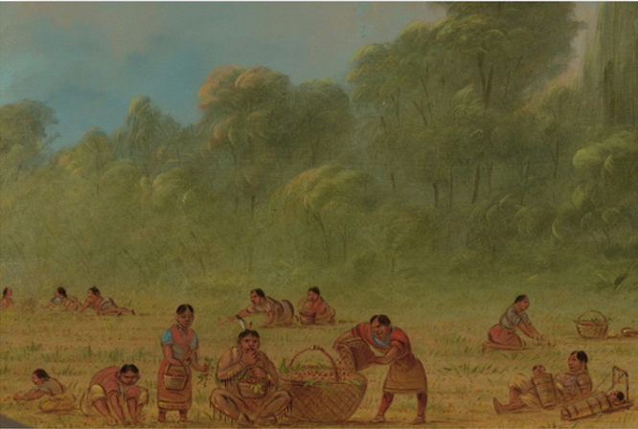

Figure 1: Caddo Indians gathering wild strawberries, George Catlin, National Gallery of Art online

Describe three things you notice in the image.

Based on the image, what are two things you predict we might learn in this unit.

### ***Let’s dig deeper!***

1. Who do you think the people in the image are?
2. What do you think they are doing in this image?
3. What do you think their homes and communities are like?
4. ***Compare and contrast:*** How were their lives probably different from yours today? How might they have been the same?

### ***Essential Ideas: Reading Passage***

***Directions:*** *As you read the passage, write a brief three- to five-word summary of each paragraph in the margin to the right. Answer the questions that follow.*

People have been living in Texas for approximately 12,000 years. Long before there were roads, houses, grocery stores, restaurants, or the internet, there were ***indigenous*** people. What was life like for these early Texas people? Their lives were very closely tied to the land. They depended on the land and its ***natural resources*** like plants and water for necessities like food, shelter, and clothing.

The land that is now the state of Texas contains very diverse geography in each ***region***. If the early people lived in a region with good soil and ***abundant*** resources, they could often create large, thriving communities. On the other hand, if they lived in a region with few resources, they often had more struggles in their daily lives.

In this unit, we will examine the different characteristics of each Texas region. We will evaluate how these differences affected the lives of the early Texas people who lived on this land thousands of years before us.

1. Based on the context, what do you think the term ***indigenous*** most likely means?
2. Which statement about ***indigenous*** people in Texas is most accurate?
   1. They all lived in essentially the same way.
   2. The tribes had access to the same resources.
   3. The land they lived on affected how they lived.
   4. They mostly lived in only a small part of Texas.
3. Give three examples of ***natural resources.***
4. Based on your knowledge and the context of the reading, write a definition of a ***region***.
5. Why would people want to live in a place with ***abundant*** natural resources?
6. According to the passage, what is the main idea of this unit? Write your answer in a complete sentence.