Unit 1: Natural Texas and Its People

Lesson 1: The Big Picture
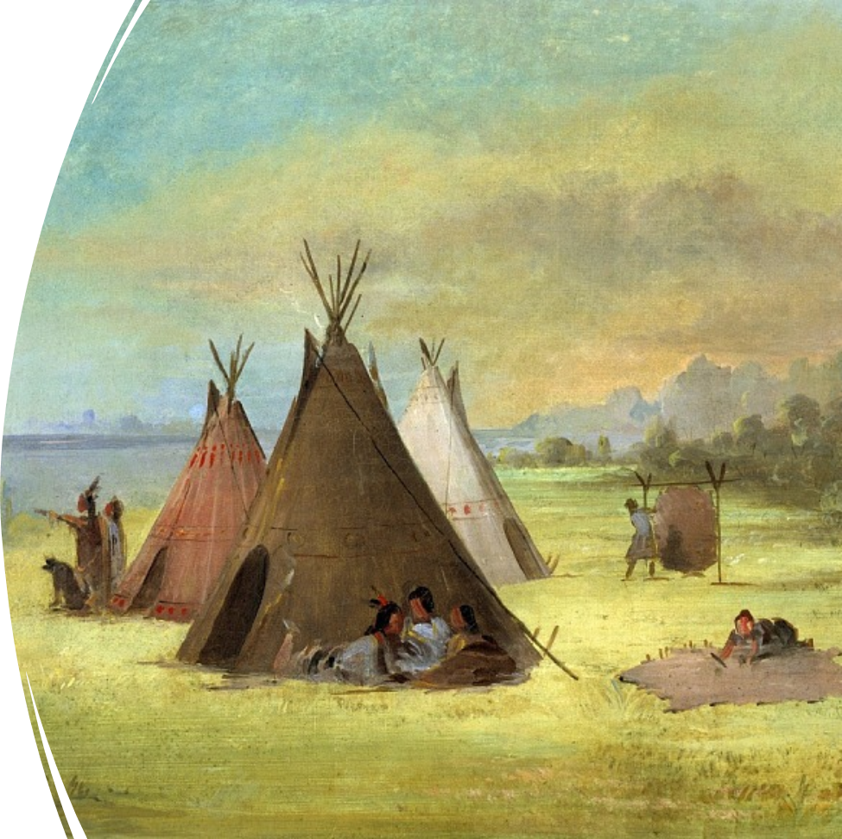

The Big Picture

Warm-up

Warm-up:
Follow the directions below to complete your warm-up
1. Read each scenario under the column titled “What’s the issue?”
2. Think about how you would respond to each situation today and 1000 years ago.
3. Write your answers on your warm-up sheet.
4. While you wait for class to begin, share your responses with a shoulder partner.
5. Do not complete the Exit Ticket yet.

Warm-up:
Share with the class

What’s the issue?
1. You’re hungry! How do you get food for meals or snacks?
Today (blank)
1000 years ago (blank)
Directions: Use the sentence stem example below to share your answer with the class
“When I’m hungry today, I (blank), but 1000 years ago I would have probably (blank).”

Essential Question
What are the major themes of Unit 1: Natural Texas and Its People?

In today’s lesson…
1. We will identify the main idea of this unit by analyzing a primary source and reading a short passage
2. I will make inferences and predictions about an image and summarize the main idea of a short passage

The Big Picture

Lesson

The Big Picture:
What are the major themes of this unit?
Analyze an image:
1. Describe three things you notice in the image
2. Based on the image, what are two things you predict we might learn in this unit?
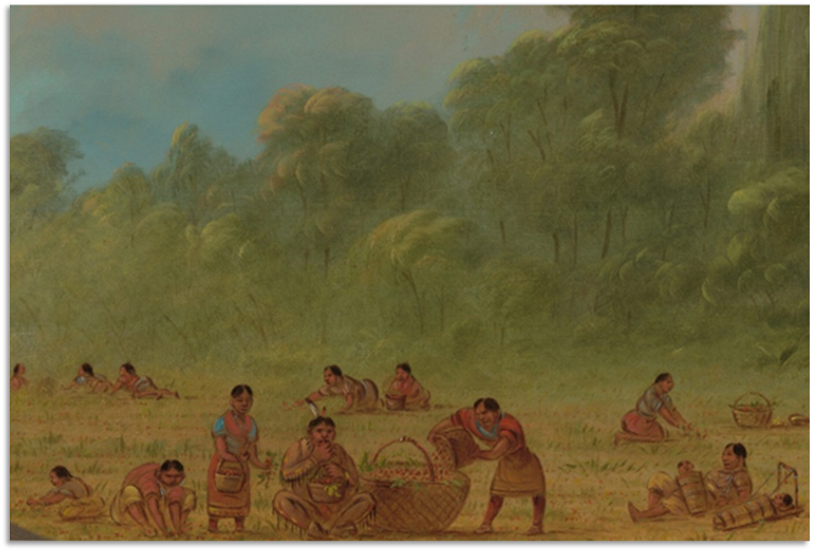

The First People in Texas

Background
The first evidence of human life in Texas dates back to approximately 12,000 years ago. These first people migrated into Texas from the Great Plains, most likely following herds of animals that they depended on for food. As they migrated into Texas, they spread out in search of resources and good places to live.
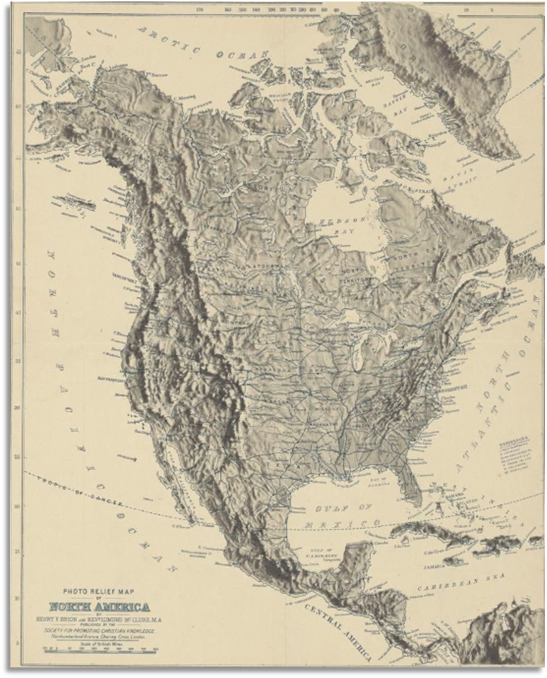

The First People in Texas

Background
It’s important to note that “Texas” as we know it now didn’t exist back then. The land was there, of course, but there were no borders to distinguish it from any other land around. These first people most likely didn’t call it Texas. In fact, the state we know now with its unique borders wouldn’t exist until thousands of years after these first people. In this unit, we will call it Texas because that’s how we understand the location of the land.
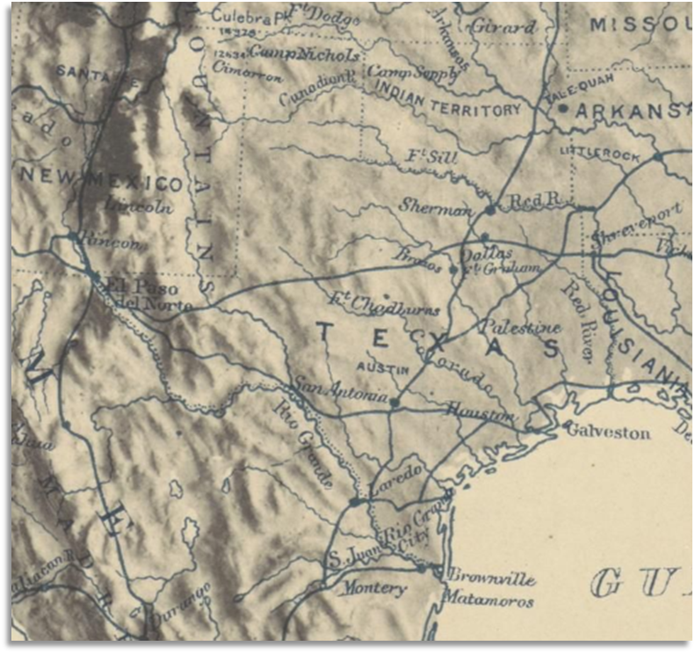

Let’s dig deeper!
Consider all the information you know so far…
The image
The class information
What you already know
Answer questions 1 through 4, making inferences* about the image based on your knowledge.
*Inferences: Educated guesses

Essential Ideas Reading Passage
First Read Through
1. Follow along as your teacher reads the passage.
2. Highlight or draw a star next to information you think is important.
3. Write a Question Mark next to anything you that you have questions about.

Essential Ideas Reading Passage
Second Read Through
1. Follow along as your classmates read the passage.
2. After each paragraph, write a three- to five-word summary of the paragraph in your own words.
3. After all three paragraphs, try to determine what ideas or themes are common in all of them. Discuss with the class.

Essential Ideas Reading Passage
Final Read Through
1. Read through the passage a final time to yourself.
2. Answer the questions that follow using context clues from the passage.
3. Use your short summaries in the margins to write your own summary of the entire passage. Discuss with the class.

The Big Picture

Exit Ticket

Special Note:
In the 8th grade, you will take a Social Studies STAAR test that has several new types of questions on it.
Our Exit Tickets introduce these new types of questions. Practice now to become an expert on how to answer these questions in 8th grade!

Exit Ticket
1. Read the Passage.
2. Answer the question based on the excerpts* from the passage.
*Excerpt: A short part of a larger text

