The Big Picture Foundations

Unit 1: Natural Texas and Its People

Analyze an Image
Directions: Use the image below to make inferences and predictions about the unit.

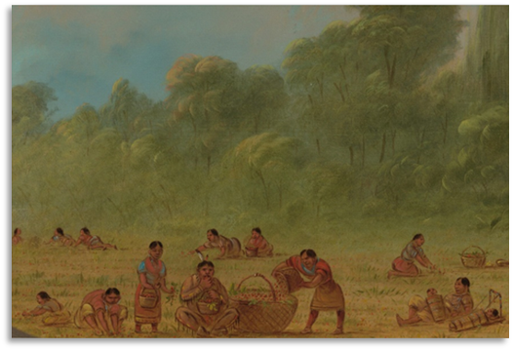
Figure 1: Caddo Indians gathering wild strawberries, George Catlin, National Gallery of Art online
Describe one thing you notice in the image.
(blank)
Based on the image, what is one thing you predict we might learn in this unit?

Let’s dig deeper!
1. Who do you think the people in the image are? Circle or highlight one or more answers.
Modern Texas people
Early people in Texas
Europeans exploring Texas
2. What do you think they are doing in this image?
(blank)

Essential Ideas: Reading Passage
Directions: As you read the passage, write one or two key words that summarize the main idea in the margin to the right. Answer the questions that follow.

People have been living in Texas for approximately 12,000 years. Long before there were roads, houses, grocery stores, restaurants, or the internet, there were indigenous people. What was life like for these early Texas people? Their lives were very closely tied to the land. They depended on the land and its natural resources like plants and water for necessities like food, shelter, and clothing.
The land that is now the state of Texas contains very diverse geography in each region. If the early people lived in a region with good soil and abundant resources, they could often create large, thriving communities. On the other hand, if they lived in a region with few resources, they often had more struggles in their daily lives.
In this unit, we will examine the different characteristics of each Texas region. We will evaluate how these differences affected the lives of the early Texas people who lived on this land thousands of years before us.
1. The word indigenous most likely means

a. Hard-working
b. Original
c. Foreign
THIS CHOICE REMOVED d. Immigrant

2. Which statement about indigenous people in Texas is most accurate?

a. They all lived in essentially the same way
THIS CHOICE REMOVED b. The tribes had access to the same resources
c. The land they lived on affected how they lived.
d. They mostly lived in only a small part of Texas

3. Which of the following is not an example of a natural resource?

a. Lumber
b. Rocks for gravel
THIS CHOICE REMOVED c. Corn and squash
d. Vehicles

4. Which answer gives the best definition of a region?

a. A large area of land with certain characteristics.
b. A country with clearly defined borders.
THIS CHOICE REMOVED c. Many different states in one country.
d. All answers are correct.

5. Why would people want to live in a place with abundant natural resources?
THIS CHOICE REMOVED a. They would have to spend more time locating food and shelter.
b. Food and supplies would be scarce and difficult to find.
c. They would have access to a lot of things they need to survive.
d. People could move around more freely from place to place.

