Unit 1: Natural Texas and Its People

Lesson 3: Vocabulary
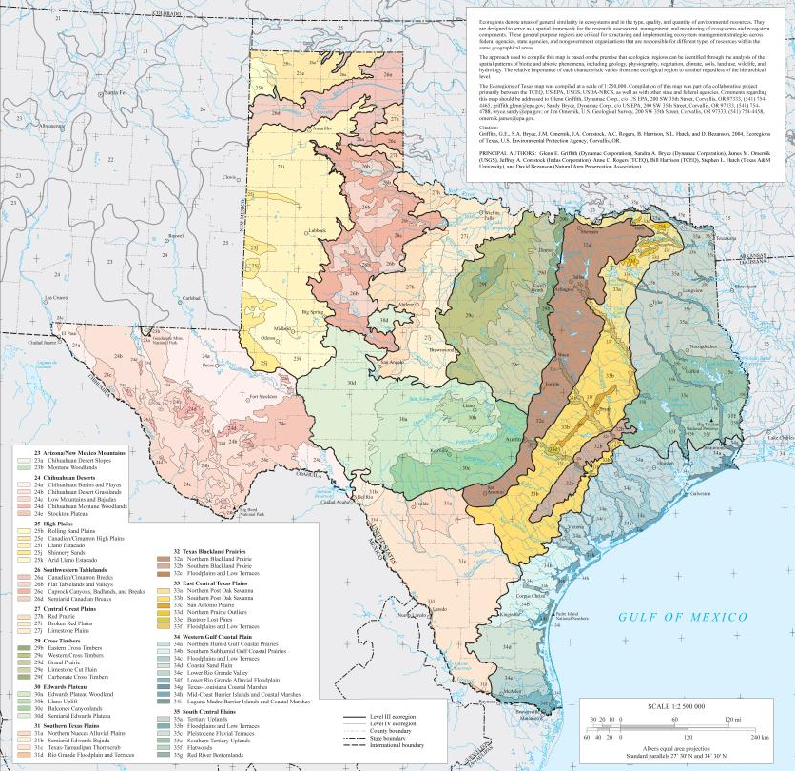

Vocabulary

Warm-up

Warm-up:
Follow the directions below to complete your warm-up
1. Choose a popular slang word or phrase that you and your friends use, but an adult might not know.
2. Define the term, give an antonym, use it in a complete sentence, and draw a visual representation of the term you chose.
3. While you wait for class to begin, share your responses with a shoulder partner.
4. Do not complete the Exit Ticket yet.

Warm-up:
Share with the class
Directions: Use the sentence stem example below to share your answer with the class
“I chose the word / phrase _.”
“It means _.”
“An antonym for the word / phrase is _.”
“The sentence I created is _.”
“The image I drew is _.”

Essential Question
What are the key terms that we need to know to be successful in this unit?

In today’s lesson…
1. We will identify, define, and exemplify key terms for this unit.
2. I will define, give an example, an antonym, and image that represents each term.

Significant (adj.)
History is full of people who do big things, changing the world for better or for worse. Throughout history there are historic events that shape the present and change the future. History is full of these significant things that influence the world in negative and positive ways.
When we discuss the significance of something in history, we are discussing why it’s important. In this unit we will examine the early Texas people and how the environment of Texas played a significant role in their lives.

Indigenous (adj.)
One of the things Texas is best known for is the beautiful bluebonnet flowers that bloom in the spring. These flowers are native to Texas, meaning they are originally from this area.
When plants or animals occur naturally in a certain location, they are native, or indigenous to that place. This is also true for people. The very first people who existed in Texas thousands of years ago are considered indigenous, because they were the original inhabitants of the land. Their descendants* often carry on elements of their traditional indigenous culture today.
*Descendants: People that came from their ancestors
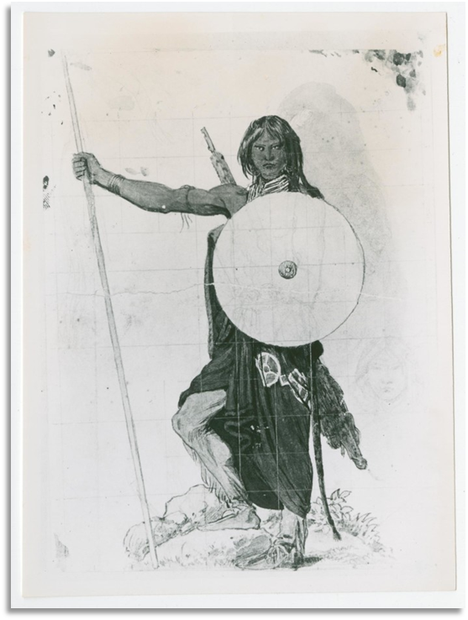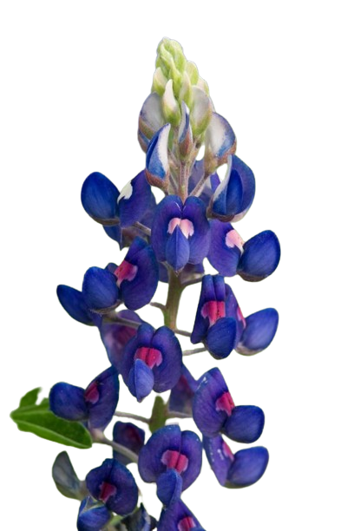

Region (n.)
When we study geography, or the land and its features, we often look for ways to organize land based on its characteristics. One way we organize land is by grouping areas of land with similar features into regions.
There are four primary regions in Texas. These four regions are divided based on the typical geography, climate, environment, and natural resources found in the region.
The Mountains and Basins region in the west, for example, has a hot, arid* climate with mountains and a desert, while the Coastal Plains region in the east has a humid* climate with forests and wetlands.
*Arid: Dry
*Humid: Wet
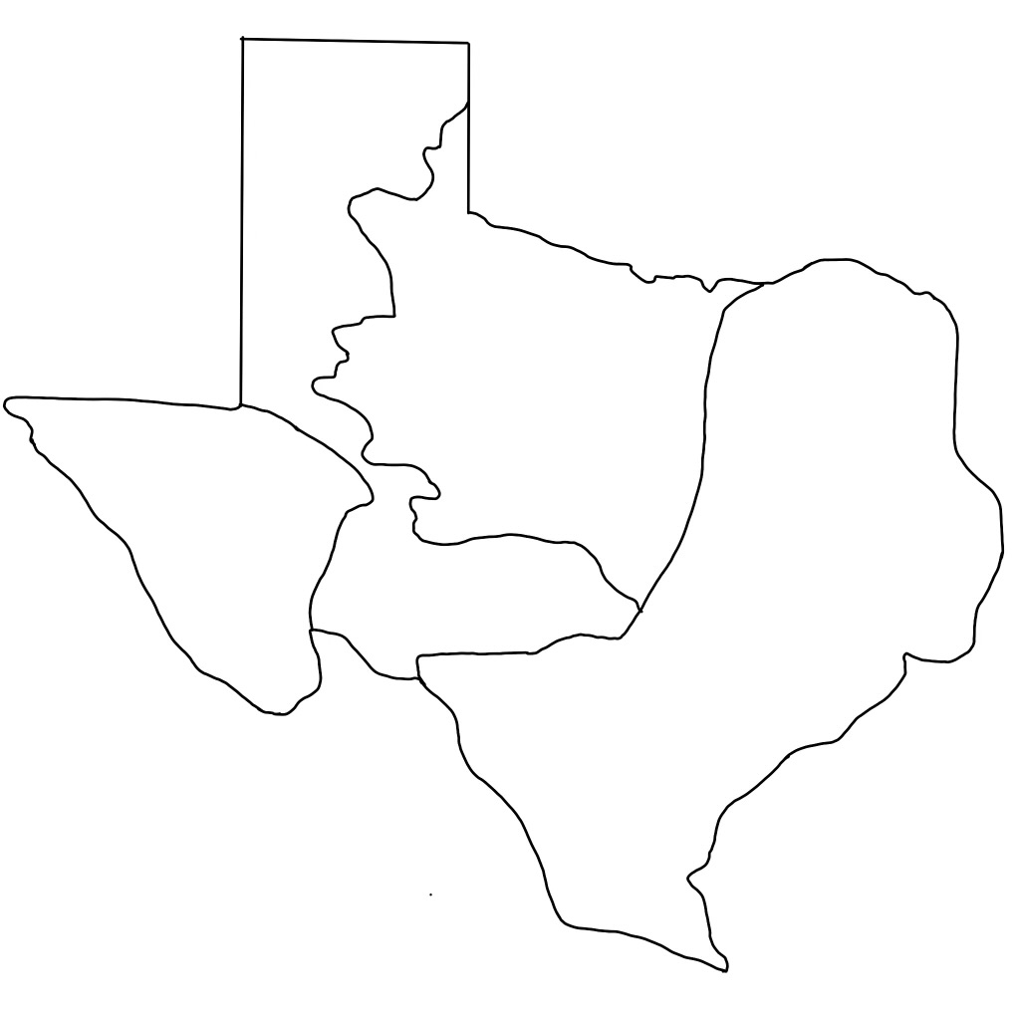
North Central Plains
Coastal Plains
Great Plains
Mountains and Basins
N
S
E
W

Physical Geographic Feature (n.)
Geography is the study of the earth and its features. Geography includes examining how the earth affects and is affected by human activity. This unit focuses on the geography of Texas and how it affected the lives of the Indigenous People who lived in this area thousands of years ago.
In order to successfully study geography, we must be familiar with the physical geographic features of the Texas. Physical geographic features are the natural characteristics of the earth’s surface. The physical geographic features of Texas include diverse* landforms including deserts, mountains, plains, forests, lakes, and marshlands. Texas even boasts the second largest canyon in the United States!
*Diverse: different
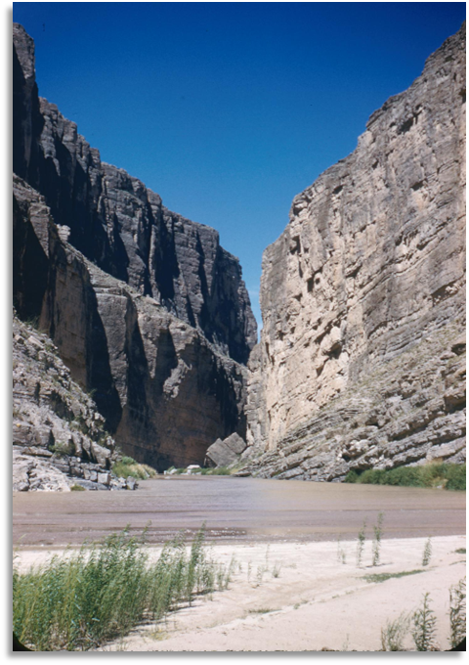
The Rio Grande River between two faces of a canyon

Agriculture (n.)
One way people obtain food and other resources is by taking part in agriculture. Farming crops like vegetables, herbs, cotton, or rice is one way people provide for their needs.
Many early Texas people depended on agriculture to provide for their needs as well. There were no grocery stores or shopping centers to go buy fruits and vegetables a thousand years ago. If early Texas people wanted these items, they had to grow them themselves.
Three common crops often grown by American Indians living in the area that is now Texas were corn, beans, and squash. These three crops grew so well together, early people in Texas often referred to them as “the three sisters.”

Natural Resources (n.)
Natural resources are all around us in our every day lives. Some of you might live in a house made of lumber or bricks. You have probably ridden around in a car powered by gasoline oil. You might eat fruits, vegetables, or meat for your meals. You likely drink water, and if you don’t you really should!
Natural resources are all the items produced by the earth that people use in their lives. Natural resources are also often used for economic* profit.
The early indigenous people living in Texas depended on the land and its natural resources for food, shelter, warmth, clothing, and many more things!
*Economic: related to the economy, or how people make and spend money

Culture (n.)
People do many things to survive. We feed ourselves, drink water, sleep, wear clothes to stay warm, and live in shelters for protection.
Not everything we do is for survival, however. There are plenty of things we do for entertainment, beauty, fashion, or fun, to name a few. We do these things because of our interests, beliefs, and identities. They are part of our culture.
An example of culture in your life might be listening to a certain type of music or watching and playing sports. An example of early Indigenous culture in Texas might be creating beaded jewelry or painting on rocks.
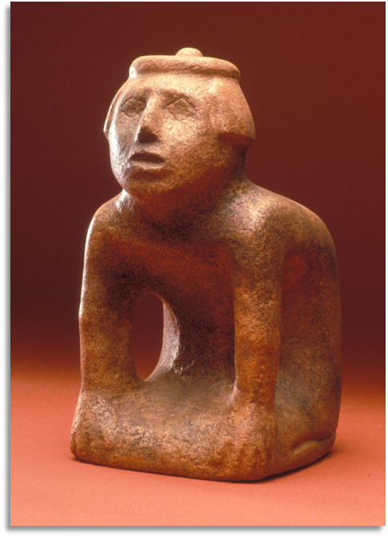
A sculpture created by the Caddo people of East Texas more than approximately 600 years ago.

Nomadic (adj.)
The lives of the early Texas people depended entirely on the land around them. The land they lived on influenced the clothes they wore, the shelters they built, and the food they ate.
Many tribes of American Indians were nomadic, moving frequently from place to place. There are many reasons a tribe would be nomadic. Some regions of Texas don’t have good environments for agriculture. In these cases, nomadic tribes would be hunter-gatherers, hunting animals like deer and bison, or gathering wild berries, nuts, and roots.
Hunter-gatherer tribes like the Comanche of the Great Plains or the Karankawa of the Coastal plains were typically nomadic, moving often to follow their food sources and search for resources.
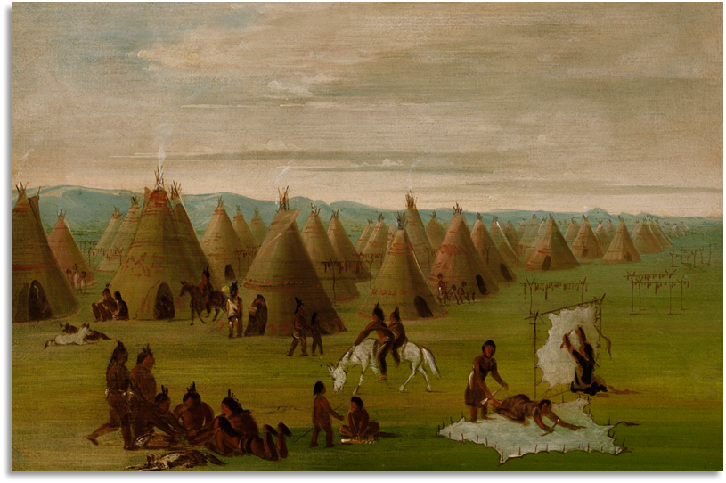
The Comanche people were nomads who didn’t originally live in Texas. They migrated to Texas in the 1700s. They moved frequently across the Great Plains as part of their nomadic lifestyle.

Sedentary (adj.)
Early Texas people depended on the land they lived on to provide for all of their needs. The clothes they wore, the shelters they built, and the food they ate all came from the land and its resources.
In regions of Texas with fertile soil and a good climate, tribes could take part in agriculture, or farming crops. The primary crops many tribes grew were corn, beans, and squash. These three crops grew so well together, they were known as “the three sisters.”
Tribes who took part in agriculture were primarily sedentary, staying in one place, to tend to their farms and cultivate their crops. The Caddo of east Texas lived in large thriving, sedentary agricultural communities.
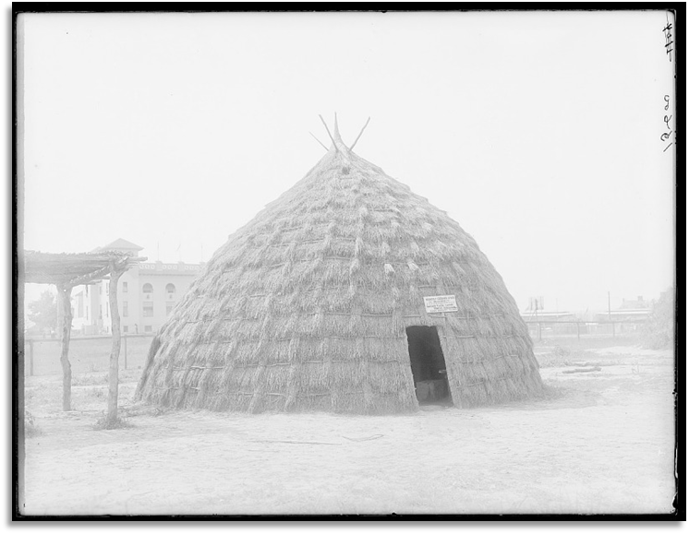
Sedentary tribes like the Caddo often built large permanent houses. Grass huts like these could be 50 feet tall and 60 feet wide. Several families would live inside.

Share with the class
Directions: Choose one term you completed to share with the class.
“(Word / phrase) means _.”
“An example of (word / phrase) from the reading is _.”

Exit Ticket
Directions: Determine which sentence best exemplifies each vocabulary term in the boxes. Write the letter of the sentence in the correct box below the statements.

