Unit 1: Natural Texas and Its People

Extension Lesson

Voices of Texas History
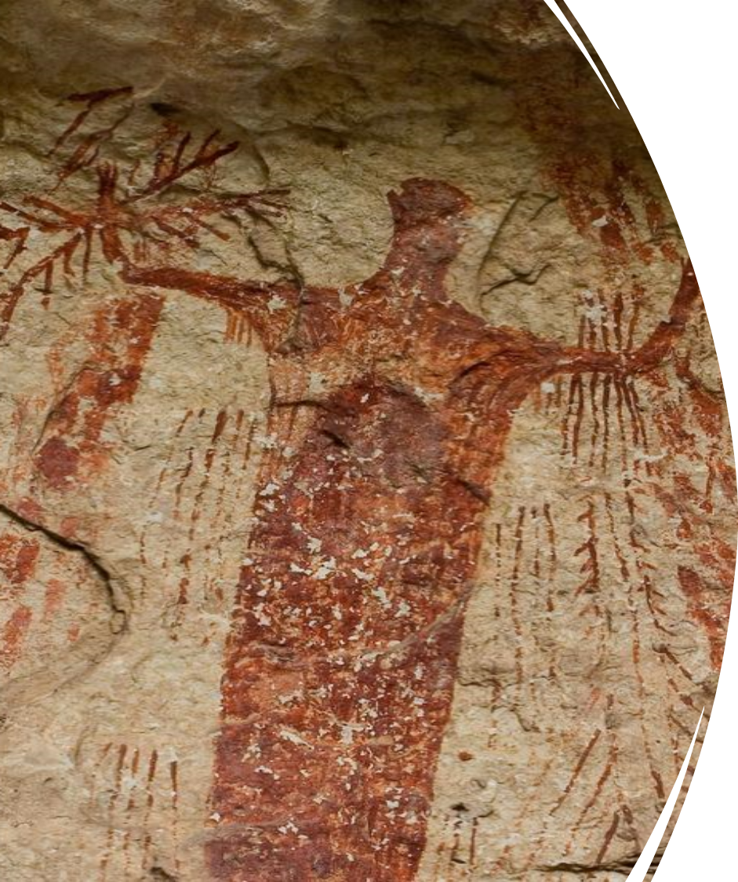

Warm-up
Follow the directions to complete your warm-up
Consider a significant person, place, thing, event, etc. from your life.
Draw an image that represents your significant thing.
Do NOT share with a partner. You’ll see why in the exit ticket.

Essential Question
What is one way early people of Texas told their stories, and how does it help us learn about their lives today?

In today’s lesson…

Day 1
1. We will examine an early American Indian artifact called pictographs.
2. I will read a passage about a specific collection of pictographs in south Texas from thousands of years ago and answer comprehension questions.

Before you read

Consider
1. What do you see?
2. What do you notice?
3. What do you think this is?
4. How do you think it was made?
5. What can you infer about the people who created this?
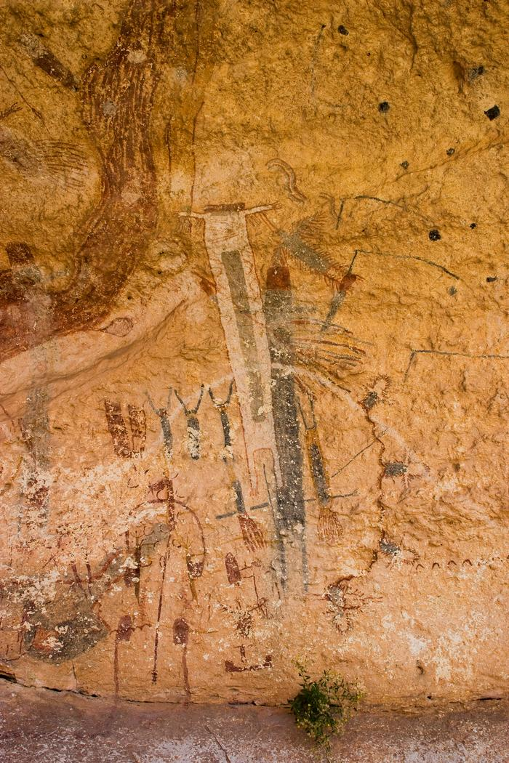

Consider
1. What do you see?
2. What do you notice?
3. What do you think this is?
4. How do you think it was made?
5. What can you infer about the people who created this?
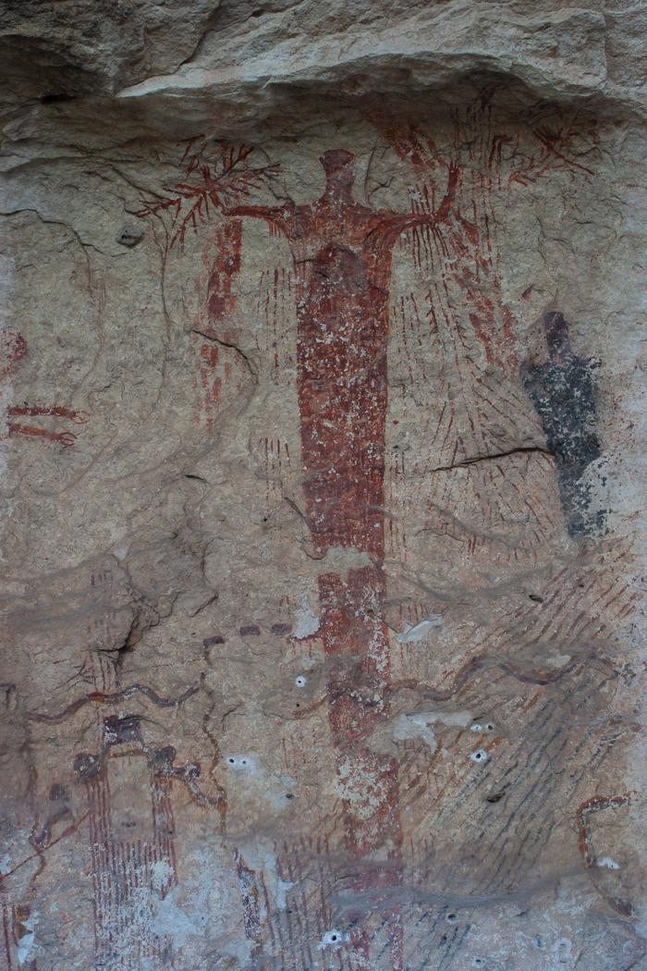

Consider
1. What do you see?
2. What do you notice?
3. What do you think this is?
4. How do you think it was made?
5. What can you infer about the people who created this?
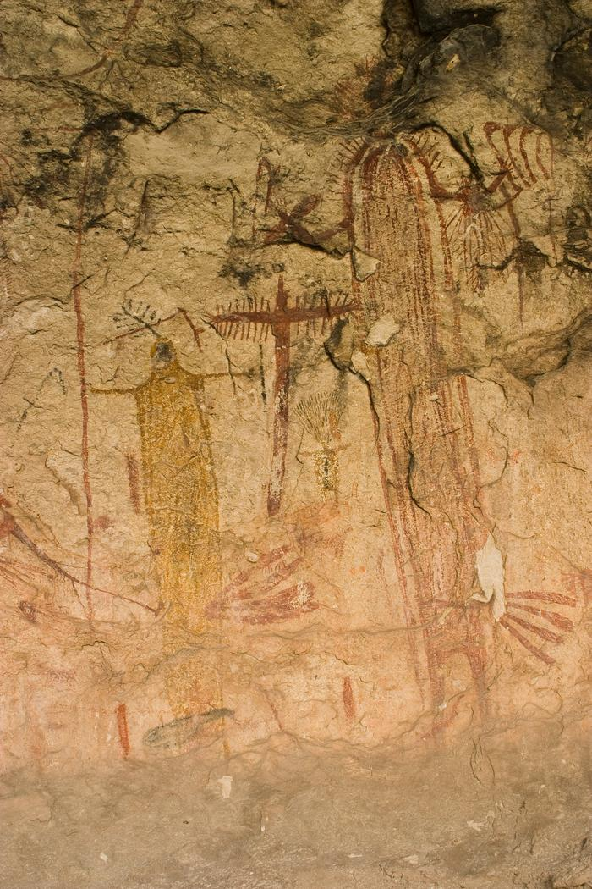

Reading Activity
Exit Ticket
Follow the directions to complete your exit ticket
Choose one of the following options:
1. Look at your own warm-up drawing as though you are someone from the future who has never seen it before. Make inferences about the drawing.
2. Swap your exit ticket with a shoulder partner. Look at their warm-up respectfully. Make inferences about the image.

Share with the class
Note: If you swapped images with a partner, be sure to get their consent before sharing your inferences about their image. Be respectful in what you share.
The image I analyzed might represent (blank)
One inference I made about the image is (blank)

