Voices of Texas History Advanced

Unit 1: Natural Texas and Its People

Part I: Early American Indian Voices in Texas History

One of the difficulties of studying the early people of Texas is that there are no written records from their point of view to help us understand their lives. Often, the best we can do is study the artifacts, or the items and evidence they left behind.
One type of artifact from these earliest Texas people is called a pictograph. Through pictographs, early Texans made paintings on the surfaces of rocks to tell stories and record their histories.
The most famous collection of Indigenous pictographs in Texas is located near the Mountains and Basins region along the modern-day border with Mexico. The artwork is approximately 4,000 years old!
The location of the paintings has come to be known as the White Shaman Rock Shelter. A Shaman was a religious leader who practiced Shamanism, which was a traditional religious practice of tribes in this region.
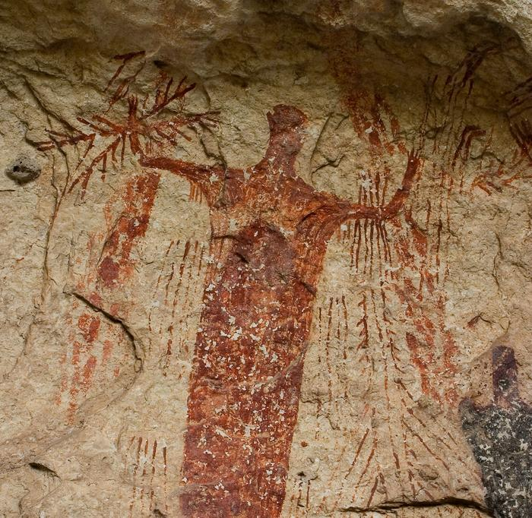
Figure 1 Photograph of American Indian pictographs at the White Shaman Rock Shelter. The Portal to Texas History. The University of North Texas.
Tribes who practiced Shamanism often believed that Shamans were their tribe’s connection to the spirit world. Shamans traditionally carried out rituals in which they took journeys into the spirit world to consult with their ancestors or do other spiritual activities.
Today, we believe that Shamans may have created the rock art to record their spiritual experiences in the spirit world for members of their tribe.
Studying the White Shaman Rock Shelter has its challenges, however. We typically learn the significance of Indigenous rock art from tribal descendants who carry on their tribe’s traditions.
In this case, he people who created these paintings thousands of years ago eventually moved away from the area. Locating their descendants has proved very difficult for us today. Often, the best we can do is make educated inferences based on what other similar tribes have done.

Part II: Evaluate and Analyze – Comprehension Questions
1. Based on the context of the passage, what does the term descendant mean? (blank)
2. Based on the context of the passage, what does the term inference mean? (blank)
3. What artifact of the early Texas people is the subject of this reading passage? Be specific in your explanation. (blank)
4. What is a modern inference about the art at the White Shaman Rock Shelter? (blank)
5. Why is it especially difficult for modern people to learn and understand the significance of the White Shaman Rock paintings? (blank)
6. How do pictographs like the ones at the White Shaman Rock Shelter help tell the story of early people? (blank)

