# **What’s the story? *Grade Level***

*Unit 1: Natural Texas and Its People*

|  |  |  |  |  |  |
| --- | --- | --- | --- | --- | --- |
| Name: |  | Date: |  | Period: |  |

**Part I: Early Texas People in Our Minds Today**

American Indians have been living in Texas for about 12,000 years. Today, hundreds of years after these first people, it can be easy to think of them as one big group that were all basically the same. When we see the maps of where they lived, it can be easy to think that those places were permanent, and those tribes were always in those locations. **This couldn’t be farther from the truth!**

**Just like people today, the early Texas people were incredibly diverse**. They had their own cultures, goals, hopes, dreams, fears, challenges, and successes. They adapted, grew, and changed as they needed to. They teamed up with ***allies*** or fought their enemies. They had their own communities and their own unique beliefs about life and the world around them. Some tribes were more powerful than others.

American Indians in Texas shared information, stories, and their history ***orally*** – or by word of mouth. They didn’t write down their stories. **In fact, for much of history, they didn’t have a written language at all; everything was spoken.** This makes it difficult for us to know their full story from their point of view. A lot of what we believe to be true we have learned from the Europeans who arrived in Texas in the 1500s. Their arrival will bring enormous changes to the region.

|  |  |
| --- | --- |
| **T / F** | 1. American Indians had distinct cultures, lives, and beliefs |
| **T / F** | 1. The maps of tribes in Texas show the permanent, unchanging habitations for each tribe. |
| **T / F** | 1. We have learned a lot from each tribe’s own written history accounts. |
| **T / F** | 1. So much happened before Europeans ever arrived in the Americas. |

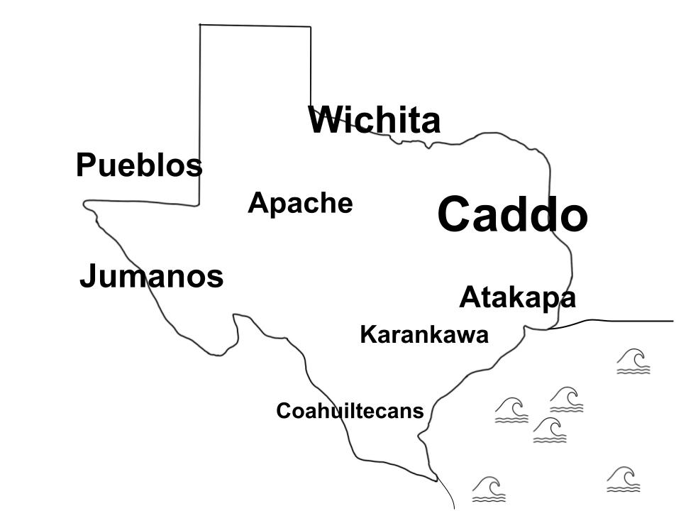**Part II: American Indians Before the Spanish Arrive**

Now, let’s fast-forward about 11,500 years, to the beginning of the 1500s, before the arrival of the first Europeans. There were many tribes spread across Texas by this time.

The **Caddo** were a large, powerful ***confederation*** of tribes who excelled in agriculture and formed trade relations and alliances with other tribes. They lived in large, well-organized communities in the most fertile and richest part of Texas: the northeast Coastal Plains and beyond into present-day Louisiana and Arkansas.

South of the Caddo, in another rich part of the Coastal Plains the **Atakapa** successfully farmed, hunted, and gathered resources. Farther south, the **Karankawa** lived in smaller groups that weren’t as organized around agriculture as the Caddo. It’s hard to farm in swampland! Farther south still, the **Coahuiltecans** lived on the most difficult part of the Coastal Plains, and regularly struggled with a lack of resources.

To the west, The **Puebloan** cultures of the Mountains and Basins had formed trade relationships with Indian tribes in modern-day New Mexico. They hunted and took part in agriculture, even in this arid region!

The **Wichita** was large group of tribes that lived in modern-day Oklahoma and North Central Texas. They lived in a similar manner to the Caddo, taking part in agriculture in their large communities.

Very few people lived on the Great Plains of Texas. Around this time, however, a tribe known as the **Apache** began making their way south onto the Texas plains. They typically lived in small bands or groups. Food and resources were scarce. The difficult environment of the Great Plains made life challenging and harsh for the Apache, who really struggled on the Texas Plains – at first.

Finally, a lot of maps of Texas Indians show the **Comanche** dominating the Great Plains of Texas. This will eventually be true, but . . . (are you sitting down for this?). . . in 1500, the Comanche didn’t even exist yet!!

Even though Texas was home to many groups of Indigenous people, most American Indians lived in other places, like present-day Mexico and South America.

**Part III: Comprehension and Analysis**



1. Based on the map to the left, which tribe appears to be the most powerful? The least? Explain your reasoning.
2. Use evidence from the passage on the previous page to support your answer in number one.
3. Which region of Texas was LEAST inhabited? Why is that, according to the passage?
   1. The Mountains and Basins; the altitude of the mountains was too high for habitation.
   2. The Coastal Plains; The region flooded too often for successful habitation.
   3. The Great Plains; There were so few resources, habitation was difficult.
   4. The North Central Plains; The climate was too harsh for habitation.
4. Why do you think some of the writing on the map extends past the modern borders of Texas?
   1. Because tribes wanted to live in more than one state to have access to more resources.
   2. Because the borders of Texas that we know today didn’t exist at that time.
   3. Because more aggressive tribes pushed less powerful tribes out of the state.
   4. All answers are correct.