Unit 1: Natural Texas and Its People

Lesson 6: What’s the story?
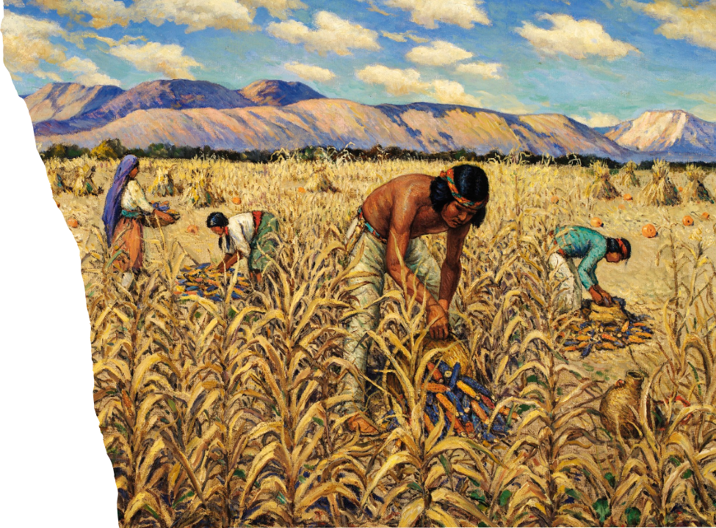

What’s the Story?

Warm-up

Warm-up:
Follow the directions below to complete your warm-up
Timeline
14,000 BCE: the first people arrived in Texas.
3,000 BCE: the first farms began, and people could access more food.
700 CE: the first bows and arrows were developed for hunting.
800 CE: the Caddo cultures developed and grew.
1400 CE: the Apache arrive on the Great Plains.
1528 CE: the Karankawa encounter the first Europeans.
Observe the information on the timeline. Write your responses to the questions on your warm-up.
Discuss your response with a partner as you wait to share with the class.

Warm-up:

Share with the class
Directions: Use the sentence stems below to share your answer with the class
“One comment I have about this timeline is _.”
“One question I have about this timeline is _.”

Essential Question
What were the dynamics* between various tribes of Texas in the 1500s, prior to the arrival of the Spanish?
*Dynamics: The patterns of behavior and interactions between people

In today’s lesson…
1. We will examine the dynamics of the different tribes in Texas at the beginning of the 1500s, or the 16th century.
2. I will make and support claims about the various tribes of Texas based on my reading passage.

What’s the story?

Lesson

Part 1: Early Texas People in Our Minds Today
Before we read:
True or False
Early American Indians were all basically the same, and they had nothing in common with us today.
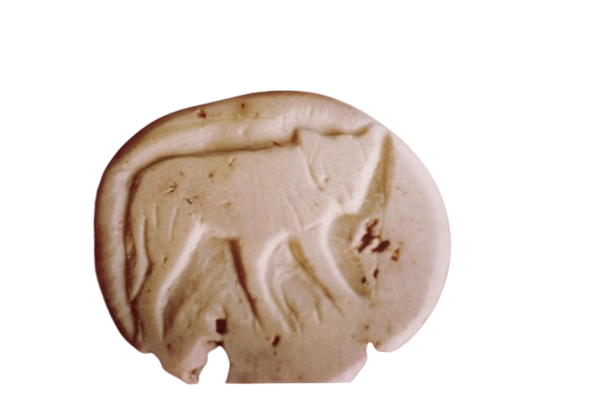
A stone carved with the image of a small canine
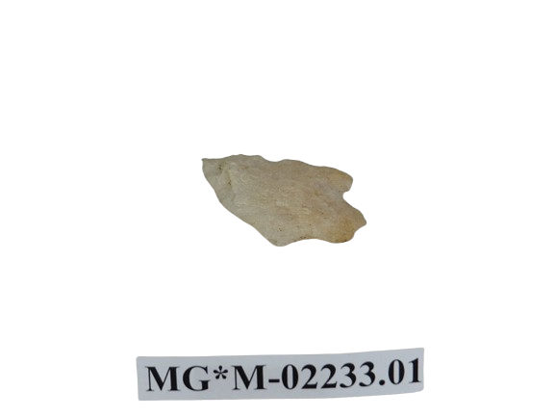
An arrowhead carved from stone

Part 1: Early Texas People in Our Minds Today
After we read:
Highlight the sentences or phrases from the reading that support your answers on the worksheet.
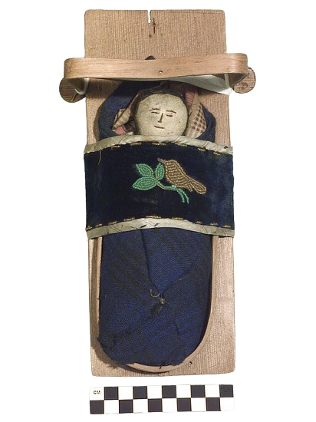
An American Indian child’s toy baby doll with cradleboard.

Part 2: American Indians Before the Spanish Arrive
Before we read:
Make a prediction:
Of all the tribes visible on the map, which do you think was the most powerful in the 1500s? Why?
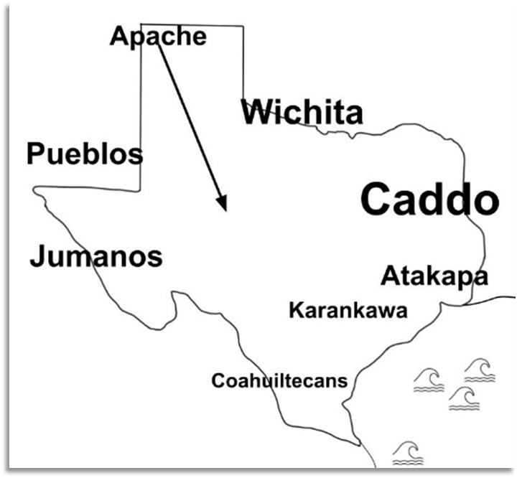
Tribes in Texas in the early 1500s

Comprehension Questions
1. Use the map on your worksheet and the reading on the previous page to answer the questions that follow.
2. Highlight or circle where you find the information in the passage.
3. After you highlight the information, write the number for the question it answers.
4. Discuss with a partner.

What’s the Story?

Exit Ticket

Exit Ticket:
Follow the directions below to complete your warm-up
The lesson today told us about the many American Indian tribes that lived in Texas for thousands of years before anyone else arrived. It mentioned that in the 1500s, people from Europe begin entering and exploring Texas. How do you think the arrival of the Europeans might affect the lives of American Indians in Texas?
Write your answer.
Discuss your response with a partner.

Exit Ticket:
Share with the class
Directions: Use the sentence stem below to share your answer with the class
“I think the arrival of the Spanish might affect the lives of American Indians in Texas by _.”

