 Warm-up: What’s the story?
Unit 1: Natural Texas and Its People
Name: |  | Date: |  | Period:

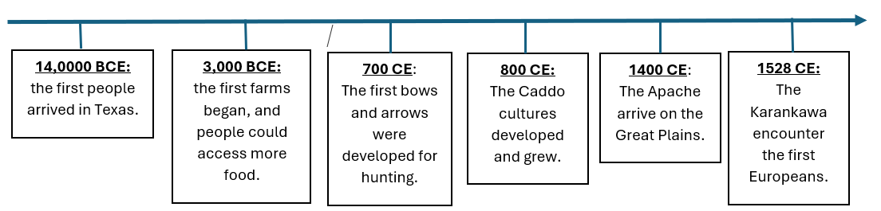
What is one comment you have about American Indians in Texas, based on this timeline? | What is one question you have about American Indians in Texas based on this timeline?

Warm-up: What’s the story?
Unit 1: Natural Texas and Its People
Name: |  | Date: |  | Period:

What is one comment you have about American Indians in Texas, based on this timeline? | What is one question you have about American Indians in Texas based on this timeline?


What’s the Story? Exit Ticket

The lesson today told us about the many American Indian tribes that lived in Texas for thousands of years before anyone else arrived. It mentioned that in the 1500s, people from Europe begin entering and exploring Texas. How do you think the arrival of the Spanish might affect the lives of American Indians in Texas?

What’s the Story? Exit Ticket

The lesson today told us about the many American Indian tribes that lived in Texas for thousands of years before anyone else arrived. It mentioned that in the 1500s, people from Europe begin entering and exploring Texas. How do you think the arrival of the Spanish might affect the lives of American Indians in Texas?

