| **Name:** | **Date:** | **Class/Period:** |
| --- | --- | --- |

Reconstruction: The Challenges of Reunification

## Hook Exercise – The “Strong” government 1869-1877

**Activity A**:

The word Reconstruction can be broken into parts. “Re” as a prefix means “again”, while “construction” means to build or create. Reflect on what you’ve learned about the effects of the Civil War on the nation to consider the goal of the period known as Reconstruction. The illustration below was drawn by J.A. Wales for Puck magazine.

Answer the following question “What aspects of America do you think will need to be reconstructed?” Compare your response with a partner.

**Activity B**:

Analyze the image to determine the main idea or meaning of the cartoon. Answer the question below.

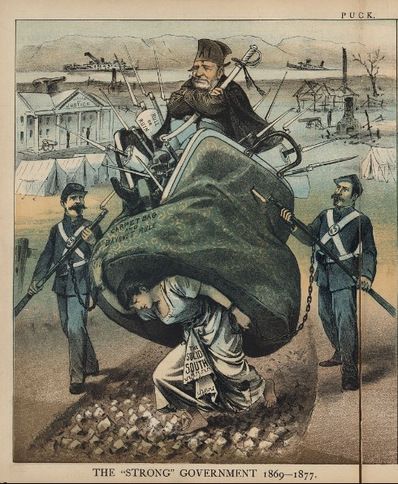

Wales, J. A. (1880) The "Strong" government -1877--The "weak" government 1877 to 1881 / J.A. Wales. United

States, 1880. [Photograph] Retrieved from the Library of Congress, https://www.loc.gov/item/93505647/.

**Image Analysis Question**:

What inference can you make about the role the Union play in Reconstructing the South? What evidence can be found in the image that illustrates the aspects of the South that need to be reconstructed?

***Analysis Questions***

1. What actions, individuals, or events do you observe in the image?

1. What is the central theme of the image?
2. How does the left side differ from the right side? What does this symbolize?
3. Write a two-sentence summary explaining the main them of the image.