Name: | Date: | Class/Period:
Reconstruction: The Civil War Ends and Reconstruction Begins

Primary Source Analysis: General Gordon Granger’s General Order No. 3
Instructions: With a partner, examine the primary source excerpts below and answer the questions that follow.
Read General Gordon Granger’s General Order No. 3
“The people of Texas are informed that, in accordance with a proclamation from the Executive of the United States, all slaves are free. This involves an absolute equality of personal rights and rights of property between former masters and slaves, and the connection heretofore existing between them becomes that between employer and hired labor. The freedmen are advised to remain quietly at their present homes and work for wages. They are informed that they will not be allowed to collect at military posts and that they will not be supported in idleness either there or elsewhere.”

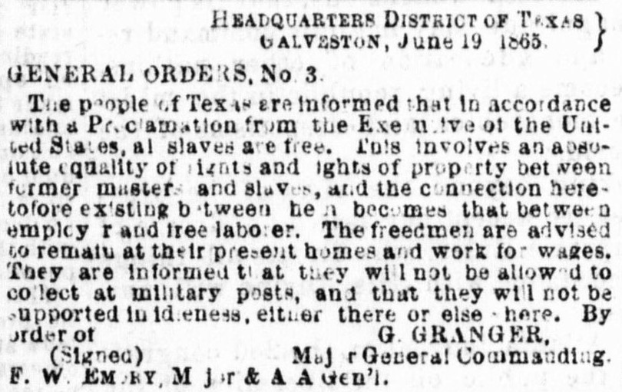
Cushing, E. H. The Houston Tri-Weekly Telegraph (Houston, Tex.), Vol. 31, No. 38, Ed. 1 Wednesday, June 21, 1865,
newspaper, June 21, 1865; Houston, Texas. (https://texashistory.unt.edu/ark:/67531/metapth235158/m1/4/?q=general%20granger: accessed April 25, 2022), University of North Texas Libraries, The Portal to Texas History, https://texashistory.unt.edu; crediting The Dolph Briscoe Center for American History.
Analysis Questions
- What was the purpose of this speech?

- What was General Granger’s overall tone in this speech?

- Based on this excerpt, what does General Granger recommend to the newly freed people?

- What can you infer about Granger’s warning to the freedmen about “idleness”?

