Name: | Date: | Class/Period:
Reconstruction: The Civil War Ends
and Reconstruction Begins

Hook Exercise - Emancipation
Instructions: With a partner, examine the image closely. This is a drawing from Harper’s Weekly created by Thomas Nast to illustrate the “Past and Future” of Emancipation. Jot down a list of major observances in the image. Next answer the questions about the image.
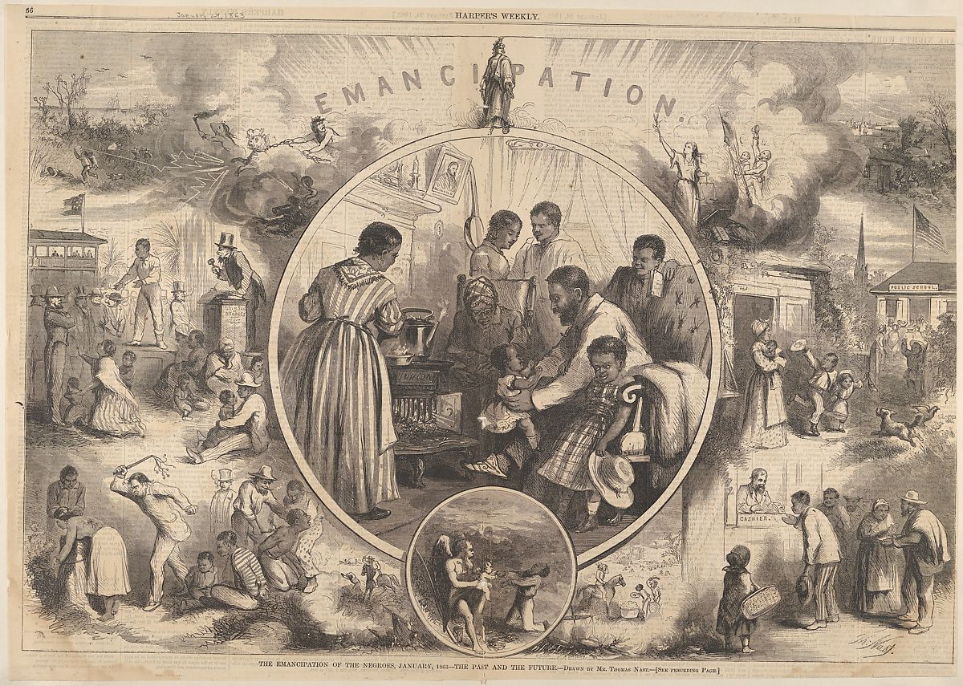
Harper’s Weekly. “Emancipation,’ Volume 4, January 24, 1863. The Met Collections. Accessed April 25, 2022. https://www.metmuseum.org/art/collection/search/429270

Analysis Questions
- What actions, individuals, or events do you observe in the image?

- What is the central theme of the image?

- How does the left side differ from the right side? What does this symbolize?

- Write a two-sentence summary explaining the main theme of the image.

