Name: | Date: | Class/Period:
The Impacts and Effects of Reconstruction in Texas

Primary Source Analysis – Two Schools: a Visual Analysis
Before the Civil War, many Southern states imposed laws that prohibited teaching enslaved people to read, write, and do arithmetic. In some cases, slave owners taught skilled laborers specific skills to assist with their daily tasks, but formal schooling for African Americans was not an opportunity before 1865.
Following Emancipation, with the assistance of the Freedmen’s Bureau, education was promoted and more widely available for newly freed people across the south.
Directions: Analyze and annotate the two images below. Highlight and discuss key similarities and differences in the images.
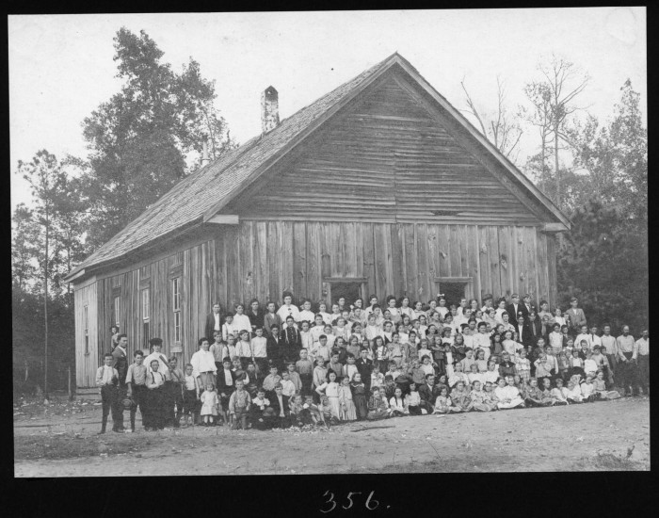
American Lumberman [White School Building], photograph, 1907;
(https://texashistory.unt.edu/ark:/67531/metapth204413/: accessed March 22, 20222), University of
North Texas Libraries, The Portal to Texas History, crediting The History Center.
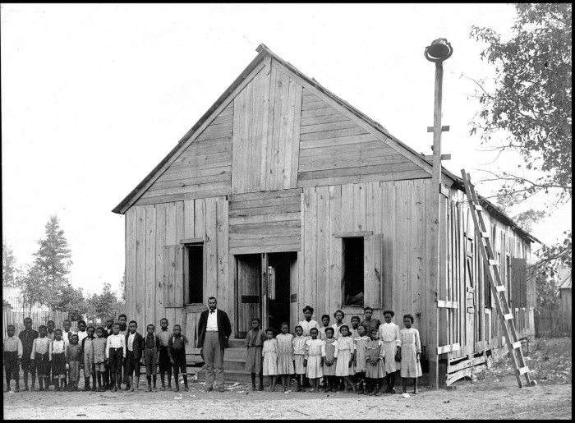
American Lumberman. [African American School House], photograph, 1907;
(https://texashistory.unt.edu/ark:/67531/metapth204411/: accessed March 22, 2022), University of
North Texas Libraries, The Portal to Texas History, https://texashistory.unt.edu; crediting The History
Center.

Visual Analysis Questions
- Based on the images, what are some main observances?

- What can you infer about the role of education during this period?

- Drawing conclusions: What can you conclude about the social relations of Texans during this time, based on the image?

