
Warm-up: Looking Ahead
Unit 9: Reconstruction
Name: |  | Date: |  | Period:

What do you observe about the image? What do you predict we will see in the next unit based on this image? | 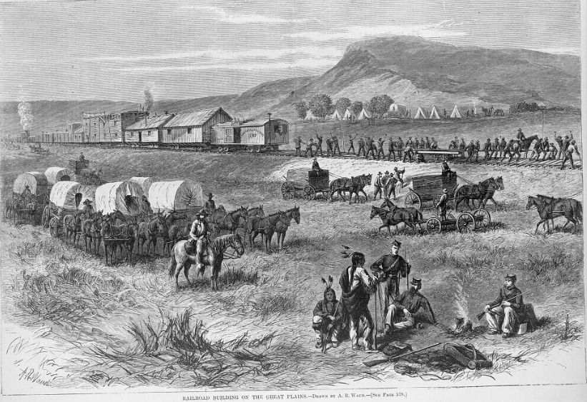  Figure 1: Railroad building on the great plains, 1875. Library of Congress.

Warm-up: Looking Ahead
Unit 9: Reconstruction
Name: |  | Date: |  | Period:

What do you observe about the image? What do you predict we will see in the next unit based on this image? | Figure 1: Railroad building on the great plains, 1875. Library of Congress.

Looking Ahead Exit Ticket

Directions: Circle or highlight THREE statements that relate to the major themes and topics we will see in the next unit.
Challenges related to cotton farming in Texas | The decrease in the farming and ranching industries | Social changes including activism for male suffrage
Economic growth due to the construction of railroads | Congressional control of Southern governments | Conflicts related to Anglo migration into the Indian frontier.

Looking Ahead Exit Ticket

Directions: Circle or highlight THREE statements that relate to the major themes and topics we will see in the next unit.
Challenges related to cotton farming in Texas | The decrease in the farming and ranching industries | Social changes including activism for male suffrage
Economic growth due to the construction of railroads | Congressional control of Southern governments | Conflicts related to Anglo migration into the Indian frontier.

