 Warm-up: Mind Map Review
Unit 9: Reconstruction
Name: |  | Date: |  | Period:

Look at the word bank below. Complete the mind map diagram by putting each term where you think it fits best.

- Congressional  - Reconstruction  - Strict  - Presidential  - Lenient | 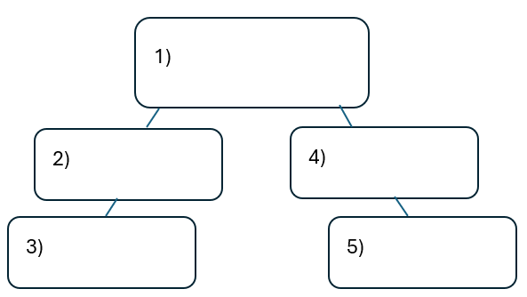

Warm-up: Mind Map Review
Unit 9: Reconstruction
Name: |  | Date: |  | Period:

Look at the word bank below. Complete the mind map diagram by putting each term where you think it fits best.

- Congressional
- Reconstruction
- Strict
- Presidential
- Lenient


Exit Ticket: Mind Map Review
Unit 9: Reconstruction
Name: |  | Date: |  | Period:

Directions: Complete the sentence by choosing the best answer for each blank from the chart below.
The (1) ____________ era is primarily characterized by (2)____________

Answer choices for blank (1)  Circle the best answer | Answer choices for blank (2)  Circle the best answer
- Reconstruction  - Congressional Reconstruction  - Redeemer Reconstruction  - Presidential Reconstruction | - The Southern states’ work to reestablish their slave-based plantation agriculture economies.  - The United States’ Congress’s policies to punish the Southern states for their rebellion in the Civil War.  - The ex-Confederates’ attempts to regain power and restrict the rights of the Freedmen.  - The U.S. government’s different policies for rebuilding the South and reuniting the country after the Civil War.

Exit Ticket: Mind Map Review
Unit 9: Reconstruction
Name: |  | Date: |  | Period:

Directions: Complete the sentence by choosing the best answer for each blank from the chart below.
The (1) ____________ era is primarily characterized by (2)____________

Answer choices for blank (1)  Circle the best answer | Answer choices for blank (2)  Circle the best answer
- Reconstruction  - Congressional Reconstruction  - Redeemer Reconstruction  - Presidential Reconstruction | - The Southern states’ work to reestablish their slave-based plantation agriculture economies.  - The United States’ Congress’s policies to punish the Southern states for their rebellion in the Civil War.  - The ex-Confederates’ attempts to regain power and restrict the rights of the Freedmen.  - The U.S. government’s different policies for rebuilding the South and reuniting the country after the Civil War.

