Study Guide Advanced
Unit 9: Reconstruction

Name: |  | Date: |  | Period:

Part I: Significant Terms
Directions: Write the term from the word-bank below in the numbered box next to the best definition or description in the chart below.
Presidential Reconstruction | Congressional Reconstruction | Redeemer Reconstruction
13th Amendment | 14th Amendment | 15th Amendment
Reconstruction Acts | Vagrancy Laws | Black Codes
Freedmen’s Bureau | Constitution of 1876 | Impeachment

1. | A series of laws passed by Congress that required Southern states to write new constitutions, end the Black Codes, ratify the 13th and 14th Amendments, and submit to federal control of state governments under martial law.
2. | A period of Reconstruction during which the ex-Confederates worked to return to power in each Southern state in order to undo policies put in place during federal control of Reconstruction. Texas ex-Confederates decentralized the government and returned power to local governments.
3. | This document established a new government for the state of Texas, undoing many of the policies that had been put in place under Congressional Reconstruction, decentralizing government power and returning much political power into the hands of local governments.
4. | This addition to the U.S. Constitution granted citizenship to all people born in the United States, thereby making all formerly enslaved people full citizens of the U.S.
5. | An action taken by the legislature to vote to officially remove a government official from office due to misconduct or illegal activity.
6. | The period of Reconstruction during which Andrew Johnson implemented lenient requirements for the Southern states to rejoin the Union. Ex-Confederates were pardoned, and control in each Southern state was essentially returned to the ex-Confederates who had rebelled against the U.S. during the Civil War.
7. | An addition to the U.S. Constitution that abolished slavery and prohibited forced servitude, except in the case of people who have been convicted of a crime.
8. | An addition to the U.S. Constitution which prohibited preventing people from voting based on race, thereby enfranchising newly freed Black men across the country.
9. | A series of laws passed by ex-Confederate-run state governments which restricted the rights of Black citizens by denying Black people the right to vote, serve on juries, marry white people, or attend public schools. These laws were overturned under Congressional Reconstruction.
10. | The period of Reconstruction during which the United States Congress passed stricter requirements for Southern states and ex-Confederates, including requiring ex-Confederates to swear a loyalty oath, disfranchising high-ranking ex-Confederates, requiring Southern states to end the Black Codes and ratify the 13th and 14th Amendments, and placing the South under martial law.
11. | A series of laws passed by Southern states like Texas in order to restrict the actions of Black Southerners and attempt to control Black labor by placing strict rules on labor, punishing people without permanent homes, and allowing the state to force people to work to pay off any fines accrued from being charged with breaking the Vagrancy Laws.
12. | A federal organization established at the end of the Civil War to provide services and support to the formerly enslaved people. Services included medical services, legal support, education, family reunification, and protection.

Part II: Cause and Effect Matching
The left column contains significant events of the Reconstruction era. The right column provides the effect of each event. Match each cause on the left with its correct effect on the right

- Presidential Reconstruction under Andrew Johnson was considered by many in the U.S. Congress to be too lenient on Southern states and ex-Confederates.
- The U.S. Congress passed stricter Reconstruction policies on Southern states, requiring them to create new constitutions, ratify the Reconstruction amendments, and placing all political power in the hands of the military-run state government.
- Before the Civil War ended in1865, Black people in the United States were not considered citizens and did not have the right to vote in elections.
- Under Congressional Reconstruction, Black participation in society, education, business, and politics increased in Southern states like Texas under the protection of the U.S. Army during martial law.
- The ex-Confederates regained political control and power in the state governments by the mid-1870s.

- As a result, Southern states were run by the federally appointed leaders, with all political power concentrated at the state level, and Black Southerners were able to participate more freely in society and politics.
- As a result, the power of state governments was decentralized and returned to local governments, with less state oversight and less protection of the rights of Black Southerners in the state.
- As a result, the U.S. Congress impeached President Johnson and took control of Reconstruction so they could institute stricter policies and requirements on the South.
- As a result, Many Black Southerners were able to successfully participate in Southern society, however some Southerners opposed this and carried out threats and violence against Black Southerners and their allies through terrorist organizations like the Ku Klux Klan.
- As a result, after the Civil War the U.S. Congress passed three new amendments to the U.S. Constitution which abolished slavery (13th) granted citizenship to the Freedmen (14th) and protecting the right of Black men to vote (15th)

Part III: Practice Test Questions
Answer the following practice test questions about Reconstruction. Questions are based on the 8th grade Social Studies STAAR question types.

- Observe the image, then choose the answer that best describes or explains the significance of the image to the Reconstruction Era.

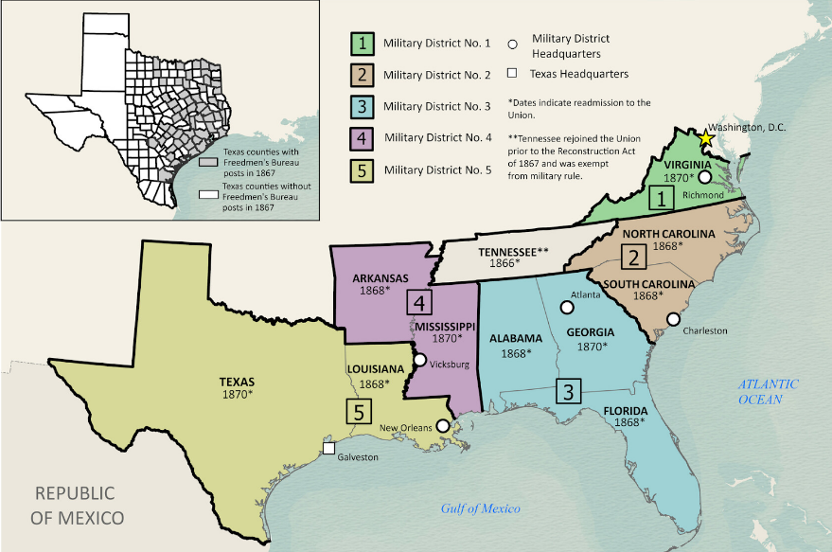

  - During the period of Congressional Reconstruction, Unionists and Northern Republicans in Congress passed stricter requirements on the South including establishing martial law over the Southern states.
  - During the period of Redeemer Reconstruction, ex-Confederates in Southern states worked to gain control over state governments to establish new Confederate districts in an attempt to restart the Civil War with the Union.
  - During the period of Presidential Reconstruction, President Andrew Johnson passed lenient policies on the South, including dividing the South into new Congressional districts under the direction of elected ex-Confederate leaders.
  - During Reconstruction, the Southern states were allowed to freely organize their governments into new Confederate districts in order to rejoin the Union.

- Observe the diagram below, then answer the question that follows.
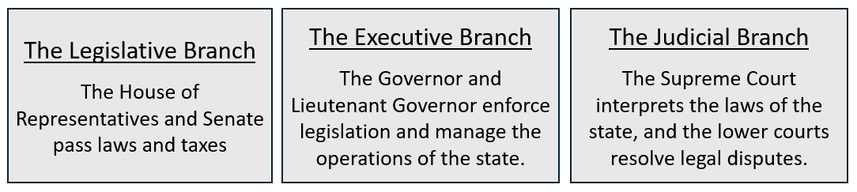
Which two principles of the government are represented by the information presented in this diagram? Choose TWO correct responses.
  - Federalism
  - Republicanism
  - Separation of Powers
  - Limited Government
  - Individual Rights

- The chart below lists some of the primary characteristics of the different phases of Reconstruction. Place a checkmark under the correct phase of Reconstruction for each statement.

Characteristics of each phase | Presidential | Congressional | Redeemer
Strict requirements for readmittance to the Union, and martial law implemented in the South.
Lenient policies for readmittance to the Union, and pardons for ex-Confederates.
Political power centralized in Texas under the federally controlled state government.
Political power decentralized in Texas and returned to the local governments.
Increased state taxes to pay for public education, state police, and courts.
Restrictions placed on Black Southerners with Black Codes and Vagrancy Laws

- There were three phases of Reconstruction: Presidential, Congressional, and Redeemer. Choose TWO of the phases of Reconstruction and write a paragraph comparing and contrasting the goals and defining characteristics of each phase.

Your response should contain five to seven complete sentences, with details and examples to support your claims. You may refer to information provided in the previous question to help guide your response.

