State Government of Texas
Executive Branch

Primary Responsibilities  Implementing and enforcing Texas laws and managing the operations of the state. | Who is involved?  - Governor  - Lieutenant Governor  - Attorney General  - Secretary of State | Departments  - Health and Human Services  - Public Safety  - Criminal Justice  - Parks and Wildlife

Legislative Branch

Primary Responsibilities  Passing laws, taxes, and setting and enacting the budget for government programs and operations. | Who is involved?  The House of Representatives  150 members representing 150 districts across the state.  The Senate  31 members, each Senator representing one of 31 Senate districts across the state | Fast Facts  The Legislative Branch meets every other year, during odd numbered years. Sessions begin in January and last a maximum of 140 days.  The Lieutenant Governor presides over the state Senate.

Judicial Branch

Primary Responsibilities  Resolving legal disputes, hearing criminal and civil cases, and interpreting the laws of the state. | The Levels of State Courts  The Supreme Courts of Texas  Texas is a unique state because it has TWO Supreme Courts: The Texas Supreme Court for Civil Cases and the Court of Criminal Appeals.  Intermediate Appellate Courts  Appellate courts can review decisions made in lower courts.  Trial Courts  Municipal (city) and county courts handle most of the cases in the state for everything from traffic violations to serious crimes.

County Governments of Texas
Each state in the United States is divided into smaller units called counties.  Texas is divided into 254 counties – more than any other state in the U.S.  The primary responsibility of the County governments of Texas is to carry out mandatory functions required by the laws of the state. | 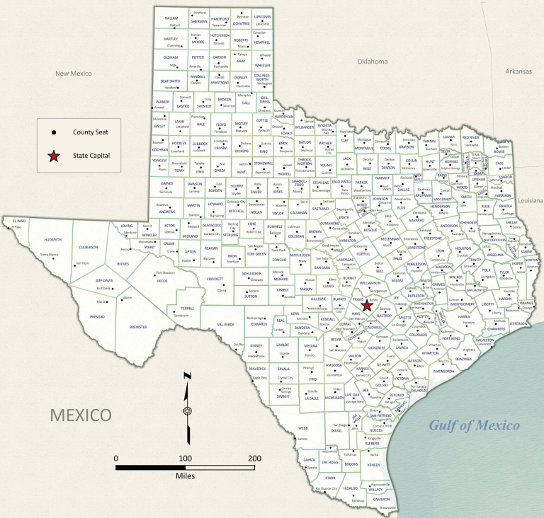  Figure 1: Map of County Seats, Texas General Land Office

Who is involved? | Some Specific Responsibilities
Each Texas county is run by a group of people called a Commissioner’s Court, made up of four commissioners elected by the people of four precincts in the county. There is also a County Judge, elected by voters across the entire county. | - Conducting elections  - Providing public safety services  - Maintaining roads and bridges  - Managing the courts and jails  - Issuing vehicle registrations  - Collecting property taxes  - Setting county sales taxes to pay for development.

Municipal Governments of Texas
The governments of each individual city are called municipal governments. The role of the municipal government is to run the day-to-day functions for the city.  Municipal governments are responsible for providing residents with necessary services like clean water, sewage, and garbage removal as well as maintaining and repairing sidewalks, traffic lights, and roads. The Municipal government is also responsible for ensuring public safety by providing services such as police and fire departments.  Additionally, municipal governments are in charge of public parks, community centers, and public transportation. |   Figure 2: A city street in Longview, Texas. The Portal to Texas History.

Who is involved?

- Mayor: An elected official who manages the operations of the city.

- City Council: A group of elected officials from different districts throughout the city. The council passes laws, creates a budget, determines city taxes, appoints some city government officials, and monitors city departments to make sure they are running effectively.

