The Big Picture Advanced
Unit 9: Reconstruction

Name: |  | Date: |  | Period:

Part I: Analyze an Image
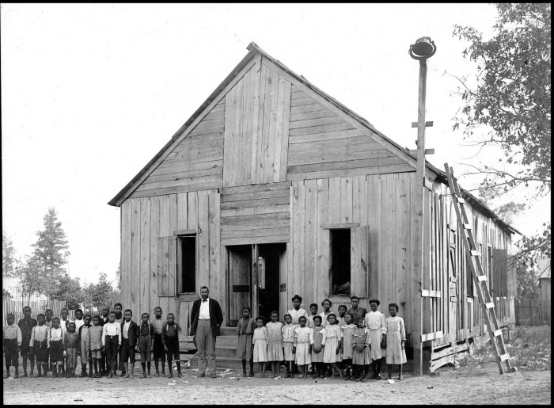  Figure 1: African American school house. The Portal to Texas History. | - What are three things you observe about the image?

- What are two things you can infer about this era of Texas history based on the image?

- What do you predict we will see in this unit based on the image?

Part II: Essential Ideas Reading Passage

In the previous unit, the Civil War, the Northern states of the Union and the Southern states of the Confederacy fought in a deadly war over the issue of slavery. Texas was one of eleven Southern states that seceded and fought against the United States. After four bloody years of fighting, the main armies of the Confederacy surrendered on April 9, 1865, and the Civil War came to an end. Cities, towns, land, and farms across the South were destroyed, and the system of slavery that had fueled the South’s profitable plantation economy was abolished. As the Civil War ended, the United States was faced with three major questions.
First, the U.S. government needed to decide what to do with the former Confederates and their leaders. These men had waged a war against the United States government, a severe crime in any nation. Should they be welcomed back into the U.S. with the full rights of citizenship? Should they be restricted from voting or holding office? Should they be imprisoned? What consequences, if any, should they face for their rebellion?
Second, the U.S. government needed to determine how to bring the Southern states of the Confederacy back into the Union. When the Southern states seceded, they wrote new constitutions and withdrew Southern Congressmen and politicians from the United States government to form their own governments. Should these states be punished for seceding? Should restrictions be placed on their political participation in the federal government? Should they be welcomed back as though nothing had happened?
Third, what would happen to the four million newly freed Black Southerners? The formerly enslaved people were starting from scratch, with no property and no money. Under the system of slavery, Black Southerners had been barred from education, political participation, and had no rights under the law. Should the U.S. government provide services and assistance to the newly freed people? Would they be granted full rights as U.S. citizens? Should the government simply leave the future of the freed people up to each individual state? What role should the government play in the future of the freed people?
There were many different opinions about how best to address these questions, and conflicts often broke out between groups with opposing viewpoints on these issues. Some favored a lenient approach to Reconstruction, including pardoning the ex-Confederates, allowing Southern states to rejoin the Union with few restrictions, and taking no special steps to ensure the rights or safety of the newly freed people. Others believed the ex-Confederates should be punished and prohibited from political participation, Southern states should be strictly controlled, and the government should provide services to ensure the rights and safety of the freed people. Which point of view would prevail, and how would the different attempts at rebuilding the South affect the people and government of Southern states like Texas during the era of Reconstruction?
Part III: Comprehension Questions
- Complete the graphic organizer below based on the information provided in the reading passage on the previous page.

Significant Questions facing the country after the Civil War: | What were some of the different opinions on how to address this question?

- Make a prediction: Which method of reconstruction do you think the U.S. government should implement in the Southern states – a lenient policy that welcomes the South back into the country, or a stricter policy that focuses on punishment and control? What do you think might be the consequences of your chosen policy? Explain your answer.

